**CROWDFUNDING PLATFORM USING BLOCKCHAIN**

**PROJECT SUBMITTED**

**FOR THE AWARD OF THE DEGREE OF**

**MASTERS IN COMPUTER APPLICATION**

**FACULTY OF SCIENCE AND TECHNOLOGY**

**TO THE**

**AMITY UNIVERSITY, MAHARASHTRA, INDIA**



***BY***

**Mr.DHIRAJ SANJU PAWAR**

**(Enrollment No: A710145022041)**

**Under the Guidance of**

**Dr. Manoj Devare**

Professor, Amity Institute of Information Technology

**AMITY INSTITUTE OF INFORMATION TECHNOLOGY**

**AMITY UNIVERSITY, MAHARASHTRA, INDIA**

**MAY 2024**

**TABLE OF CONTENTS**

|  |  |  |  |
| --- | --- | --- | --- |
| **Sr. No.** |  | **Title** | **Page No.** |
|  |  | Declaration And Certificate | i |
|  |  | Originality Certificate | iii |
|  |  | Acknowledgement | vii |
|  |  | List of Acronyms and Abbreviations | ix |
|  |  | List of Tables | xii |
|  |  | List of Figures | xiii |
|  |  | Abstract | xviii |
| **1** |  | **Introduction** |  |
|  | 1.1 | Introduction | 7 |
|  | 1.2 | Problem Statement | 9 |
|  | 1.3 | Objectives of the Project | 13 |
|  | 1.4 | Functionalities | 20 |
|  | 1.5 | Scope | 22 |
| **2** |  | **Literature Review / Background / Analysis** | **30** |
|  | 2.1 | Survey of Existing System | 35 |
|  | 2.2 | Historical Context and Evolution of Emotion Analysis | 36 |
|  | 2.3 | Theoretical Framework and Models | 38 |
|  | 2.4 | Research Gap | 39 |
|  | 2.5 | Case Studies and Applications | 49 |
| **3** |  | **Methodology /** |  |
|  | 3.1 | Overview and Flow Chart | 51 |
|  | 3.2 | Real Time Analysis | 53 |
| **4** |  | **Results and Analysis** | **61** |
|  | 4.1 | Creation of Smart Contract | 63 |
|  | 4.2 | Result Analysis | 68 |
|  | 4.3 | Ganache. Experiment | 76 |
| **5** |  | **Conclusions and Future Work** |  |
|  | 5.1 | Conclusions | 95 |
|  | 5.2 | Future Work | 97 |
|  |  | References | 99 |



**DECLARATION AND CERTIFICATE**

This is to certify that this project report entitled: **“Crowdfunding Platform using Blockchain”** submitted by Mr. / Ms Dhiraj Pawar in partial fulfillment of the requirement of the degree of Master of Computer Application in the Amity Institute of Information Technology, Amity University Maharashtra, is based on the project and research work carried under the guidance and supervision of Dr. Manoj Devare the manuscript has been subjected to plagiarism check by TURNITIN software. This project report and any part thereof had not been submitted for any purpose to any University or Institute.

|  |  |
| --- | --- |
| Place: Mumbai | Mr. / Ms. Dhiraj Pawar |
| Date: /05/2024 | Student |

Prof. Dr Manoj Devare

Guide

**Prof. (Dr.) Manoj Devare**

HOI, Amity Institute of Information Technology

Amity University Maharashtra.

**ORIGINALITY REPORT**

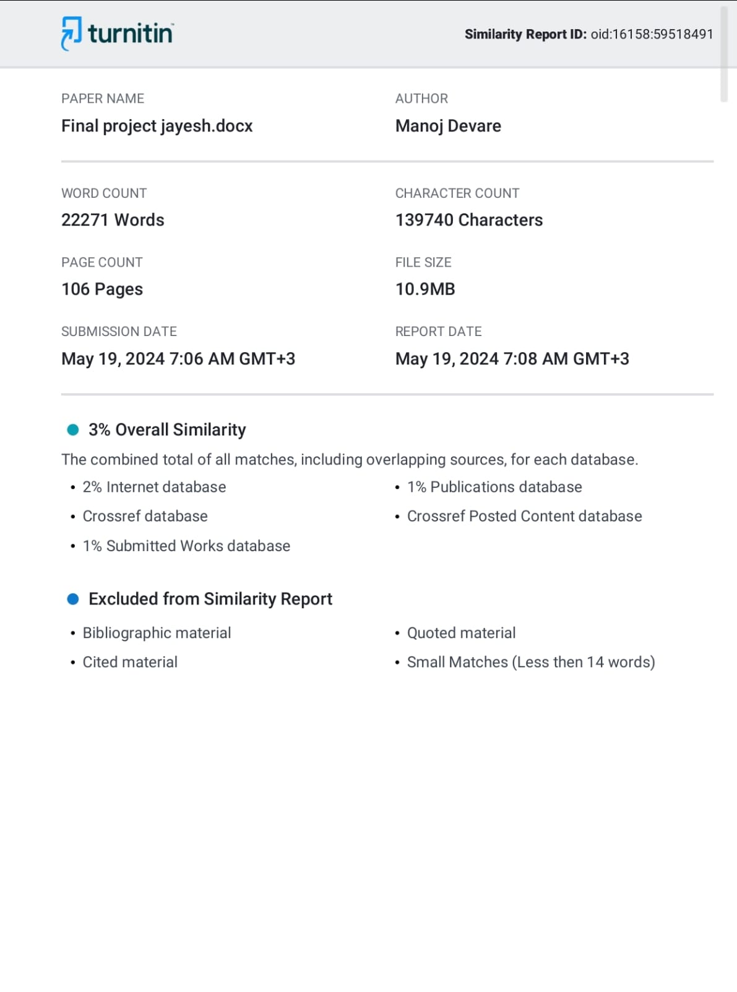

**ACKNOWLEDGEMENT**

We are thankful to our college Amity University, Mumbai and Amity Institute of Information Technology for considering our project and extending help at all stages needed during our work of collecting information regarding the project.

It gives us immense pleasure to express our deep and sincere gratitude to Professor **Prof. Dr. Manoj Devare** for his kind help and valuable advice during the development of project synopsis and for his guidance and suggestions.

We are deeply indebted to Head of the Master of Computer Applications

Department **Prof. Dr. Manoj Devare**

We express our hearty thanks to them for their assistance without which it would have been difficult in finishing this project synopsis and project review successfully.

We convey our deep sense of gratitude to all teaching and non-teaching staff for their constant encouragement, support, and selfless help throughout the project work. It is a great pleasure to acknowledge the help and suggestions which we received from the Department of Master of Computer Applications.

We wish to express our profound thanks to all those who helped us in gathering information about the project. Our families too have provided moral support and encouragement several times.

Dhiraj Pawar

**LIST OF ACRONYMS AND ABBREVIATIONS**

|  |  |
| --- | --- |
| **Abbreviation** | **Meaning** |
| SEO | Search Engine Optimization |
| SERPs | Search Engine Results Pages |
| DAG | Directed Acyclic Graph |
| GSM | Global System for Mobile Communications |
| AES | Advanced Encryption Standard |
| API | Application Programming Interface |
| AML | Anti-Money Laundering |
| KYC | Know Your Customer |
| ROI | Return on Investment |
| BTC | Bitcoin |
| SMS | Short Message Service |
| DAG | Directed Acyclic Graph |
| JDSM | Joint Deep Survival Model |
| DBC | Donation-Based Crowdfunding |
| SCM | Supply Chain Management |
| HC | Healthcare |
| IM | Immutability |
| SAI | Service-Asset Integration |

**LIST OF FIGURES**

|  |  |  |
| --- | --- | --- |
| **Figure No.** | **Figure Name** | **Page No.** |
| 1 | System architecture | 52 |
| 2 | Flow oF Ether in propsed blockchain model | 52 |
| 3 | Solidity Contract Code 1 | 64 |
| 4 | Solidity Contract Code 2 | 65 |
| 5 | Adding Deploy Variables | 66 |
| 6 | Campaign Overview | 67 |
| 7 | Deployed SuccessFully | 67 |
| 8 | Create Campaign Front page | 69 |
| 9 | Donate Ethereum | 69 |
| 10 | Date Of Transaction | 70 |
| 11 | Active Events | 71 |
| 12 | Upcoming Events | 72 |
| 13 | Completed Events | 74 |
| 14 | Ganache Connected To ETH | 75 |
| 15 | Ganache Block 0 | 76 |

**Abstract**

Crowdfunding has become a well-liked alternative financing approach in recent years, giving inventors, artists, and business owners access to funds outside of established channels. However, inefficiencies, a lack of transparency, and fraud susceptibility are common problems with the systems that are currently in use for crowdfunding. The emergence of blockchain technology transforms the crowdfunding market and provides a possible answer to these problems. This paper explains how blockchain technology is being incorporated into crowdfunding platforms and how it is changing the dynamics of fundraising. The immutable ledger of blockchain technology promotes trust and transparency by decentralizing the recording of all transactions, reducing the possibility of fraud, and strengthening accountability. Smart contracts are self-executing contracts that can be programmed and deployed on blockchain networks. They automate the crowdfunding process, allowing for smooth transactions and doing away with middlemen. Additionally, blockchain makes fractional ownership possible and Tokenized assets provide investors increased flexibility and the possibility of trading on secondary markets by representing shares or stakes in projects. Furthermore, crowdfunding platforms built on blockchain technology have a worldwide reach that cut beyond national borders and democratizes money access for investors and creators alike. Moreover, the decentralized characteristic of blockchain technology removes the necessity for middlemen, hence diminishing transaction expenses and enabling individuals to participate directly in crowdfunding endeavours. Decentralized Autonomous Organizations (DAOs) facilitate collaborative ecosystems by empowering stakeholders to participate in project management and funding allocation, as well as community governance and decision-making.   
But obstacles like user uptake, scalability, and legal compliance still stand in the way of the general use of blockchain-based crowdfunding platforms. To create strong frameworks and standards, industry stakeholders, legislators, and digital innovators must work together to address these issues.

**Chapter 1**

**Introduction**

The advent of crowdfunding platforms has revolutionized the philanthropic fundraising scene by fostering greater compassion and connectedness. The growth of crowdfunding and online giving platforms has made it possible for individuals, businesses, and organizations to raise money from a wide range of possible donors. These platforms have given philanthropic causes access to a new stream of financing. More projects can now be funded for charity purposes thanks to the growth of crowdfunding, which makes it feasible to fund more projects than could be accomplished using conventional fundraising techniques. To finish a project, crowdfunding platforms use a provision-point process. Donors who finish have a higher chance of using the site again and earn a personal incentive from completing the donation.

Benevolent and JustGiving are two crowdfunding platforms that support various kinds of humanitarian projects. Benevolent is an online marketplace in the United States where funders give money to low-income Americans to assist them achieve certain objectives. On the other hand, JustGiving is a UK-based marketplace where people raise money for UK charities and other organizations. As long as the charity is still a JustGiving member, a campaign can be run forever on the JustGiving platform. In order to meet their own fundraising goals, contributors are now making noticeably larger gifts more frequently and at a faster rate thanks to the rise of crowdfunding platforms.

The rise of crowdfunding platforms in recent years has completely changed how philanthropic groups interact with contributors and collect money. In contrast to conventional fundraising techniques, which sometimes depend on big donors or institutional grants, crowdfunding platforms offer a democratic and easily accessible means for people and groups to rally support for their altruistic endeavours. By using these platforms, people can contribute little amounts of money that add up to a big impact, opening up philanthropy to a larger population.   
This study aims to investigate how crowdfunding platforms can promote donations to charitable organizations. In particular, the study is to investigate the efficiency, difficulties, and prospects related to crowdsourcing as a means of fundraising for charity causes. Through learning more about the workings of crowdfunding for philanthropic purposes, this research

information and suggestions to help platform operators, donors, and charitable organizations get the most out of their fundraising initiatives.

Online systems such as crowdfunding enable people, groups, and companies to raise money for a range of initiatives or causes by obtaining modest donations from a large number of donors. These networks have increased in prominence in recent years as a result of their reachability, usability, and broad audience appeal.

Platforms for donation-based crowdfunding allow people and businesses to raise money for philanthropic endeavours, social causes, or individual needs. These platforms offer a forum for fundraisers to discuss their projects, exchange their experiences, and establish fundraising targets. In return, supporters have the option to peruse different initiatives and make monetary contributions to those that they deem intriguing or significant.

All things considered, crowdsourcing websites for good causes have developed into effective social impact instruments that help people and groups generate money, spread awareness, and change the world.

# 1.2 Problem Statement

The use of blockchain technology into crowdfunding platforms signifies a significant change in the administration and operation of fundraising campaigns. Conventional crowdfunding platforms have had intrinsic restrictions arising from their centralized character, yet being crucial in linking project creators with possible backers. These restrictions show themselves as a variety of issues like inadequate accessibility, security flaws, and a lack of transparency, which eventually reduces the efficacy and efficiency of crowdfunding projects.

Traditional crowdfunding platforms' centralized architecture is the root of the issue. Vulnerabilities brought about by centralization include dependency on intermediaries for transaction processing, single points of failure, and vulnerability to hackers and data breaches. The integrity and security of fundraising campaigns are jeopardized by this centralized paradigm, which undermines stakeholder trust and discourages potential contributors from taking part in crowdfunding activities. Another major problem with traditional crowdfunding platforms is transparency. Once money is provided to a campaign, donors sometimes have no idea how it is being used. Potential backers' confidence and participation may decline if there are opaque and auditable procedures in place, raising questions about the accountability and integrity of fundraising initiatives.

Moreover, conventional crowdfunding sites have trouble expanding to a worldwide audience, especially for those in underprivileged areas who have no access to fiat money or banking infrastructure. The inclusion and accessibility of crowdfunding campaigns are hindered by legislative limits, currency conversion difficulties, and geographic barriers, which can stifle innovation and social development.

The incorporation of blockchain technology presents a great deal of promise for transforming the crowdfunding market in response to these issues. Blockchain provides an innovative remedy for the drawbacks of conventional crowdfunding platforms. It is frequently referred to as a decentralized and unchangeable ledger. Crowdfunding platforms can overcome the restrictions of centralization and provide unprecedented levels of transparency, security, and accessibility by utilizing blockchain's decentralized design, cryptographic security features, and smart contract functionality.

Increased transparency is one of the main advantages of incorporating blockchain technology into crowdfunding platforms. With real-time tracking and verification of transactions made possible by blockchain's transparent and unchangeable ledger, contributors can see, for the first time, exactly how their money is being used during a campaign. The blockchain ensures accountability and integrity in fundraising efforts by securely recording every transaction.   
Blockchain technology also solves security issues that are present in conventional crowdfunding systems. Because blockchain is decentralized, there are no single points of failure, which makes it immune to censorship, hacking, and data manipulation. Digital signatures and encryption are two examples of cryptographic systems that guarantee the security and privacy of transactions, shielding user information and financial assets from fraud and illegal access.

Furthermore, blockchain technology provides unmatched accessibility, especially for people living in underprivileged areas. Crowdfunding platforms can reach a worldwide audience without geographical limits or currency conversion concerns by utilizing blockchain's borderless and decentralized nature. By utilizing cryptocurrency, contributors from all around the world can take part in fundraising campaigns without being restricted by traditional banking infrastructure or legal restrictions. Smart contracts are essential to the use of blockchain technology in crowdfunding platforms. Smart contracts are blockchain-encoded, self-executing contracts with predetermined conditions. By automating the execution of transactions in accordance with preset norms, these programmable contracts remove the need for middlemen and streamline the fundraising procedure. For instance, once a fundraising target is met, smart contracts can distribute money immediately to project founders, guaranteeing speed and transparency in the distribution of funds.

Furthermore, new financing models like tokenization and decentralized autonomous organizations (DAOs) are made possible by smart contracts. Tokenization is the process of putting rights or assets on the blockchain as digital tokens so that contributors to crowdfunding campaigns can have partial ownership and liquidity. On the other side, decentralized autonomous organizations, or DAOs, are run by community consensus and regulated by smart contracts. This gives contributors a voice in project governance and decision-making procedures.   
Furthermore, the use of blockchain technology into crowdfunding platforms has several advantages beyond transparency, security, and accessibility. These consist of lower transaction costs, quicker settlement times, more effective fundraising, and more chances for innovation and social impact. Blockchain technology lowers overhead expenses and administrative difficulties associated with traditional crowdfunding platforms by doing away with middlemen and automating transaction processes.

Furthermore, among the stakeholders in the crowdfunding ecosystem, blockchain technology promotes a culture of trust and cooperation. Contributors can participate with assurance since they are aware that their efforts are transparently tracked on the immutable ledger and protected by the cryptographic protocols of the blockchain. On the other side, project creators can concentrate their efforts on project creation and execution rather than administrative responsibilities and can acquire funding more effectively

. To fully utilize blockchain technology in crowdfunding platforms, a number of issues and concerns must be resolved, notwithstanding the technology's many advantages. These include constraints on scalability, adherence to regulations, user experience, compatibility with current systems, and environmental issues related to blockchain's energy usage

.One major obstacle that blockchain technology still faces is scalability, especially when it comes to the amount of transactions that are handled on the network. Blockchain networks may get congested and incur slower transaction processing times as the volume of transactions rises, which would result in higher costs and less efficiency. To solve scalability issues and improve the efficiency of blockchain networks, technologies including layer 2 scaling, sharding, and off-chain protocols are being investigated.

Another important factor for crowdfunding sites that use blockchain technology is regulatory compliance. The regulatory environment pertaining to cryptocurrencies and blockchain-based fundraising strategies is changing quickly, with different countries having differing levels of clarity and enforcement. To maintain compliance and reduce legal risks, crowdfunding platforms have to manage a variety of complicated regulatory obligations, such as securities laws, anti-money laundering (AML) rules, and know-your-customer (KYC) standards.  
Another area of concern is user experience, since blockchain technology presents new ideas and technological challenges to the general public. In order to provide transparent and seamless user experiences, crowdfunding platforms need to provide intuitive and user-friendly interfaces that abstract away the complexity of blockchain technology. To fully onboard and inform users about the features and advantages of blockchain-based crowdfunding platforms, outreach and education initiatives are also crucial.

Blockchain-based crowdfunding platforms also face the issue of interoperability since their legacy infrastructure and current systems might not work with blockchain technology. Interoperability solutions that provide smooth data transmission and system integration are necessary to close the gap between blockchain technology and conventional financial systems. To overcome these obstacles and promote interoperability, interoperability standards including cross-chain protocols and interoperability frameworks are being created.

Environmental issues around the energy usage of blockchain have also been scrutinized, with a focus on the proof-of-work (Pow) consensus techniques employed by numerous blockchain networks. Pow consensus algorithms raise concerns about network security and transaction validation since they consume a significant amount of energy and computational resources.

# Objectives of the Project

**a.To assess the effectiveness of crowdfunding platforms in facilitating donations for charitable causes via intangible and tangible benefits.**

Evaluating crowdfunding platforms for the purpose of facilitating donations for charity purposes requires a thorough analysis of their many advantages. Beyond financial contributions, intangible rewards include the sense of purpose and emotional bond that contributors have when they support worthwhile projects. Crowdfunding platforms provide as a digital forum for people to interact with like-minded people, exchange personal stories, and demonstrate empathy. This promotes a sense of community and group action. Donors are frequently inspired to give beyond strictly financial reasons by these intangible benefits because they feel like they are a part of something greater than themselves.

Furthermore, the accountability and transparency features built into crowdfunding platforms boost contributor confidence and trust. Donors can monitor the impact of their gifts and see the actual consequences of their giving through real-time updates, progress reports, and direct engagement with campaign organizers. In addition to confirming contributors' confidence, this openness promotes continued involvement and devotion to the cause.

Crowdfunding platforms provide concrete incentives and benefits to donors, which serve as a means of encouraging involvement and augmenting donation quantities. As a thank you for their support, donors can be eligible for unique benefits like branded goods, event tickets, or mentions in campaign materials. Furthermore, tax incentives for charity contributions encourage giving by benefiting donors monetarily and concurrently aiding the

Moreover, crowdfunding platforms remove geographical restrictions and make charitable giving accessible to people from a wide range of backgrounds, democratizing access to generosity. Crowdfunding platforms enable contributors to make contributions to projects they are enthusiastic about, regardless of their financial situation, whether through modest individual gifts or bigger contributions from foundations and organizations.

Crowdfunding platforms are also an effective means of bringing attention to social issues and generating support for marginalized groups. Campaigns on these platforms have the power to garner a lot of attention and spark group action around important societal issues through captivating storytelling, multimedia material, and social media outreach.

In conclusion, the capacity of crowdfunding platforms to provide a wide range of both concrete and intangible advantages accounts for their effectiveness in facilitating donations for charitable purposes. These platforms are essential for generating support, increasing effect, and promoting positive social change since they not only encourage emotional ties and community participation but also offer transparency, accountability, and material incentives. Crowdfunding platforms play a crucial role in addressing societal problems and constructing a more compassionate and equitable world by leveraging the global generosity of individuals and organizations.

**b.To add the functionality to overcome the key challenges faced by charitable organizations when utilizing crowdfunding platforms for fundraising.**

Although crowdfunding platforms have transformed philanthropic giving, organizations still face several difficulties with them, including fraud, oversaturation and rivalry, sustainability of funding, transparency, and donor involvement. Oversaturation makes it harder to stand out among the many efforts, which wears out donors. Even with current verification procedures in place, maintaining the validity of campaigns is still important since deceptive practices can undermine confidence. Furthermore, crowdfunding frequently concentrates on short-term objectives, which makes it challenging to get continuous funding for long-term projects. Issues with accountability and transparency occur when donors are not fully informed about the use of their contributions. Finally, a lot of platforms don't have the resources to interact and keep donors, which encourages one-time gifts rather than building a network of recurring contributors.

Platforms can utilize advanced search and customization algorithms to improve campaign exposure and offer tailored suggestions based on user interests in order to overcome these problems. Strict verification procedures, such as required identity checks and project validity documentation, help reduce fraud. Funding sustainability can be ensured by putting in place tools for long-term participation, like subscription-based donations and frequent updates on campaign progress. Reassuring donors about the efficient use of their gifts can be accomplished by comprehensive financial reporting and impact tracking, leading to increased transparency. Crowdfunding platforms can assist nonprofits in their fundraising endeavours and provide a more dependable and stimulating atmosphere for contributors by integrating these functional improvements.

**a.To examine and maintain the immutable records of the impact of storytelling and multimedia content on the success of crowdfunding campaigns for charitable causes.**

Understanding and improving fundraising methods requires examining and keeping unchangeable records of the effects of multimedia content and narrative on the success of crowdfunding campaigns for charitable purposes. Multimedia storytelling—that is, using pictures, videos, and in-depth narratives—is essential for drawing in prospective contributors because it effectively communicates the purpose and urgency of a cause. By giving the campaigns a more relevant and emotional appeal, these components humanize the campaigns and can greatly boost donor involvement and contributions. Crowdfunding platforms can generate an unchangeable record of campaign activity, such as the kinds of content utilized and how much each contributed, by utilizing blockchain technology.

This openness makes it possible to evaluate various storytelling modalities and multimedia components objectively throughout time. Platforms, for example, have the ability to monitor the success rate of advertisements that use high-quality videos in comparison to those that only use text and photos. Through meticulous documentation of donor engagement and contribution trends associated with particular content categories, organizations can get significant understanding about the most compelling content for their target audience. The most successful storytelling formats, visual motifs, and narratives for encouraging donations can be identified by analysing this data.

Furthermore, these records are unchangeable due to the immutable nature of blockchain, offering a reliable and everlasting record of campaign performance. This can be especially helpful for determining long-term trends and making wise choices for upcoming marketing. Using actual proof of what works best, charitable organizations may use this data to improve their campaigns, customize their messaging, and put best practices into action. Organizations might give priority to personal tales and testimonials in their campaigns, for instance, if research indicates that these aspects greatly increase engagement.

Furthermore, unchangeable data can improve crowdfunding platforms' accountability and transparency. If donors can easily observe how their money is being spent and the results it is producing, they will be more inclined to contribute. Platforms can reassure contributors about the efficient use of their contributions by offering comprehensive financial data and impact tracking. In addition to fostering trust, this increases the likelihood that contributors will make additional contributions since they are more assured that their money is having an impact.

Innovative features like smart contracts, which can automatically disburse funds depending on reaching predetermined milestones or objectives, are also made possible by the usage of blockchain technology. This can further improve trust and accountability while guaranteeing that gifts are used as intended. To give supporters even more peace of mind, a smart contract might be programmed to disburse money only when a campaign hits a particular financial target or when particular project milestones are fulfilled.

In conclusion, there are several advantages to using blockchain technology to analyse and preserve unchangeable records of how multimedia and narrative affect crowdfunding campaigns. It gives organizations a transparent, unchangeable record of what works, allowing them to keep refining their fundraising tactics over time. By ensuring contributors about the efficient use of their contributions and promoting repeat donations, it improves openness and confidence. In the end, this data-driven strategy optimizes the financial and emotional impact of charity storytelling, assisting organizations in reaching their fundraising objectives and improving donor engagement.

**a.creating sustainable crowdfunding platform as a fundraising strategy for charitable organization for the long-term benefits of all stakeholders like doners, government, judicial and beneficiaries.**

Establishing a long-lasting crowdfunding platform as a means of raising money for nonprofits guarantees long-term gains for all parties involved, including beneficiaries, government agencies, courts, and donors. A sustainable platform assures contributors that their gifts are having a real effect by offering transparency, accountability, and confidence through unchangeable records and frequent updates. Improved elements that preserve donor involvement and promote a sense of community and belonging include impact stories, customized thank-you notes, and thorough financial reports.

Such a platform provides governments and judicial authorities with a safe and reliable way to track finances, guarantee adherence to legal and regulatory requirements, and lower the possibility of fraud. Blockchain technology can offer a transaction record that is impenetrable, which facilitates auditing and confirming the use of funds. Greater public trust in charitable organizations and the crowdfunding process may result from this enhanced transparency, which may encourage more accommodating laws and government backing.

The beneficiaries, who are the main users of the donations, gain from steady and dependable support for their causes because the platform makes ongoing and efficient fundraising possible. Beneficiaries can strengthen their relationship with supporters by communicating the tangible results of donations through frequent updates and impact reports. Long-term donor connections may be maintained and a consistent flow of resources to meet their requirements can be ensured with this continuous contact.

Furthermore, including cutting-edge technologies like smart contracts can boost operational efficiency and trust by automating fund payments upon reaching predetermined milestones. For instance, money can be distributed gradually when projects finish at specified points, guaranteeing that the money is used wisely and according to plan. In addition to safeguarding the interests of donors, this system makes sure that recipients are nevertheless held responsible for, In addition to providing campaign creators with support and instructional materials, a sustainable crowdfunding platform may also help them create more impactful campaigns that connect with a larger audience. Through the provision of tools for social media integration, data analytics, and storytelling, the platform can enable nonprofit organizations to optimize their reach and influence. Furthermore, features like donor matching programs and possibilities for recurring donations can promote consistent giving, offering philanthropic enterprises a steady source of funding.

In order to further improve sustainability, the platform might collaborate with foundations and businesses to provide matching grants and sponsorships. By showcasing broader support for the causes, these collaborations can increase the impact of individual gifts and draw in new ones. In addition to gaining more recognition and credibility, cooperative campaigns and co-branded projects might attract new donors who conventional fundraising techniques might not have been able to reach. By encouraging creativity and exchanging best practices, a sustainable crowdfunding platform can also benefit the broader ecosystem of philanthropic giving. The platform can determine the most effective patterns and tactics by analysing data from campaigns that are successful and sharing this information with other campaign developers. This method to collaborative learning has the potential to improve fundraising strategies over time and increase the sector's overall efficacy.

In conclusion, developing a long-lasting crowdfunding platform as a means of generating money for nonprofits guarantees long-term gains for funders, authorities, courts, and recipients. It guarantees regulatory compliance, boosts accountability, transparency, and trust, and consistently supports philanthropic causes. Through the integration of sophisticated features such as smart contracts and provision of instructional materials, the platform may optimize its influence, promoting a robust and flourishing nonprofit sector that efficiently caters to the requirements of global communities

**1.4 Functionalities**

Fundraising is revolutionized by a blockchain-based crowdfunding platform that integrates cutting-edge features that improve efficiency, security, and transparency. The platform gives users the necessary information, such the project name, description, financing target, and minimum contribution amount, to enable them to develop and manage projects with ease. Every project is managed by a smart contract, a self-executing agreement with terms encoded straight into code that automates money collection, monitors objectives, and guarantees that funds are disbursed in accordance with predetermined guidelines. Because of this automation, there is no longer a need for middlemen, which lowers prices and speeds up transactions.

Contributions are safe and documented on the blockchain, which offers an unchangeable, transparent ledger that guarantees traceability and is open to public auditing. Contributors gain confidence because they can confirm that their money is being spent for the intended purpose thanks to this transparency. A layer of security against fraud is provided by smart contracts, which hold funds in escrow until the funding target is reached and guarantee that money is only delivered once certain requirements are met. The smart contract can automatically return contributions to the contributors in the event that the funding target isn't met in the allotted time, guaranteeing system fairness and confidence.

Tokens can be distributed by the platform as a means of encouraging participation and providing incentives for support. These tokens may be used to represent a variety of values, including voting rights, project equity, and access to special content. By providing material incentives, the platform may draw in a larger pool of contributors and promote increased involvement.   
Another important component is the decentralized governance mechanisms, which let contributors take part in decision-making by means of voting procedures. Voting on significant project choices, including redefining the project's scope or requesting more money, allows contributors to make sure the project stays in line with their interests. The democratic method strengthens contributors' sense of belonging and ownership.

The platform incorporates Know Your Customer (KYC) and Anti-Money Laundering (AML) protocols to guarantee security and compliance by authenticating the identities of project founders and contributors. Frequent security assessments of the platform's infrastructure and smart contracts prevent against hackers and weaknesses, preserving the interests of all parties involved.   
Proficient analytics and reporting instruments furnish project initiators with discernments into campaign efficacy, facilitating data-oriented decision-making and optimizing fundraising tactics. In-depth statistics that display the overall amount raised, individual contributions, and engagement data can be used to watch the campaign's progress in real-time. Building further confidence and accountability, transparency reports for contributors provide specifics about the project's progress and how money are being used.

The visibility of projects and community involvement are improved via social features and marketing tools. Project managers may communicate with contributors, solicit new sponsors, and provide updates when their platforms are integrated with social media. An active community is created using forums, comment sections, and update tools, allowing backers to communicate, exchange ideas, and follow the project's progress.

Additionally, the platform provides blockchain networks and other services with integration and interoperability. API integration makes it possible to connect with a wide range of apps and services with ease, improving functionality and reach. Multiple cryptocurrencies are supported by cross-chain interoperability, which enables projects to communicate with different blockchain ecosystems and accept contributions in numerous digital currencies.

A blockchain-based crowdfunding platform guarantees a safe, transparent, and efficient fundraising experience for all parties involved by integrating these extensive features. It makes funding more accessible to all, encourages creative endeavours, and cultivates a cooperative atmosphere where creators and contributors can cooperate to accomplish common objectives. Using blockchain technology, this revolutionary method to crowdfunding creates a fairer and more effective fundraising environment.

**1.5 Scope**

A crowdfunding platform powered by blockchain technology has a huge reach, is revolutionary, and greatly outperforms more conventional crowdfunding techniques. This creative method overcomes many of the restrictions and difficulties that traditional crowdfunding platforms have by utilizing the decentralized, transparent, and secure characteristics of blockchain technology. Here, we explore the wide-ranging application of this platform, emphasizing its capacity to transform fundraising, improve accountability and trust, and offer a host of advantages to all parties concerned.

**Enhancing Transparency and Trust**

The increased trust and transparency that blockchain technology provides is one of the biggest benefits of using it for crowdfunding. Contributors to traditional crowdfunding sites frequently have little visibility into how their money is being spent, which leads to a lack of transparency. Because of its unchangeable ledger, blockchain technology guarantees that every transaction is documented on a public ledger that is open to all parties. Because of this openness, donors can monitor their contributions, see how money is spent, and make sure their money is going to where it's supposed to.

The implementation of smart contracts improves accountability and confidence even further. Self-executing contracts, or smart contracts, have the conditions of the contract explicitly encoded into the code. These contracts can automatically distribute money in the context of crowdfunding according to predetermined thresholds or requirements. To ensure that funds are spent wisely and lower the danger of misuse, a smart contract can be set up to distribute cash to the project developer only if specific milestones are fulfilled.

**Democratizing Access to Capital**

Crowdfunding systems built on blockchain lower traditional barriers to entry, democratizing access to capital. Entrepreneurs and innovators frequently encounter major obstacles when trying to obtain funds through traditional fundraising, especially if they don't have any connections or collateral. Anyone with internet access may take part in crowdfunding thanks to blockchain technology, regardless of where they live or their financial situation. This inclusion promotes innovation and entrepreneurship by providing financial options for a wider range of initiatives and ideas.

Furthermore, contributions made using cryptocurrencies are frequently accepted by blockchain crowdfunding platforms, allowing participation from a worldwide audience without the need for expensive transaction fees or currency conversion. This worldwide reach raises the possibility of a successful fundraising campaign by broadening the pool of possible contributions.

**Reducing Costs and Increasing Efficiency**

The amount of money that eventually reaches the project author is usually decreased by intermediaries that demand fees for their services on traditional crowdfunding platforms. Blockchain technology enables peer-to-peer transactions directly, doing away with the need for these middlemen. In addition to cutting expenses, this elimination of middlemen improves the effectiveness of the fundraising procedure.

Smart contracts' automation further simplifies processes and lessens the administrative load on project developers. Creators can concentrate more on building their projects by automating tasks like fund distribution, milestone monitoring, and contributor communication, freeing them up from having to oversee the fundraising process.

**Enhancing Security and Reducing Fraud**

In the world of crowdfunding, security is crucial since fraud and hacks have the potential to destroy confidence and discourage contributions. Because blockchain technology is immutable and decentralized, it improves security. Because every transaction is documented on a distributed ledger, tampering or alteration of the transaction history is nearly impossible. Because of its immutability, crowdfunding is guaranteed to be legitimate, shielding contributors and project creators from dishonest practices.

Moreover, blockchain systems frequently use cutting-edge cryptography methods to protect user information and transactions. Money and private data are safeguarded by these security measures, which guard against hacking and illegal access

.

**Enabling Micro-Investments and Fractional Ownership**

Contributors can now make little donations in projects thanks to the concept of micro-investments made possible by blockchain technology. For those who wish to support a cause or project but may not have a substantial amount of money to invest, this inclusion is especially advantageous. Platforms for blockchain crowdfunding can draw in a wider range of donors by reducing the minimum commitment required.

Blockchain also makes it possible to create digital tokens that indicate different percentages of ownership in a project or asset. Contributors can realize returns on their investments and gain liquidity by trading these tokens on secondary markets. In sectors where typical crowdfunding techniques might not be as practical, such real estate or large-scale infrastructure projects, this fractional ownership model can be very alluring.

**Facilitating Regulatory Compliance**

An essential component of crowdfunding is adhering to regulations, especially when it comes to financial transactions and investments. Blockchain technology can help with regulatory compliance by giving all transactions a transparent, auditable record. Know-your-customer (KYC) and anti-money laundering (AML) standards, among others, can be encoded into smart contracts to enforce compliance.

Identity verification systems based on blockchain technology have the potential to optimize the compliance procedure by guaranteeing that crowdfunding campaigns only include confirmed contributors. By protecting contributors and project creators and fostering confidence with authorities, this improved compliance opens the door for blockchain crowdfunding platforms to be used and accepted more widely.

**Promoting Social Impact and Philanthropy**

Blockchain-based crowdfunding systems have great promise for advancing charitable giving and societal impact. Through these channels, contributions for environmental and social concerns can be drawn in an open and responsible manner. Donors may be guaranteed that their funds are allocated appropriately since the blockchain tracks and reports on the contributions' effects.

To generate money for disaster assistance, for example, a blockchain-based crowdfunding platform might be utilized. Smart contracts would make sure that the money is only distributed to verified organizations who meet predetermined requirements. Increased donations and a bigger social impact can result from donor confidence bolstered by the blockchain's transparency and traceability.

**Fostering Innovation and Entrepreneurship**

Blockchain crowdfunding sites have the potential to be extremely important for promoting entrepreneurship and innovation. These platforms give entrepreneurs and small enterprises the tools they need to realize their ideas by democratizing access to funding. By showcasing their initiatives to a worldwide audience, business owners can win over donors who are aligned with their mission

. Additionally, the application of blockchain technology creates new opportunities for creative fundraising strategies. For instance, businesses can generate money by issuing digital tokens that represent ownership or rights to future revenues through Initial Coin Offerings (ICOs) and Security Token Offerings (STOs). By giving business owners access to several funding options, these models can help them diversify their revenue streams and lessen their dependency on conventional venture capital.

**Building a Decentralized Economy**

Crowdfunding has included blockchain technology as part of a larger push to create a decentralized economy. People in this economy are more in charge of their investments and financial dealings because there are no centralized middlemen involved. Peer-to-peer fundraising, where trust is built through technology rather than intermediaries, is exemplified by blockchain crowdfunding platforms. his decentralized strategy encourages financial inclusion in addition to empowering individuals. People can engage in the global economy and support organizations and projects they support by living in underserved or unbanked areas. The decentralized economy promotes a more just allocation of opportunities and resources, in line with the values of inclusion and justice.

**Future Trends and Opportunities**

Blockchain-based crowdfunding platforms have a bright future ahead of them, with a number of trends and opportunities to look forward to. We should anticipate more advancements in scalability, security, and user experience as blockchain technology develops. These developments will increase the efficiency and accessibility of blockchain crowdfunding platforms, encouraging a wider use.

The incorporation of decentralized financing (DeFi) into crowdfunding platforms is one such trend. DeFi protocols can improve the usefulness of crowdfunding sites by offering more financial services including lending, borrowing, and staking. Contributors might, for instance, use their tokens as collateral for loans or earn interest on their contributions while they wait for a project to meet its financing target.

Tokenizing assets and building online marketplaces present further opportunities. Platforms for blockchain crowdfunding can make it easier to issue and exchange tokenized assets, allowing for fractional ownership and liquidity. This strategy opens up new investment opportunities and democratizes access to wealth creation for a wide range of assets, including real estate, art, and intellectual property.

Furthermore, the matching of projects with possible contributors can be improved by the application of artificial intelligence (AI) and machine learning in blockchain crowdfunding platforms. AI systems are capable of analysing data to find initiatives that fit the interests and preferences of donors, which raises the possibility that fundraising efforts will be successful.  
The potential for blockchain-based crowdfunding platforms will only increase as blockchain technology develops, presenting fresh chances for donors, businesses, and society as large. These platforms are a big step toward a decentralized economy, where people own more power over their investments and financial dealings, and where technology, not middlemen, establishes trust. The development of blockchain technology will surely influence crowdfunding in the future, bringing forth a more open, effective, and inclusive fundraising environment.

**History**

The story of blockchain-powered crowdfunding platforms is an engrossing one, weaving technology advancement and fundraising democracy together.

The inception of decentralized fundraising models driven by cryptocurrencies was pioneered by Bitcoins tarter and Swarm in the early 2010s, which is when blockchain-based crowdfunding sites first appeared. These platforms created a thrustless environment where anyone could contribute to projects without depending on centralized middlemen by utilizing the security and transparency aspects of blockchain technology.

The Ethereum project is among the first instances of successful blockchain crowdfunding. Using its own platform, Ethereum held an Initial Coin Offering (ICO) in 2014 that raised over $18 million in Bitcoin in just 42 days. This ground-breaking occasion showed how blockchain-based crowdfunding may be used to generate substantial funds for creative enterprises.  
  
Crowdfunding systems developed to include more advanced features and use cases as blockchain technology advanced. Giveth and We Trust are two examples of platforms that have arisen to support decentralized charitable giving. These platforms use smart contracts to guarantee an open and responsible allocation of donations. Giveth, for instance, allows contributors to directly support projects they are passionate about guaranteeing that donations are only released if noticeable progress is made by having money stored in smart contracts until particular project milestones are reached.

The emergence of blockchain-based crowdfunding platforms for companies and artistic endeavours is another noteworthy example. Crowdfunding was first made possible by websites like Kickstarter and Indiegogo in the early 2000s, but blockchain-based substitutes like Fund Request and We funder increased the process's openness and inclusion. Through these platforms, investors can contribute to firms and projects in their early stages, frequently in exchange for shares or tokens that reflect ownership rights.

Blockchain crowdfunding has pushed into new areas recently, such as impact investing, renewable energy, and real estate. Blockchain-based projects like Real and Grid+ tokenize real-world assets, making fractional ownership possible and democratizing access to financial opportunities that were previously unattainable for a large number of people. In a similar vein, blockchain technology is being used by Abundance Investment and Ethic to enable impact investment, enabling anyone to fund environmentally and socially responsible enterprises.

Looking ahead, blockchain-based crowdfunding platforms have a bright future ahead of them. As blockchain technology continues to progress, we should anticipate even higher degrees of accessibility, efficiency, and openness in fundraising endeavours. Blockchain crowdfunding platforms have the potential to completely change how money is generated and distributed in the digital age, whether they are used to assist creative enterprises, finance social impact initiatives, or democratize access to investing possibilities.

**Chapter 2**

**Literature Review**

In response to the global problem of surplus and waste food, this article presents an online system for managing food charity activities. The system simplifies every step of the process, from gathering extra food donations to effectively running food bank organizations and dispersing food to eligible recipients. This creative strategy decreases food waste while bridging the access gap between food charity organizations, donors, and the underprivileged by utilizing technology. Improving total service quality and efficiency in food charity operations is the goal.[1]

By examining and forecasting donor behaviours such as donation recurrence and retention, this addresses the issue of high donor attrition in online donation-based crowdfunding. To incorporate many variables and jointly model these behaviours while taking their importance into account, the Joint Deep Survival model (JDS) is presented. The approach tackles issues like filtering phenomena and heterogeneity of influence. The efficiency of the suggested model in understanding and forecasting donor behaviours in crowdfunding is demonstrated by extensive tests conducted with data from Kiva.org.[2]

This explores the problem of donor retention in online crowdfunding platforms, concentrating on the platform for educational projects DonorsChoose.org. Given that donor turnover rates are higher than 70%, it is imperative to comprehend the factors that impact retention. Donor return rates are highly impacted by nice interactions and effective recognition of support, according to studies based on millions of contributors and donations. The results provide guidance for improving donor retention tactics for conventional non-profit organizations as well as online crowdfunding groups.[3]

Emergency situations around the world arouse a moral obligation to help, but concerns about transparency stifle excitement. As a solution, blockchain technology (BCT) is introduced, which removes the need for middlemen and provides a safe, transparent contribution process. This article presents a blockchain-based donation system that can be especially helpful in times of calamity, such as the Covid-19 pandemic. It ensures fund traceability through the use of smart contracts and the Ethereum blockchain, building confidence between donors, charities, and recipients. [4]

The time required by different consensus methods to create a new block in a blockchain varies. Proof of Work (Pow) requires a lot of computation power and takes time. Because Proof of Stake (Po's) depends on validators' holdings, it is typically faster. IOTA's Directed Acyclic Graph (DAG) uses prior approvals to validate transactions, removing the need for miners and enabling faster block production. Each mechanism's efficiency is affected by various factors, including the characteristics of the protocol and network conditions.[5]

This creative method lowers expenses, increases donation transparency, and protects against fake campaigns—all of which help to make disaster recovery operations more successful. The study also finds social motives such as perceived effectiveness and contributing to group efforts.[6]

This offers a flexible donation box system that is intended to successfully prevent fraud. The system counts coins and bills, determines the total amount of money set aside for particular uses, and sends the information to a Blynk server. The owner's smartphone receives the information from this server thereafter. The system communicates with the Blynk server over the GSM cellular data network in order to guarantee autonomy and reduce Wi-Fi connectivity problems. With 100% accuracy in determining the value of entered money and an average overall acceptance rate of roughly 91.29% for both coins and notes, the system exhibits a high degree of accuracy.[7]

The purpose of this is to investigate how the number of intended beneficiaries affects the effectiveness of digital platform donation-based crowdfunding (DCF) campaigns. The literature on the effect of beneficiary volume in offline fundraising efforts is reviewed first. Next, theories are put forth that relate DCF campaigns to determinants found in the literature. A database of 360 campaigns from the donation-based crowdfunding platform Microdonations is used in the study. The hypotheses are supported by logistic regression analysis, which shows that effective DCF efforts for charitable organizations on digital platforms frequently concentrate on a smaller and more constrained number of possible beneficiaries.[8]

This supports the use of blockchain technology to create a trustworthy and transparent method for processing charitable donations, tackling issues brought on by the Covid-19 pandemic. Its main objectives are organizational management, information sharing, and the distribution of funds and materials. The suggested approach seeks to mitigate trust difficulties with Chinese charity services through more openness, and it could serve as a model for blockchain-driven advancements in the charity industry.[9]

This study looks at the impact of target beneficiary volume on donation-based crowdfunding (DCF) campaigns on digital platforms, which is important for offline fundraising success. After reviewing pertinent literature, the paper quantitatively examines 360 DCF campaigns on Microdonations from 2012 to 2017 and puts forth hypotheses connecting factors to DCF campaigns. A smaller and more constrained number of possible beneficiaries is frequently given priority in DCF campaigns for charity organizations run on digital channels, according to logistic regression study.[10]

This proposes the use of blockchain technology to improve transparency in the contribution process, hence addressing donor mistrust. The goal is to have a single platform that keeps track of all the data about contributors, transactions, and gifts. Using blockchain technology, the system guarantees open accounting of activities for contributors, nonprofit organizations, and beneficiaries. The platform prioritizes a transparent donation process by giving contributors and the general public access to track the distribution of charity funds. This allows them to see exactly when, where, and to whom resources are allocated. [11]

As the public's involvement in charitable giving increases, it is critical to protect user privacy. Because blockchain is unchangeable and decentralized, it appears to be a solution to privacy issues. This work presents data-oriented protection using an enhanced AES algorithm and user-oriented privacy using smart contracts. The algorithm's parallelization increases operating efficiency while its dynamic S-box creation improves security. The algorithm's ability to secure charity system data and improve overall performance is confirmed by experimental findings.[12]

This offers a comprehensive framework that clarifies loyalty reactions in luxury product markets with high levels of engagement and service. Differentiating between the direct and indirect effects of model constructs on behavioural and attitude-based loyalty responses is the main goal. The findings support the established chain while emphasizing how crucial it is to foster trust and develop exchange-specific assets in order to increase customer loyalty. It has been determined that achieving overall satisfaction comes before developing SAI and being loyal. The study also emphasizes how important it is to account for the detrimental impact of product-market expertise on behavioural loyalty in order to have a thorough grasp of the factors that influence loyalty. [13]

The increasing importance of philanthropic contributions as a way for contemporary businesses to maximize intangible assets and satisfy their social obligations. It contrasts local and international dominant firms using a case study methodology, concentrating on donor motivation, form, and correlation. The purpose of the study is to find patterns and distinctions in their donating habits. The study also explores cause-related marketing as a tactic that helps businesses, consumers, and nonprofit organizations in turn.[14]sCorrupt centralized charity institutions create societal isolation in a society rapidly modernizing. This paper suggests a decentralized method for donations that makes use of finance and cryptocurrencies. The system includes people or organizations donating work that is exchanged as certificates on a cryptocurrency exchange through Blockchain, Smart Contracts, and Cryptocurrency. This novel approach guarantees openness and encourages group endeavours for bettering society outside of financial donations. Keywords: charity, cryptocurrency, blockchain, Ethereum, and smart contracts.[15]

The study presents charity, an online application that improves accessibility for contributors to help charities in Metro Manila, wherein charity groups support disadvantaged populations amid global concerns such as the pandemic. This program ushers in a new era of humanitarian initiatives by using technology to accomplish goals and offer a useful answer. Future improvements could be as simple as increasing the diversity of participants for overall development and providing motivation for related research projects.[16]

The absence of clarity in the mechanisms used for collecting donations impedes donor participation and trust in the global charity giving landscape. This study proposes a blockchain-based crowdfunding platform as a solution to these issues. This creative solution eliminates the shortcomings of the existing method, guarantees fundraising transparency, and makes use of blockchain's decentralized structure to prevent data breaches. The platform offers transparency and accountability while serving as a safe entry point for charitable endeavours and fundraising. [17]

The current issues surrounding material giving, the flaws of conventional charitable platforms, the insufficiency of current remedies, and the presence of security risks. We suggest a blockchain-based material donation platform as a solution to these issues. [18]   
Crowdfunding has shown to be successful in the fundraising landscape for new projects, but it offers little insight into the reasons behind donors' contributions to charitable crowdfunding, where there are no financial incentives. The study offers important implications for the development of crowdfunding theory, practice, and research by illuminating how contributors use charity crowdfunding to solve social issues, raise awareness, and encourage action.[19]  
Given that natural disasters are a common occurrence in India, there is a high level of motivation to contribute to society. Nevertheless, there are difficulties during disasters because to the opaqueness of civic supply tracking and humanitarian groups. The article suggests using Proof of Work and Blockchain technology, particularly Ethereum, to improve the reliability and transparency of the charitable donation process in order to address this. For the benefit of both donors and those in need, the objectives are to increase confidence, reduce the danger of fraud, and enhance the distribution of help.[20]

**2.1 Survey of Existing System**

A review of the current crowdfunding landscape reveals a diverse array of platforms, each suited to particular preferences and market niches. As industry titans in creative crowdfunding, Kickstarter and Indiegogo have successfully funded a wide range of projects in the fields of technology, design, and art. These platforms, which link creators to a global audience of backers ready to fund new projects, have empowered creators to fulfil their ambitions, from ground-breaking gadgets to independent films and music albums. Furthermore, the dynamic character of equity crowdfunding platforms such as Crowd cube and Seed Invest has made investing more accessible by allowing individuals to participate as investors in early-stage firms and maybe gain from their success.

. In the interim These platforms have made venture finance more accessible to a wider range of investors by doing away with conventional entrance hurdles like certification requirements, which has encouraged innovation and entrepreneurship. Similar to how crowdfunding for real estate has democratized access to real estate investments, real estate crowdfunding platforms, such Realty Mogul and Fundraise, have traditionally been the purview of institutional investors. Donation-based crowdfunding platforms such as GoFundMe have emerged as effective tools for mobilizing support and solidarity in times of need. By allowing individuals to diversify their investment portfolios with exposure to commercial and residential properties through fractional ownership models, these platforms democratize wealth creation and financial inclusion.

These platforms have mobilized millions of people's collective goodwill in the wake of natural disasters and assisted individuals in covering medical costs, demonstrating the revolutionary potential of crowdfunding to bring about positive change on a global scale. Essentially, the evaluation of current crowdfunding platforms highlights the democratizing power of group effort and community-driven funding in enabling people and organizations to realize their goals, changing markets, encouraging creativity, and advancing social impact in the process.

**2.2 Historical Context and Evolution of Emotion Analysis**

Crowdfunding platforms for emotion analysis have evolved throughout time, reflecting a dynamic journey driven by both cultural shifts and technology improvements. The practice of recognizing and comprehending human emotions through computational techniques is known as emotion analysis, and it has become more and more popular in recent years because of its potential uses in a variety of industries, such as social sciences, marketing, and healthcare. Adding emotion analysis to crowdfunding platforms is a new way to improve user decision-making, engagement, and campaign success rates.

Crowdfunding platforms that use emotion analysis have developed as a result of the increasing understanding of the role that emotions play in shaping human behaviour, especially when it comes to online interactions and decision-making. In the beginning, there were only basic attempts to integrate emotion analysis into crowdfunding platforms. Sentiment analysis was one such technique that tried to determine the general sentiment or mood of campaign supporters based on their textual contributions and comments.

But as technology developed and our comprehension of human emotions deepened, emotion analysis crowdfunding sites grew to use increasingly complex methods and algorithms. With the use of artificial intelligence (AI), machine learning, and natural language processing (NLP), these systems can now recognize and evaluate a greater variety of emotional indicators, such as tone, voice intonation, facial expressions, and physiological signals.

The broader trends in digital fundraising and crowdfunding also influence the historical background of emotion analysis crowdfunding platforms. Crowdfunding is a popular alternative funding mechanism that has gained popularity over the past ten years. Through online platforms, individuals and organizations can receive funds from a vast pool of donors. The increasing rivalry among crowdfunding projects necessitated the development of creative approaches to draw in and keep backers.

Crowdfunding platforms with emotion analysis features cater to this requirement by giving campaign creators an understanding of the emotional reactions of potential supporters. This allows them to adjust their campaign strategies, images, and messaging to suit the backers' emotions. Creators can boost the likelihood of campaign success by using emotion analysis tools and techniques to develop more appealing storylines and elicit stronger emotional responses.

Crowdfunding sites that use emotion analysis are evolving in line with larger cultural trends toward personalization, digitization, and data-driven decision-making. People need individualized experiences and information that speaks to their emotions and values in a world that is becoming more connected and data rich. By using data analytics and predictive modelling, emotion analysis crowdfunding platforms enable campaign designers to anticipate and cater to the emotional requirements and preferences of their target audience.

Looking ahead, as technology develops and our comprehension of human emotions expands, emotion analysis crowdfunding platforms are probably going to keep evolving. New technologies that have the potential to improve real-time human emotion analysis and response include biometric sensors, virtual reality (VR), and affective computing. These advancements could lead to more customized and engaging crowdfunding experiences.

Crowdfunding platforms that use emotion analysis have evolved over time, reflecting a confluence of customer preferences, technology innovation, and broader societal tendencies towards digitalization and personalization. These platforms give campaign creators an effective tool to motivate and engage their audience by utilizing emotion analysis, which increases campaign creators' success and influence in the crowdfunding space.

**2.3 Theoretical Framework and Models**

The conceptual basis for a crowdfunding platform's design, functionality, and efficacy is represented by the models and theoretical framework that support it. A crowdfunding platform is fundamentally a complicated socio-technical system that facilitates communication between various parties, such as platform operators, contributors, project developers, and regulators. A number of theoretical models and frameworks can be used to clarify the dynamics and workings of these kinds of platforms.

The agency theory is a well-known theoretical framework that studies the interactions between agents, such as platform operators, and principals, such as project designers, as well as the strategies employed to align their interests. Agency theory clarifies how platform operators encourage project creators to behave in contributors' best interests while minimizing agency costs and conflicts of interest in the context of crowdfunding platforms.

The signalling theory, which focuses on how information asymmetry between stakeholders influences decision-making and outcomes, is another pertinent approach. Through signals like project descriptions, videos, and social proof, project creators in crowdfunding communicate to potential contributors the quality and viability of their work. In order to increase trust and encourage contributions, platform design and project presentation techniques can benefit from an understanding of signalling dynamics.

Furthermore, the structure and dynamics of the social networks created within crowdfunding platforms can be understood via the lens of network theory. Platform growth and results are greatly influenced by network effects, such as the positive feedback loop that exists between the number of contributors and project success. Platform operators can provide incentives and features that promote community involvement and aid in the spread of viral content by utilizing network effects.

A number of models have been put up to codify and examine the dynamics of crowdfunding. For instance, the funding lifecycle model outlines the pre-launch, launch, and post-campaign phases of a crowdfunding campaign and highlights the critical elements affecting each stage's success. Similar to this, the crowdfunding success model incorporates variables including social dynamics, creator credibility, and project quality to forecast campaign results and pinpoint areas that require improvement.

A crowdfunding platform's theoretical foundation and underlying models offer a conceptual road map for comprehending its dynamics, results, and operation. Through the use of theories derived from computer science, sociology, and economics, platform operators can enhance the efficiency of their platforms, maximize the use of available resources, and add value for all parties involved. Furthermore, by providing a foundation for empirical research, these frameworks and models help practitioners and academics better understand crowdfunding and support its ongoing innovation and progress.

**2.4 Research Gap**

1. How Well Does It Work: Recognize the extent to which crowdfunding platforms facilitate the accomplishment of altruistic objectives. Determine the long-term effect of crowdsourcing on the continuation of philanthropic enterprises.

An in-depth analysis of the short- and long-term effects of crowdfunding platforms is necessary to determine their efficacy in accomplishing philanthropic objectives. Crowdfunding platforms have demonstrated remarkable efficacy in the short term in terms of mobilizing resources and funds for charitable projects. These platforms can collect donations for a variety of causes by reaching a large audience of potential donors and utilizing the power of social networks and online communities. Furthermore, many crowdfunding systems' intrinsic accountability and transparency features foster donor trust by guarantee

that contributions are used for the intended purposes.Nonetheless, a more thorough examination is necessary to determine the long-term effects of crowdfunding on maintaining philanthropic enterprises. Crowdfunding can help launch projects and meet short-term requirements by providing seed money, but long-term sustainability may be more difficult. Beyond the initial fundraising campaign, charitable ventures frequently need continuous support and resources for things like operational expenditures, upkeep, and growing initiatives. Projects may find it difficult to maintain support on crowdfunding sites after the initial excitement and urgency of the campaign fades.

Furthermore, the potential of crowdfunding campaigns to achieve long-term impact is dependent on a number of elements, such as the projects' scalability, the efficiency of project management and execution, and the capacity to draw in consistent donations and support. Certain initiatives might effortlessly shift from crowdsourcing to conventional fundraising methods or sources of income, but others would find it difficult to keep their momentum and viability in the long run.

In conclusion, crowdfunding platforms have varying long-term effects on the sustainability of philanthropic programs, even though they might be quite effective in the short term at fulfilling charitable aims. Strategic planning, continuous support, and a variety of financing sources must be added to crowdfunding activities in order to guarantee their success and sustainability. In order to maximize crowdfunding campaigns' long-term influence on sustaining philanthropic projects, continuous monitoring and assessment are also essential for determining areas for improvement and gauging the effectiveness of the campaigns.

**2**Credibility and Trust: Find out how much people believe and trust various crowdfunding sites when it comes to contributing to charity causes. Examine whether dishonest or fraudulent activity affects people's confidence in these sites.

The degree to which crowdfunding platforms are successful in encouraging charity giving is largely determined by criteria such as trust and trustworthiness. These platforms, which employ technology to overcome geographical obstacles and increase effect, have become essential conduits for matching donors with organizations they care about. The development of confidence among donors—who must have faith that their funds will be used sensibly and morally to meet urgent social needs—is essential to the success of these platforms.  
By using a variety of tactics and procedures, crowdfunding platforms have achieved notable progress in building credibility and trust. Transparency is a crucial component, with platforms offering comprehensive details about the fundraising initiatives, including their aims, purposes, and intended use of the money. Transparency increases confidence in the platform's integrity by empowering contributors to make well-informed decisions about how to deploy their resources.

Furthermore, a lot of crowdfunding sites use validation and verification procedures to confirm the integrity of organizers and humanitarian projects. These procedures could include confirming the identification and qualifications of project creators, running background checks, and confirming project plans to make sure they comply with the rules and regulations of the platform. These verification processes gain funders' confidence by demonstrating the legitimacy of the initiatives that are displayed on the site.

Notwithstanding these initiatives, fraud and other dishonest behavior on crowdfunding platforms can have a negative impact on credibility and confidence. Donors' faith in the platform's ability to protect their contributions and uphold ethical standards may be eroded by well-publicized instances of fraudulent campaigns or financial mismanagement. In order to safeguard contributors and uphold confidence, crowdfunding platforms must respond by being watchful and aggressive in identifying and resolving cases of fraud. They should also put strong security measures and fraud detection algorithms in place.

Crowdfunding platforms have the potential to improve trust and credibility by utilizing technology to augment openness and accountability. To ensure that contributions are traceable and verifiable, blockchain technology, for instance, provides a decentralized and immutable ledger that logs all platform transactions. This allows for transparent visibility into the movement of funds. Crowdfunding platforms can enhance their legitimacy and establish confidence by utilizing blockchain technology and other inventive approaches, thereby solidifying their role as reliable middlemen in the philanthropic sector.

Thus, trustworthiness and legitimacy are crucial tenets supporting crowdfunding systems' ability to effectively encourage philanthropic donations. Transparency, verification procedures, and proactive steps to combat fraud are some of the ways these platforms may boost contributor confidence and enable them to contribute meaningfully to causes they care about. Crowdfunding platforms may maintain their positive social impact and cultivate a culture of generosity in the digital era by emphasizing trust and trustworthiness.

3. Why People Donate: Use crowdfunding to investigate the reasons behind people's decisions to contribute to charity causes. Determine whether a person's decision to donate is influenced by their age, income, or place of residence.

The choice to use crowdfunding to make a charity donation is impacted by a number of intricately intertwined elements, such as one's own values, emotional attachment to the cause, and the donation's perceived impact. Research indicates that the underlying reasons for donating are frequently universal and go beyond demographic criteria like age, wealth, and geography, even though these factors may influence people's charitable giving behaviour.

Altruism, or the intrinsic desire to assist others and improve the world, is a major motivator for charitable giving. People are frequently inspired to donate by a sincere concern for the welfare of others and a desire to support worthwhile causes that are consistent with their values and views, regardless of their age, financial status, or geographic location.

Donation selections are also significantly influenced by emotional engagement. Crowdfunding platforms employ narrative techniques and multimedia content to elicit empathy and establish affective bonds between contributors and the causes they endorse. When someone has a personal connection to the cause or is touched by an engaging story that speaks to their experiences or convictions, they could be more likely to donate.

Peer pressure and social influence can also have an effect on donation behaviour, especially among younger populations. People's impressions of social standards and their decisions to donate are greatly influenced by social media and online forums. When friends, family, or influencers utilize crowdfunding sites to support charity organizations, it can inspire others to do the same, creating a positive feedback loop of giving and group effort.

Research indicates that while demographic variables like age, income, and place of residence may affect the volume or frequency of gifts, the underlying reasons for charity giving are frequently the same for a wide range of demographic groups. The desire to have a positive impact and contribute to the greater good unites people from all backgrounds and socioeconomic statuses, highlighting the universality of compassion and altruism.

In conclusion, a mix of social influence, emotional investment, and compassion motivate people to use crowdfunding to donate money to good organizations. Although demographic variables can influence a person's contribution behaviour, the underlying reasons for donating are universal and stem from core human values like empathy, compassion, and the desire to make a positive difference in the world. These motives are greatly aided and amplified by crowdfunding platforms, which give people a way to contribute to causes they care about and significantly improve the lives of others, regardless of their age, financial status, or geography.

4. Regulation and Supervision: Review the laws and regulations pertaining to charity crowdfunding. See if these crowdfunding initiatives are aided or hindered by having strong regulations and monitoring.

Various laws and regulations, which change based on the country and the particulars of the crowdfunding campaign, apply to charitable crowdfunding. These rules are intended to safeguard contributors, maintain accountability and openness, and stop dishonest or immoral behaviour. Important rules could cover things like license or registration requirements, limitations on solicitation techniques, and fund-use transparency requirements.

Regulations can be difficult and complex for both organizers and contributors, even while they serve as crucial safeguards for funders and support the integrity of crowdfunding initiatives for charitable organizations. Regulatory compliance frequently entails large administrative costs and responsibilities, especially for grassroots projects or smaller nonprofit groups with limited funding. Organizations that operate in numerous locations may face additional compliance problems due to the potential differences in regulatory standards across different jurisdictions. Strict or onerous laws may reduce innovation, stifle creativity, and discourage participation, all of which could be detrimental to the success of crowdfunding initiatives for charitable organizations. Overly onerous regulations may discourage prospective crowdsourcing campaign organizers and hinder the flow of money to charitable organizations.

.

Effective regulations and monitoring, however, can also raise the legitimacy and dependability of crowdfunding initiatives for nonprofit organizations, which will promote more donor involvement and support. Donors are aided in making educated selections and are given peace of mind that their contributions will be handled in an ethical and responsible manner by transparent regulations that offer accountability and transparency. Furthermore, regulatory oversight can save charity organizations and contributors from harm by assisting in the detection and prevention of dishonest or deceptive acts.

In summary, regulations and supervision have a variety of effects on charitable crowdfunding initiatives. Regulations must find a balance between offering the essential protections and avoiding needless costs that could discourage charitable giving, even while they are vital to safeguard contributors and maintain the integrity of crowdfunding projects. Policymakers may secure the interests of contributors and recipients while fostering the expansion and longevity of crowdfunding initiatives for charity by creating clear and efficient policies that encourage accountability, openness, and creativity.

5. New Technology and Trends: Observe how people's charitable giving is evolving as a result of new technologies like blockchain and artificial intelligence. Check whether these modifications make it simpler or harder to use crowdfunding for charitable causes.   
The worlds of crowdfunding and charity giving are changing due to new technologies like blockchain and artificial intelligence (AI). This presents opportunities as well as obstacles for platforms that facilitate crowdfunding, charitable organizations, and donors. The decentralized and transparent ledger system of blockchain technology has the power to completely transform the tracking, distribution, and verification of charitable contributions. Donors can have more faith in the honesty and accountability of nonprofit organizations when donation transactions are recorded on a blockchain that is impervious to manipulation.

Furthermore, blockchain-powered smart contracts can automate donation procedures, guaranteeing that funds are distributed in accordance with predetermined terms and benchmarks, lowering administrative burden and boosting transparency.

In a similar vein, artificial intelligence is revolutionizing charitable giving by utilizing machine learning algorithms and data analytics to tailor donor experiences and enhance fundraising tactics. AI-powered platforms may customize marketing and fundraising appeals by analysing patterns, donor behaviour, and preferences. This allows for more focused and successful campaigns. AI can also improve donor engagement and communication by sending out individualized updates on project progress, answering questions automatically, and offering real-time help.

Although there are many advantages to crowdfunding and charitable giving due to technological improvements, there are also issues that need to be resolved. The intricacy and novelty of blockchain technology might make it difficult for donors and nonprofits to adopt it; therefore, initiatives to raise awareness and foster understanding are needed. Furthermore, the application of AI in donor engagement and fundraising operations may give rise to issues regarding data privacy, security, and regulatory compliance, calling for strong protections and ethical norms to secure donor information and guarantee compliance with applicable laws.

All things considered, while new technologies like blockchain and artificial intelligence have the ability to completely transform crowdfunding and charitable giving, their effective integration and acceptance hinge on resolving ethical, legal, and technological issues. Stakeholders in the charity sector can seize new chances for creativity, efficiency, and impact by ethically and responsibly utilizing these technologies, thereby furthering the group's objective of bringing about constructive social change.

6. Across Different Cultures: Examine the ways in which crowdfunding is applied to charitable causes around the globe. Examine whether cultural variations have an impact on the effectiveness of these crowdfunding initiatives.

Charity crowdfunding takes on diverse forms in different cultures, reflecting regional differences in society conventions, beliefs, and giving attitudes. Certain cultures have effective crowdfunding initiatives because of a strong sense of community and shared duty, with people coming together to help those in need.

For instance, crowdfunding campaigns frequently highlight social harmony and group cohesion in collectivist cultures, which are common in many Asian nations like South Korea and Japan. They do this by utilizing social networks and community ties to rally support for humanitarian causes. Individualistic cultures, on the other hand, like those found in Western nations like the US and Europe, may place a higher value on a person's autonomy and choice when it comes to charitable giving. This could result in more diverse and decentralized crowdfunding projects that are influenced by the interests and preferences of specific donors. The types of charity cause that appeal to donors in various locations are shaped by cultural ideas and customs.

In nations where faith-based organizations are heavily involved in social welfare, for example, religious and spiritual values may have an impact on philanthropic giving. This could result in crowdfunding initiatives that support religious institutions or humanitarian projects that are consistent with religious teachings. The effectiveness of crowdfunding initiatives can also be influenced by cultural perspectives on wealth, poverty, and social inequality; campaigns in areas with significant levels of income inequality or socioeconomic imbalances frequently receive more attention and support.

Moreover, cultural variations in language preferences, communication styles, and degrees of digital literacy may have an impact on how successful crowdfunding campaigns are in various regions of the world. When developing messaging, narrative, and outreach techniques, campaign organizers need to take these cultural quirks into account in order to connect with local audiences and increase involvement. Crowdfunding attempts may be less successful if cultural norms and preferences are not recognized and accommodated, which could lead to lower participation rates and less successful fundraising results.

While charitable crowdfunding is not limited by geography, cultural variations have a significant impact on how these initiatives are viewed, welcomed, and supported in various locales. Crowdfunding platforms and organizers can optimize the global impact of philanthropic giving by recognizing and valuing cultural variety and customizing their strategy and tactics accordingly.

Moreover, cultural variations in language preferences, communication styles, and degrees of digital literacy may have an impact on how successful crowdfunding campaigns are in various regions of the world. When developing messaging, narrative, and outreach techniques, campaign organizers need to take these cultural quirks into account in order to connect with local audiences and increase involvement. Crowdfunding attempts may be less successful if cultural norms and preferences are not recognized and accommodated, which could lead to lower participation rates and less successful fundraising results.

While charitable crowdfunding is not limited by geography, cultural variations have a significant impact on how these initiatives are viewed, welcomed, and supported in various locales. Crowdfunding platforms and organizers can optimize the global impact of philanthropic giving by recognizing and valuing cultural variety and customizing their strategy and tactics accordingly.

Moreover, cultural variations in language preferences, communication styles, and degrees of digital literacy may have an impact on how successful crowdfunding campaigns are in various regions of the world. When developing messaging, narrative, and outreach techniques, campaign organizers need to take these cultural quirks into account in order to connect with local audiences and increase involvement. Crowdfunding attempts may be less successful if cultural norms and preferences are not recognized and accommodated, which could lead to lower participation rates and less successful fundraising results.

While charitable crowdfunding is not limited by geography, cultural variations have a significant impact on how these initiatives are viewed, welcomed, and supported in various locales. Crowdfunding platforms and organizers can optimize the global impact of philanthropic giving by recognizing and valuing cultural variety and customizing their strategy and tactics accordingly.

Moreover, cultural variations in language preferences, communication styles, and degrees of digital literacy may have an impact on how successful crowdfunding campaigns are in various regions of the world. When developing messaging, narrative, and outreach techniques, campaign organizers need to take these cultural quirks into account in order to connect with local audiences and increase involvement. Crowdfunding attempts may be less successful if cultural norms and preferences are not recognized and accommodated, which could lead to lower participation rates and less successful fundraising results.

While charitable crowdfunding is not limited by geography, cultural variations have a significant impact on how these initiatives are viewed, welcomed, and supported in various locales. Crowdfunding platforms and organizers can optimize the global impact of philanthropic giving by recognizing and valuing cultural variety and customizing their strategy and tactics accordingly.

Moreover, cultural variations in language preferences, communication styles, and degrees of digital literacy may have an impact on how successful crowdfunding campaigns are in various regions of the world. When developing messaging, narrative, and outreach techniques, campaign organizers need to take these cultural quirks into account in order to connect with local audiences and increase involvement. Crowdfunding attempts may be less successful if cultural norms and preferences are not recognized and accommodated, which could lead to lower participation rates and less successful fundraising results.

While charitable crowdfunding is not limited by geography, cultural variations have a significant impact on how these initiatives are viewed, welcomed, and supported in various locales. Crowdfunding platforms and organizers can optimize the global impact of philanthropic giving by recognizing and valuing cultural variety and customizing their strategy and tactics accordingly.

Moreover, cultural variations in language preferences, communication styles, and degrees of digital literacy may have an impact on how successful crowdfunding campaigns are in various regions of the world. When developing messaging, narrative, and outreach techniques, campaign organizers need to take these cultural quirks into account in order to connect with local audiences and increase involvement. Crowdfunding attempts may be less successful if cultural norms and preferences are not recognized and accommodated, which could lead to lower participation rates and less successful fundraising results.

While charitable crowdfunding is not limited by geography, cultural variations have a significant impact on how these initiatives are viewed, welcomed, and supported in various locales. Crowdfunding platforms and organizers can optimize the global impact of philanthropic giving by recognizing and valuing cultural variety and customizing their strategy and tactics accordingly.

Moreover, cultural variations in language preferences, communication styles, and degrees of digital literacy may have an impact on how successful crowdfunding campaigns are in various regions of the world. When developing messaging, narrative, and outreach techniques, campaign organizers need to take these cultural quirks into account in order to connect with local audiences and increase involvement. Crowdfunding attempts may be less successful if cultural norms and preferences are not recognized and accommodated, which could lead to lower participation rates and less successful fundraising results.

While charitable crowdfunding is not limited by geography, cultural variations have a significant impact on how these initiatives are viewed, welcomed, and supported in various locales. Crowdfunding platforms and organizers can optimize the global impact of philanthropic giving by recognizing and valuing cultural variety and customizing their strategy and tactics accordingly.

Moreover, cultural variations in language preferences, communication styles, and degrees of digital literacy may have an impact on how successful crowdfunding campaigns are in various regions of the world. When developing messaging, narrative, and outreach techniques, campaign organizers need to take these cultural quirks into account in order to connect with local audiences and increase involvement. Crowdfunding attempts may be less successful if cultural norms and preferences are not recognized and accommodated, which could lead to lower participation rates and less successful fundraising results.

While charitable crowdfunding is not limited by geography, cultural variations have a significant impact on how these initiatives are viewed, welcomed, and supported in various locales. Crowdfunding platforms and organizers can optimize the global impact of philanthropic giving by recognizing and valuing cultural variety and customizing their strategy and tactics accordingly.

Fund disbursement, donor stewardship, and campaign administration are examples of logistical issues that charities using crowdfunding must overcome. Large amounts of time, money, and experience are needed to manage and promote a crowdsourcing campaign, which may be beyond the means of smaller or less resource-rich groups. Furthermore, it can be difficult for charities, especially those who are not familiar with the nuances of online fundraising, to navigate the administrative and legal requirements associated with crowdfunding, such as tax consequences, reporting duties, and compliance with platform standards.

Despite these difficulties, charities use a variety of tactics to get over roadblocks and successfully raise money through crowdsourcing. Charities can attract contributors and elicit empathy and engagement by crafting a captivating tale and using storytelling techniques to communicate the organization's mission, effect, and urgency. Additionally, charities frequently use digital marketing platforms and social media to boost their crowdfunding campaigns, reaching a larger audience and enlisting support from a variety of donor groups.

For charities to inspire confidence and promote contributions, it is imperative that they cultivate transparency, accountability, and donor trust. Donors can be reassured of the organization's legitimacy and influence by receiving regular updates on campaign progress, seeing success stories and testimonials shared, and enjoying transparency regarding the use of funds. Furthermore, building relationships with contributors via individualized correspondence, contribution recognition, and stewardship initiatives can strengthen donor allegiance and promote sustained support for the charitable cause.

Crowdfunding campaigns can be made more effective and widely distributed by collaborating and forming relationships with other organizations, influencers, and community stakeholders. This allows charitable organizations to use their current networks and increase their impact. Charity organisations can effectively manage the obstacles posed by crowdfunding and maintain their success in raising funds and awareness for their causes by utilizing these tactics together with creativity and flexibility.

**2.5 Case Studies and Utilization**

Giveth's use of blockchain technology improves accountability and transparency while streamlining and strengthening the security of the contribution process. Giveth uses smart contracts to automate fund disbursement and milestone tracking, among other areas of donation administration. For instance, a smart contract records a donor's contribution to a campaign on the Giveth platform on the Ethereum blockchain. These smart contracts are designed to only distribute money to campaign organizers following the achievement of mutually agreed-upon milestones or objectives. By doing away with the need for middlemen like banks or payment processors, this automated procedure lowers transaction costs and guarantees that money is distributed effectively.

Furthermore, contributors have access to auditable and unchangeable records of every transaction thanks to Giveth's interface with the Ethereum blockchain. A transparent and impenetrable ledger of financial activity is produced by recording each donation, transfer, and allocation of funds on the blockchain. Donors have greater faith and confidence in the platform since they can readily access this information and confirm the accuracy of the donation process.

Giveth not only offers cutting-edge technology but also cultivates a lively and involved user base dedicated to promoting social change. Giveth gives users the ability to influence platform direction, take part in decision-making processes, and direct funding toward initiatives that reflect their interests and beliefs thanks to its decentralized governance approach. In addition to fostering a stronger sense of community, this cooperative approach guarantees that resources are deployed efficiently to address urgent social and environmental challenges.

All things considered, Giveth is a powerful illustration of how blockchain technology may transform platforms for philanthropic crowdfunding by providing greater transparency, effectiveness, and community involvement. Giveth is revolutionizing charitable giving by utilizing blockchain technology and decentralized governance to increase accountability and impact in the philanthropic industry.

**Chapter 3 Methodology**

**3.1 Synopsis and Process Diagram**

ReactJS is used as the front end of the system, and NodeJS is used as the back end. Solidity language development is utilized for contracts. Using the sold nm. package, the contract is compiled into ABI code in JSON format. After that, the ABI interface is parsed to a Web3 provider instance for contract deployment. We connected to the Ethereum network using Infula, a remote node, as opposed to a local node. We must first set up a cryptocurrency wallet called MetaMask in order to use the system. With the help of the browser extension MetaMask, users can communicate with any decentralized application (daps).

The user can move Ethereum to his MetaMask account after creating one. The user can begin engaging with the system as soon as he has any Eth in his account because MetaMask has inserted a Web3 instance into the web browser. After that, users can start contributing to the campaign and it can begin launching campaigns. In addition, the campaign manager has the ability to make requests that outline the intended use of the funds raised. Just the Ether will be delivered to the vendors if the majority of backers approve the expenses, which is up to the contributors to determine.

Through the use of Infula infrastructure, the system is linked to the Ethereum network. We use the test net, which performs identically to the main Ethereum network, instead of the main Ethereum network because this system is merely a prototype. In this project, we leverage the Rinkeby network, a proof-of-authority blockchain, to encourage user-performed transactions. Ether cannot be mined because we are using the Rinke by network; instead, we must make a request through the Rinkeby Test Faucet at https://faucet.rinkeby.io/. The Etherscan API can be used to view the specifics of user transactions, whether they are successful or unsuccessful. Figure 1 displays the system architectural diagram, while Figure 2 displays the Ethereum transaction flow within the system.

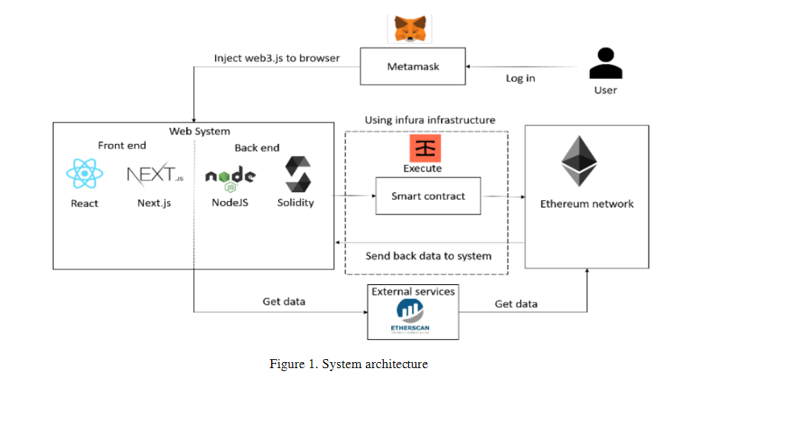

*Figure 1. System architecture*

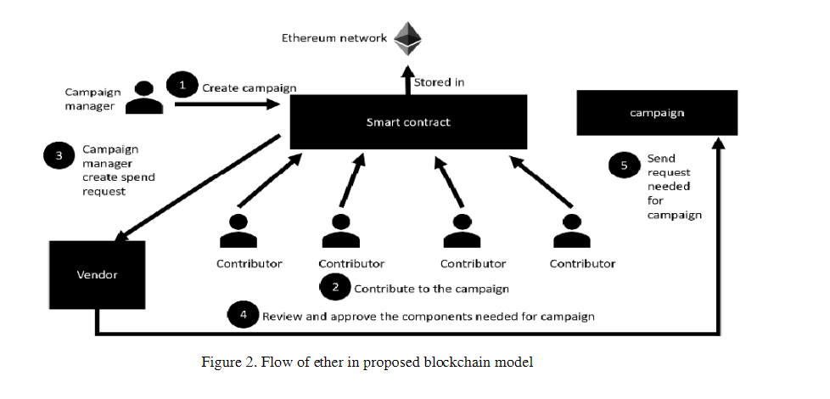

*Figure 2. Flo of ether in Proposed blockchain Model*

**Flow:**

A campaign manager initiates one. He must fill out the campaign details in order to create the campaign. He could also upload the suggestion in PDF format in an effort to persuade contributors. The proposal will be kept in the peer-to-peer Interplanetary File System (IPFS) file sharing network.

b. The campaign page will then display the campaign. Contributors may give to the campaign if they are interested in it.

c. The campaign manager creates an expense request by listing all of the supplies required to carry out the campaign.

d. Notifications of new expense requests were sent to contributors.

e. Contributors decide whether or not the item the campaign manager has suggested is appropriate. If it is, they can vote to approve the item.

f. The smart contract will transfer the money gathered to the appropriate vendors if the majority of contributors approve.

g.The relevant vendor then provides the campaign manager with the agreed-upon item. Every transaction is visible to all users on the Ethers can website and is documented in the blockchain.

**3.2 Instantaneous Analysis**

Blockchain-based real-time analysis on crowdfunding platforms is a game-changer for the philanthropic giving industry. By combining real-time analytics with blockchain's transparent and unchangeable ledger, stakeholders gain new insights and flexibility in the field of charity. In this in-depth investigation, we examine the complex aspects of real-time analysis, how it is revolutionizing crowdfunding platforms, and the wider ramifications for the non-profit industry.

**Comprehending Real-Time Evaluation inside the Framework of Crowdfunding Sites**

The term "real-time analysis" describes the ongoing review and interpretation of data as it is produced, offering immediate insights into a range of platform activity-related topics. Real-time analysis in the context of blockchain-powered crowdfunding platforms includes, among other important data, keeping tabs on donation transactions, campaign performance measures, and user engagement levels. Real-time analysis makes it possible for stakeholders to move quickly and decisively, increasing the efficiency, accountability, and effect of the charity giving process by utilizing the transparency and immutability of blockchain data.

**Blockchain Technology's Function in Enabling Real-Time Analysis**

Real-time analysis on crowdfunding platforms is based on blockchain technology, which provides a decentralized, tamper-proof database of all donation transactions. Every donation made on the platform is documented as an open, permanent entry on the blockchain, giving all parties involved a thorough, auditable record of all platform activity. The foundation of real-time analysis is the transparency and immutability of blockchain data, which gives stakeholders instant access to precise and current data on user engagement, campaign advancement, and donation flows.

**Giving Donors Accountability and Transparency**

By offering contributors instant access to the results of their gifts, real-time analysis promotes accountability and openness in philanthropic giving. Donors can follow the path of their contributions from the point of contribution to the completion of supported projects with the use of dashboards and analytics tools powered by blockchain technology. Donors may confirm that their donations are being used as intended with the help of real-time information on campaign progress, expenses, and results, which boosts their faith in the platform's honesty. Additionally, the transparency of blockchain data discourages fraud, guaranteeing the safekeeping and responsible distribution of donations.

**Enhancing Ad Performance with Data-Driven Understanding**

Because real-time analysis offers meaningful insights into donor behaviour, campaign efficacy, and market trends, it enables campaign organizers to maximize the performance of their fundraising endeavours. Organizers can track important performance metrics like donation amounts, conversion rates, and engagement levels via real-time analytics dashboards. This helps them spot areas for development and modify their approach accordingly. For instance, in order to better target outreach efforts and increase contribution volumes, campaign organizers can assess donor demographics and preferences in real-time if donation volumes are low. In a similar vein, real-time analysis gives organizers the ability to monitor the success of marketing campaigns, pinpoint top-performing channels, and strategically distribute resources to optimize fundraising potential.

**Increasing Participation and Engagement with Users**

Because real-time analysis offers insights into user behaviour and preferences, it is essential for improving user engagement and involvement on crowdfunding platforms. Platform administrators can evaluate user engagement levels and spot opportunities to improve the user experience by tracking data like website traffic, social media mentions, and campaign interactions in real-time. In the event that a specific campaign is creating a lot of discussion on social media, for instance, operators can take advantage of this momentum by prominently showcasing the campaign on the platform and using social media channels to increase its reach. Furthermore, operators can quickly detect and resolve problems with user engagement thanks to real-time analysis, which makes sure that the platform is still user-friendly, accessible, and entertaining for all users

.**Recognizing and Avoiding Fraudulent Behaviour**

Real-time analysis is an effective technique for identifying and stopping fraudulent activity on crowdfunding sites, preserving the platform's integrity, and defending the rights of contributors. Operators are able to spot suspicious trends or anomalies in real-time donation transactions by continuously monitoring blockchain data. This allows them to report possibly fraudulent behaviour’s for additional investigation. Transaction data can be analysed by automated fraud detection algorithms to look for signs of fraudulent activity, such as erratic donation patterns, several contributions from the same source, or strange withdrawal requests. Operators can preserve faith in the integrity of the platform and provide a safe and secure environment for charitable giving by quickly identifying fraudulent activity and taking measures to reduce risks.

**Case Studies: Practical Uses of Real-Time Data Analysis on Crowdfunding Sites**  
  
**1. Provides:**

Giveth is a decentralized crowdfunding platform that uses real-time analysis to improve accountability and transparency in philanthropic giving. It is built on the Ethereum blockchain. Giveth enables contributors to publicly track the impact of their gifts by giving them real-time updates on campaign progress, resource distribution, and project outcomes through dashboards and analytics tools enabled by blockchain technology. Real-time analytics are employed by campaign organizers to maximize their impact through resource allocation, pinpoint high-performing campaigns, and optimize their fundraising techniques. Additionally, Giveth uses real-time analysis to identify and stop fraudulent activity, maintaining the platform's integrity and safeguarding donors' money.

1. Give Track from Bit Give:

Another crowdfunding platform that makes use of real-time monitoring to improve accountability and transparency in charity giving is Give Track, which was created by Bit Give. Give Track allows contributors to follow their gifts in real time, from the point of contribution to the completion of the project, with the use of dashboards and analytics tools enabled by blockchain technology. Donors are empowered to confirm the impact of their contributions and hold organizations responsible for the prudent use of funds with real-time updates on campaign progress, expenses, and results. Furthermore, Give Track uses actual

**Easily Reachable on All Platforms**

Using blockchain technology to create a cross-platform crowdfunding platform is a big step toward democratizing charitable contributions and improving donor involvement. Such a platform can provide funders and campaign organizers with seamless access and functionality across web, mobile, and other digital channels by utilizing blockchain's decentralized architecture and interoperability. This is how the landscape of philanthropic giving can be changed by a blockchain-based crowdfunding platform that is available on all platforms:

1. Cross-Platform Accessibility: A crowdfunding platform built on blockchain technology may be made to work with a variety of hardware and operating systems, such as tablets, smartphones, and desktop computers. Donors and campaign organizers can interact with the platform whenever and wherever they choose, on the device of their choice, thanks to its accessibility. Through the use of a specialized mobile app or a web browser, users can easily navigate campaigns, make contributions, and monitor the status of their donations on the platform.

2. User-Friendly Interface: The crowdfunding platform can be made to have an intuitive, responsive user interface in order to optimize accessibility and usability across platforms. In order to provide a consistent and interesting user experience across devices, the interface needs to be adjusted for various screen sizes and resolutions. Clear navigation menus, interactive components, and efficient workflows are examples of features that improve usability and motivate both organizers and contributors to get involved.

3. Integration with Social Media: It is possible to easily integrate social media platforms with the platform to increase its reach and encourage user interaction. Donors can use well-known social media sites like Facebook, Twitter, and Instagram to directly encourage people to donate by sharing campaigns with their networks and raising awareness. Moreover, social media integration gives campaign managers the ability to take advantage of virality and social proof to draw in more contributors and boost fundraising results.

4. Safe Cross-Platform Transactions: Blockchain technology offers a transparent and safe environment for cross-platform transactions. Donors have the option of making contributions with fiat money or cryptocurrencies; all transactions are instantly documented on the blockchain. Strong security features on the platform, like encryption and multi-factor authentication, guarantee the confidentiality and integrity of donor data while protecting it from illegal access and data breaches.

5. Real-Time Updates and alerts: Giving users access to real-time updates and alerts is a major benefit of a blockchain-based crowdfunding platform that is cross-platform. Through constant updates on project status, milestones attained, and campaign advancement, donors are kept informed and involved at every stage of the donation process. In order to promote openness and confidence, campaign organizers can also speak with funders face-to-face, thank them, and provide them periodic information on the status of the project.

6. Interoperability with Third-Party Services: The crowdfunding platform can be made to easily interact with third-party apps and services in order to improve functionality and give users more value. For instance, donors can simply track their payments and produce tax receipts thanks to interaction with financial management solutions. In a similar vein, project management platform integration allows

campaign organizers to streamline project planning, execution, and reporting, enhancing efficiency and accountability.

In summary, developing a blockchain-based crowdfunding platform that is cross-platform compatible is a big step toward democratizing charitable giving and enabling contributors and organizers anywhere. Such a platform can provide a smooth and interesting user experience across web, mobile, and other digital channels by utilizing blockchain technology's decentralized architecture, interoperability, and security features, promoting increased transparency, efficiency, and impact in the charitable sector.

**Use Cases and Applications**

Blockchain-powered crowdfunding platforms have opened up a world of applications and use cases, transforming the way people give to charities and empowering people all over the world. The following are a few significant uses and applications of blockchain-based crowdfunding platforms:

1. Transparent Donation Tracking: Real-time tracking of contributions from donors to recipients is made possible by blockchain technology's transparent and unchangeable ledger. Because every donation transaction is tracked on the blockchain, contributors can see exactly how their money is being used during a campaign's entire lifecycle. By fostering accountability and trust, this transparency makes sure that contributors have faith in the platform's integrity and the effectiveness of their contributions.

2. Decentralized Governance: Crowdfunding platforms built on blockchain frequently use decentralized governance models, which let users influence the platform's course and take part in decision-making. Users are able to propose and vote on money allocations, project priorities, and platform innovations through voting mechanisms and community-driven projects. By giving users a say in what charitable projects get funding, this democratic method encourages a sense of accountability and ownership among the community.

3. Smart Contracts for Automated Execution: The foundation of blockchain-based crowdfunding platforms is the use of smart contracts, which are self-executing contracts with the conditions of the agreement explicitly put into code. These contracts enforce predefined conditions, such as distributing payments to campaign organizers upon the fulfilment of particular milestones and automate the execution of transactions. By doing away with the need for middlemen and cutting administrative costs, smart contracts simplify the donation process and guarantee that money is distributed effectively and openly.

4. Global Accessibility and Inclusion: Anyone with internet connection can engage in philanthropic giving thanks to blockchain technology, which cuts through both financial and geographic obstacles. Blockchain-powered crowdfunding platforms enable international donations and give marginalized populations access to capital for community initiatives and social causes. Furthermore, these platforms give people in areas with weak banking infrastructure a way to support humanitarian causes by taking cryptocurrency donations.

5. Tokenization of Assets and incentives: Tokenization is a technique used by certain blockchain-based crowdfunding platforms to symbolize incentives, assets, or ownership shares in charity endeavours. Contributors receive tokens in accordance to their amounts, which they may exchange for incentives, passes to special events, or even shares in the underlying projects. Crowdfunding becomes more dynamic and engaging when donors are encouraged to contribute through tokenization.

6. Fraud Prevention and Security: Blockchain is resistant to fraud and tampering because of its built-in security features, which include cryptographic hashing and consensus procedures. Blockchain-based crowdfunding platforms reduce the possibility of fraudulent activities like double-spending or donation record manipulation by logging donation transactions on a decentralized ledger. Furthermore, pseudonymity and encryption safeguard donors' private and sensitive data, guaranteeing the confidentiality of their financial transactions.

7. Impact Measurement and Reporting: Crowdfunding systems built on blockchain technology provide impact measurement and reporting that is transparent and verifiable. Real-time tracking of supported initiatives' progress and results is possible for stakeholders thanks to the blockchain's immutable record of donation transactions. Donors can observe the real results of their contributions and make well-informed judgments regarding future gifts by receiving monthly updates on project milestones, expenditure reports, and beneficiary testimonies.

**Chapter 4**

**Results and Analysis**

By integrating blockchain technology into a crowdfunding platform, contributor privacy, openness, and confidence are increased, and the concept of crowdfunding itself is completely transformed. Because blockchain transactions link contributions to wallet addresses rather than revealing personal information, they preserve some degree of contributor confidentiality even in the face of their inherent transparency. This permits contributors to remain anonymous and secure while yet enabling them to take part in campaigns. Furthermore, the crowdfunding ecosystem benefits from a higher degree of confidence and responsibility due to the transparent nature of blockchain transactions. The unchangeable transaction ledger makes it simple for contributors to confirm the authenticity of campaigns and monitor the money's movement in real time. Contributors and the project as a whole gain more confidence as a result of this transparency, which acts as a potent deterrent against fraud and poor management.

In addition, the incorporation of smart contracts presents crowdfunding sites with a novel type of unreliability. Smart contracts are self-executing contracts containing preprogrammed conditions that, when specific requirements are satisfied, cause transactions to happen automatically. Crowdfunding platforms can streamline the fundraising process and lower the possibility of human error or manipulation by using smart contracts to do away with the need for middlemen and manual oversight. This improves the crowdfunding process's efficiency as well as its integrity because transactions are carried out exactly as planned, free from bias or outside intervention.

Blockchain technology provides unmatched security and immutability along with improved secrecy, transparency, and trust. Every transaction that is registered on the blockchain is tamper-proof and cryptographically secured, meaning that once it is recorded, it cannot be removed or changed. For the sake of regulatory compliance and auditing, this offers an auditable and indisputable record of all crowdfunding activity. Additionally, transactional data is distributed throughout blockchain networks due to their decentralized nature.

a network of nodes, which protects it from single points of failure and censorship.

Conducting comprehensive acceptance studies is crucial to assess the effectiveness of blockchain technology as crowdfunding platforms finalize its deployment and tackle any possible obstacles or constraints. These investigations will yield insightful information on transactional patterns, user experiences, and overall platform performance, which will guide incremental enhancements and optimizations. Crowdfunding platforms can revolutionize the crowdfunding industry by adopting blockchain technology. This will allow for a more transparent, secure, and trustworthy crowdfunding experience, which will enable contributors and project creators to participate in a more fair and effective fundraising process. The integration of blockchain technology into crowdfunding platforms produces numerous observable benefits that are advantageous to all parties concerned.

First, the improved contributor confidentially guarantees that people can contribute to campaigns without jeopardizing their privacy, which promotes wider engagement from a variety of contributors. More funding options for projects and initiatives across a variety of sectors—from technology and innovation to social impact and environmental sustainability—are made possible by this inclusion.

Furthermore, the crowdfunding ecosystem's accountability and integrity culture is strengthened by the transparency that blockchain transactions provide. Contributors gain confidence in the platform and its users by being able to track their donations with assurance and confirm that money is being used as intended. Project creators can utilize this transparency to their advantage by showcasing their campaign's financial responsibility and transparency to draw in additional backers and cultivate a devoted following.

Smart contract adoption considerably simplifies the crowdfunding procedure and lowers administrative burdens for project creators and contributors alike. Money is automatically distributed based on preset criteria, removing the need for human involvement and guaranteeing precise and efficient transaction execution. Because of this automation, fundraising campaigns go more quickly, freeing up project creators to concentrate on developing and completing their projects rather than handling administrative duties.

All things considered, the integration of blockchain technology into crowdfunding platforms boosts engagement, openness, effectiveness, and safety, which eventually benefits projects, donors, and the community at large. Blockchain technology will become more and more important in determining the direction of fundraising and charity as crowdfunding platforms develop and expand, opening up new avenues for social impact and global empowerment.

A smart contract written in Solidity language is required to construct the crowdfunding platform. Next, using the Solidity compiler, this is assembled and put into the Ethereum network. Every transaction is made using Metamask, a plugin for the Chrome browser. How to create a platform for crowd funding:

• Step 1: A smart contract is created.

* Step 2: The smart contract is compiled to produce the application binary interface (ABI) and bytecode.
* Step 3 involves the bytecode deployment to the Ethereum network

.   
**4.1 Establishing a Smart Contract**

Solidity language is used to write a program that handles all transactions automatically. Prior to beginning any project, the project manager must specify its name, purpose, and minimal contribution. After that, the user can draft a spending request to use the investor-contributed funds. The developers of this project must include a description of where they plan to spend the money, how much they plan to spend, and the address of the vendor who will offer the service.The project manager may transfer funds to the vendor's address if the majority of investors approve the spending request. After then, the vendor gives the project manager the service that was requested.

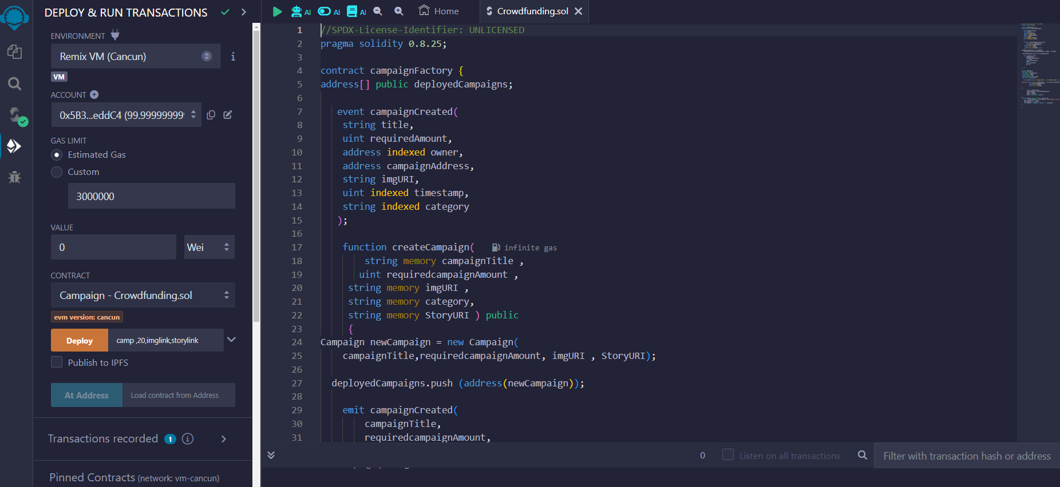

*Figure 3:- Solidity Contract Code*

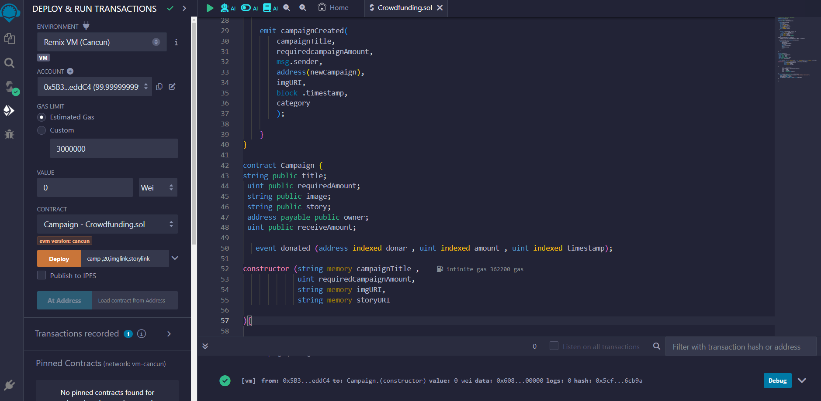

*Figure 4 :- Solidity Contract Code 2*

B. Assembly and Implementation

Using the Solidity compiler to compile the contract code is the first stage in the deployment process of a smart contract. The application binary interface (ABI) and bytecode are the two main outcomes of this process. The built contract is represented in bytecode, which the Ethereum Virtual Machine (EVM) can execute in hexadecimal format. It includes the low-level instructions that specify the smart contract's logic and operation. The produced bytecode can then be distributed to different Ethereum networks, such as the Ethereum main net, the Robsten test network, or the Rinkeby test network.

Sending a transaction including the bytecode as the data payload and any required parameters or initialization data is the process of deploying the bytecode to a network. The network's miners then process the transaction, running the bytecode and adding the smart contract to the blockchain.

Following deployment, the smart contract's presence on the blockchain is uniquely identified by the address returned by the network. This address is used to communicate with the contract and carry out its operations. The ABI serves as the smart contract's interface specification, allowing users to interact with its features and information. Developers can more easily incorporate the contract into their applications because the ABI defines the parameters and methods that can be used to communicate with the contract.

The smart contract's code cannot be altered or changed once it has been deployed, making it immutable. On the other hand, transactions submitted to the contract's address can update its state. These transactions may cause the contract's declared functionalities to be activated, enabling users to carry out a range of activities and actions as specified by the logic of the contract. In general, deploying a smart contract entail gathering the contract address, deploying the bytecode to the Ethereum blockchain, assembling the contract code, and utilizing the ABI to communicate with the contract.

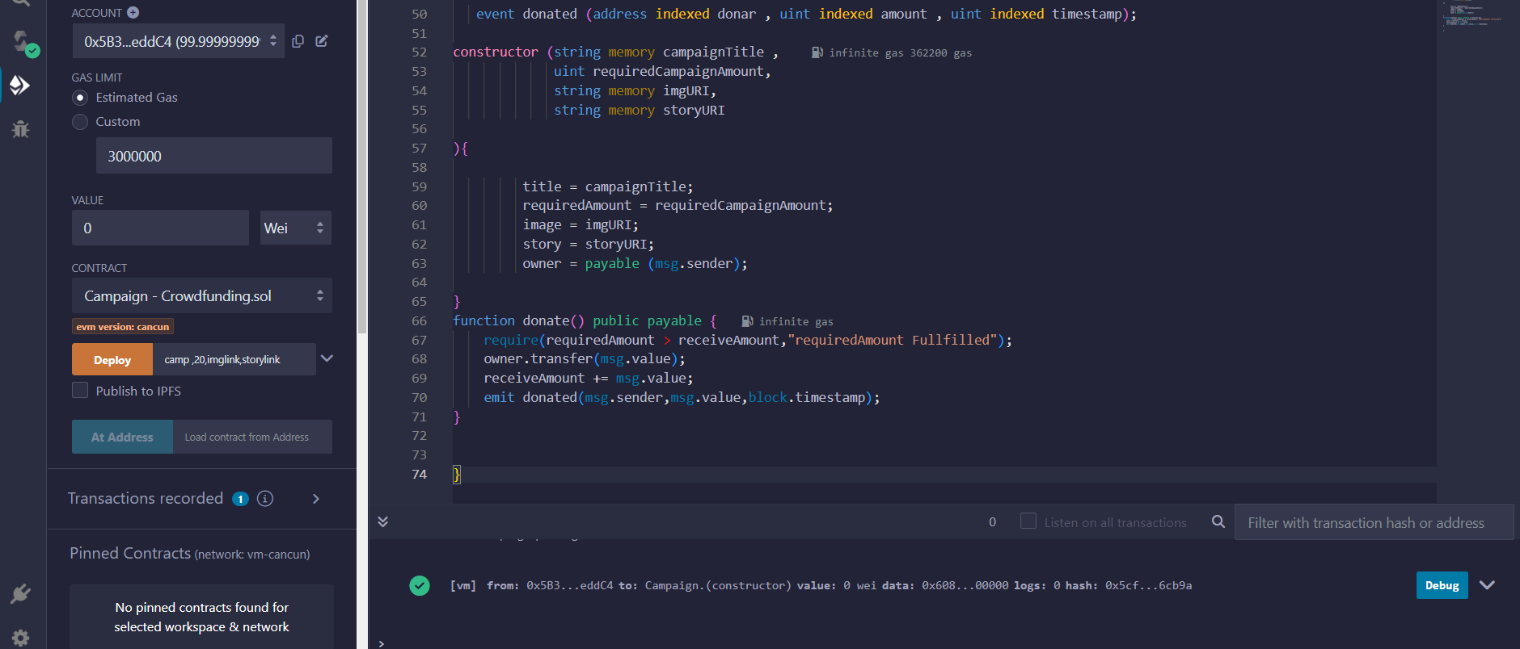

*Figure 5:- Adding Deploy Variables*

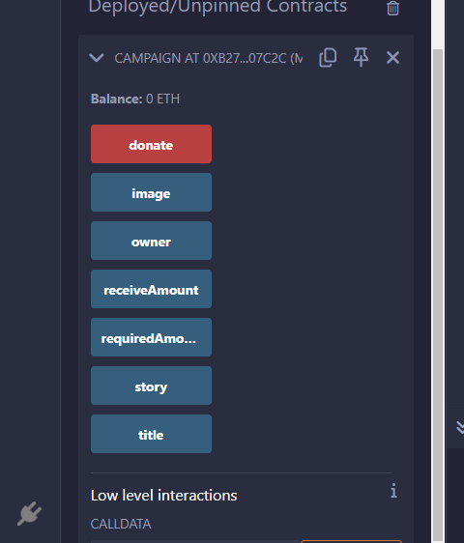

*Figure 6:- Campaign Overview*

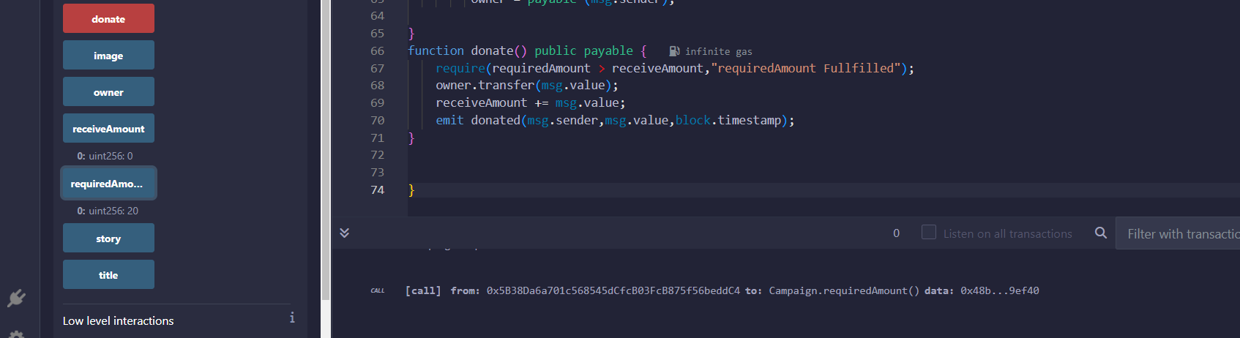

*Figure 7:- Deployed Successfully*

**4.2. Analysis of the Outcome**

A dedicated button streamlines the procedure for users who want to start a new project, making it a seamless experience. When this button is clicked, the user is prompted to provide important information such as the project name, a summary that describes the project, and the minimum amount that must be contributed in order for the project to be realized. The project's name functions as its key identification, condensing its essence and goal into a brief title. A catchy and memorable name can draw in potential backers and have a big impact on how visible the project is. The project description provides a thorough synopsis of the goals, parameters, and anticipated results. The project's aim, relevance, and the possible impact of potential donors may all be comprehended by reading this narrative, which offers context and clarity. A well-written description makes the value proposition of the project clear and encourages readers to get involved and support it. Setting a minimum contribution level also gives prospective contributors a clear idea of what is expected of them. This criterion establishes the minimal quantity needed to participate, guaranteeing that the project raises enough money to move closer to its objectives. In order to ensure the project's financial sustainability and balance accessibility and viability, it is imperative to set a minimum contribution requirement that encourages widespread involvement.

In essence, the process of initiating a new project through a designated button streamlines the user experience, allowing individuals to easily create and share their initiatives with the community. By providing essential details such as the project name, description, and minimum contribution, users can effectively communicate their vision and inspire others to join their cause, fostering collaboration and collective action towards shared objectives. as shown in Fig.

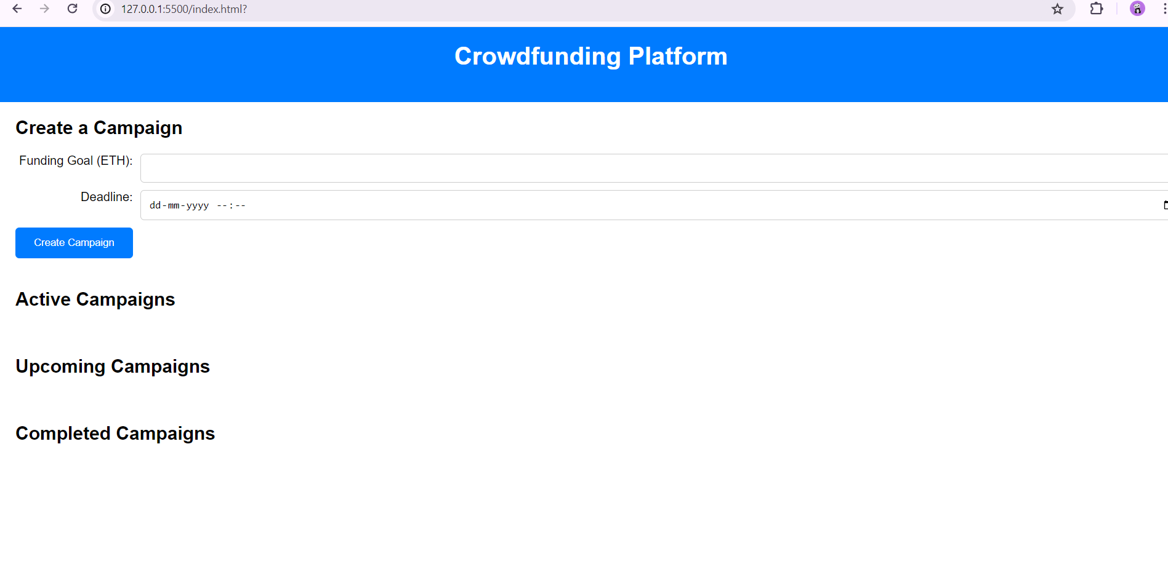

*Figure 8:- Create Campaign Front Page*

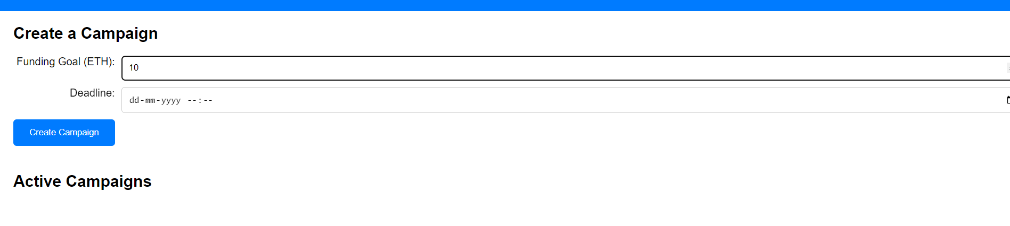

*Figure 9: Donate Ethereum*

Giving precise information about the length of a crowdfunding campaign is known as a crowdfunding date explanation. Usually, when starting a crowdfunding campaign, the organizers give the campaign a start and finish date. These dates indicate the time frame in which donations are received and the fundraising campaign is underway. The start date indicates to possible donors that the project is now formally available for funding. It also signifies the beginning of the crowdfunding campaign. On this day, campaign organizers start spreading the word about the initiative, asking those who are interested in contributing to the project, and asking for donations. On the other hand, the end date denotes the moment at which the crowdfunding campaign comes to an end and contributions are no longer accepted.

As a deadline for fundraising, this date installs a sense of urgency among prospective donors, encouraging them to contribute as soon as possible. Additionally, it makes the campaign's duration clear, enabling organizers to schedule their promotional efforts and control expectations appropriately.

Explaining the crowdfunding date is important for contributors and organizers alike. Setting specific objectives and deadlines for the campaign aids in the coordination and concentration of fundraising efforts on the part of the organizers. Additionally, it enables planners to schedule actions for after the campaign, like award fulfilment and project delivery.

Contributors are better equipped to decide when and how to help the campaign when they are aware of the crowdfunding dates. They can schedule their donations to coincide with the campaign's duration, making sure to contribute before the deadline passes. Furthermore, being aware of the deadline motivates contributors to act now, before the chance to contribute expires, by assisting them in determining the urgency of their contribution.   
To sum up, the explanation of crowdfunding dates elucidates the commencement and conclusion dates of a campaign, furnishing organizers and contributors with crucial details regarding the campaign's duration and schedule. Crowdfunding dates aid in the success of fundraising campaigns and encourage openness and responsibility in the process by establishing precise expectations and deadlines.

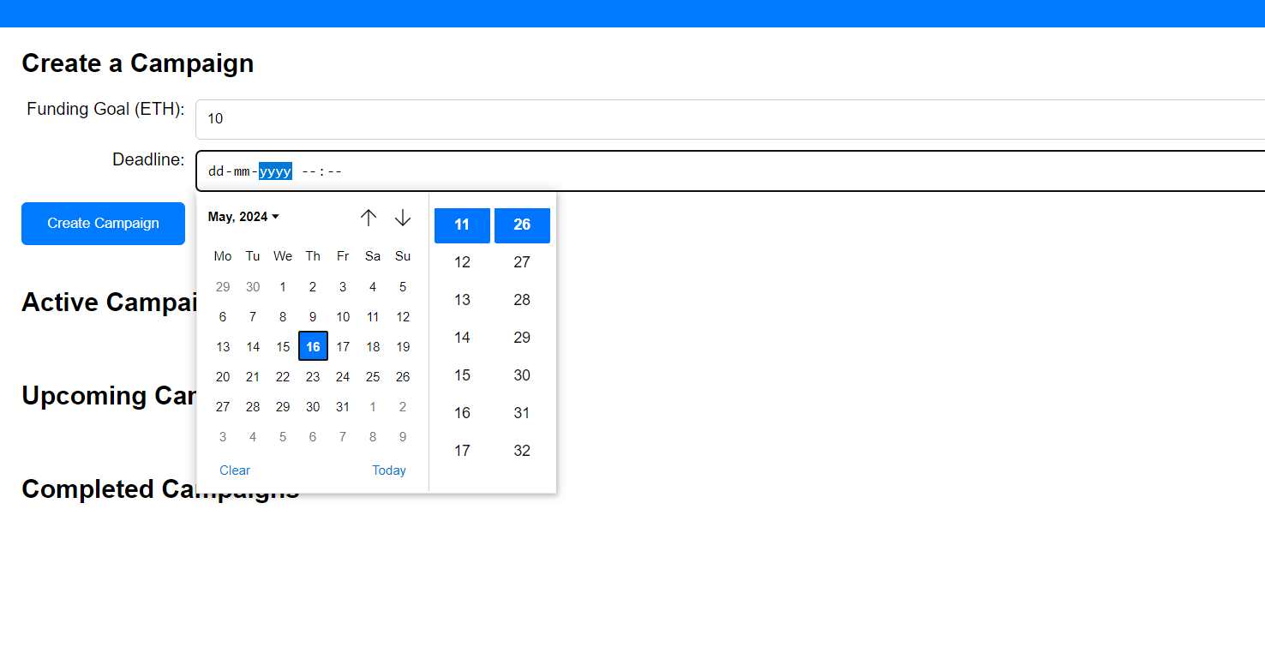

*Figure 10:- Date Of Transaction*

**Active campaigns:**

Crowdfunding campaigns in progress are examples of ongoing projects that are actively looking for public support. The fact that these projects remain open means that backers can still contribute to them at this time. For the length of a campaign that is currently in action, organizers work nonstop to spread the word and draw in new supporters. In order to reach a larger audience, this entails leveraging a variety of marketing platforms, including social media, email newsletters, and press releases. In addition, funders receive regular updates from the organizers regarding the campaign's status, accomplishments, and obstacles faced.

During active campaigns, backers' engagement is also a top emphasis. Organizers actively react to questions, address issues, and build a sense of community around the initiative. To keep the campaign moving forward and encourage further contributions, dynamic financial targets could be added. Even though they only last a limited time—usually a few weeks or months—active campaigns make backers feel compelled to contribute before the campaign ends. All things considered, live crowdfunding campaigns are vibrant forums for interacting with backers, obtaining money, and realizing goals for endeavours, projects, or causes.

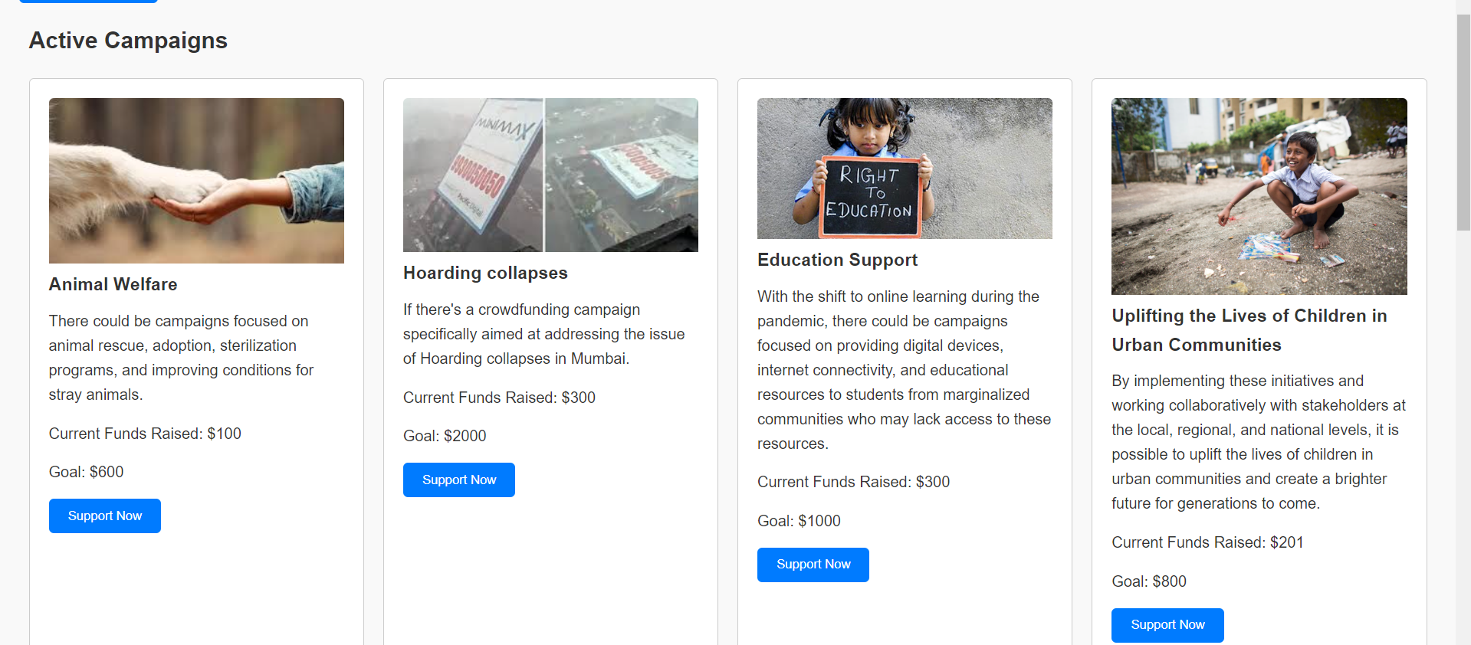

*Figure 11:- Active Events*

**Upcoming campaigns:**

In the world of crowdfunding, upcoming campaigns are projects that are set to go live soon and provide a sneak peek at fresh and creative endeavours that potential backers can be excited to support. In order to spark interest, raise anticipation, and establish momentum prior to the actual start date, these initiatives are frequently publicized ahead of time. Key information about the upcoming campaigns, such as the objectives of the project, the issues it seeks to solve, and the advantages it offers backers, is usually provided by organizers. Pre-launch is a critical time for community engagement, feedback collection, and campaign strategy refinement based on suggestions from possible supporters.

To offer more in-depth insights into the project's evolution and the team's vision, organizers may release sneak peeks or behind-the-scenes content prior to the campaign's launch. To further entice potential supporters, they may additionally describe the benefits or incentives that backers can anticipate receiving in exchange for their contributions. To ensure that the initiative reaches a wide audience, information about planned campaigns is generally disseminated through social media, email newsletters, and dedicated campaign pages.

Crowdfunding platforms may create a dynamic and engaging environment where users are always aware of fresh possibilities to donate to causes they care about by showcasing upcoming projects. This proactive approach ensures that there is already a base of knowledgeable and motivated backers ready to donate and spread the word about the campaign among their networks when the project officially opens. It also helps to create a supportive community around the campaign.

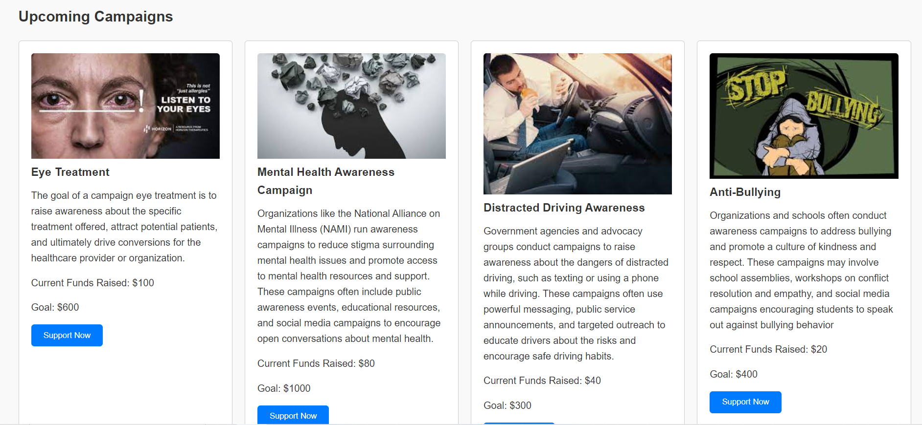

*Figure 12: - Upcoming Events*

**Completed campaigns:**

Crowdfunding campaigns that have achieved their end date and are no longer actively seeking contributions are referred to as completed campaigns. The fundraising phase of these campaigns has successfully ended, and the outcomes are evaluated in comparison to the original objectives that the project designers set out to achieve. A campaign that has ended may have met or exceeded its financial target, partially fulfilled its objectives, or, in certain situations, not reached the intended amount.

After a campaign ends, the project developers usually go on to the next stage, which is fulfilling the pledges made to the supporters. This might be putting the financed project into action, creating and shipping incentives, or giving updates on the results and progress. Promising campaigns typically provide contributors with comprehensive reports detailing the allocation of funds and the anticipated outcomes.

When a campaign comes to an end, backers look forward to the benefits and outcomes they were promised. They are excited to see the project through to completion and reap the rewards, which could be useful items, positive societal effects, or creative solutions. Successful campaigns can give project creators and any future funders useful information and insights. Creators can have a better understanding of what techniques worked, pinpoint areas for development, and make better plans for future initiatives by analysing the effectiveness of previous campaigns. When choosing whether or not to support new efforts, potential backers may find some degree of credibility and dependability in the campaign's past successes.

Completed campaigns, as a key turning point in a crowdfunding project's lifespan, essentially signal the shift from fundraising to implementation. They represent the pinnacle of community support, preparation, and work, opening the door for the project's objectives and promises to be fulfilled.

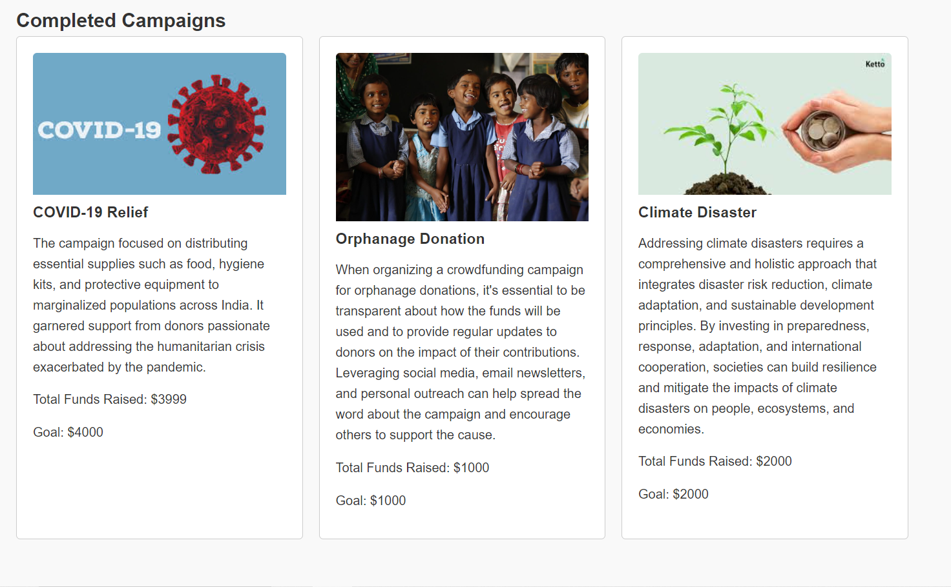

*Figure 13:- Completed Events*

**Ganache**

Ganache is a crucial component of the Ethereum ecosystem and is especially helpful for building, testing, and implementing smart contracts. As such, building an Ethereum-based crowdfunding platform can greatly benefit from Ganache's use. Ganache offers developers a personal Ethereum blockchain that mimics a real-world blockchain environment, making it easier to create, simulate, and debug smart contracts in a safe environment. Developers can test transactions and contract interactions without requiring actual Ether by simply installing and launching this tool, which comes with default accounts filled with Ether.

In the context of a crowdfunding platform, Ganache enables the thorough testing of functionalities such as project creation, contribution handling, and fund distribution before these features are deployed on a live Ethereum network. By using Ganache, developers can ensure that the smart contracts governing the crowdfunding platform are robust, secure, and perform as expected, ultimately leading to a more reliable and trustworthy platform for users to fund and support projects.

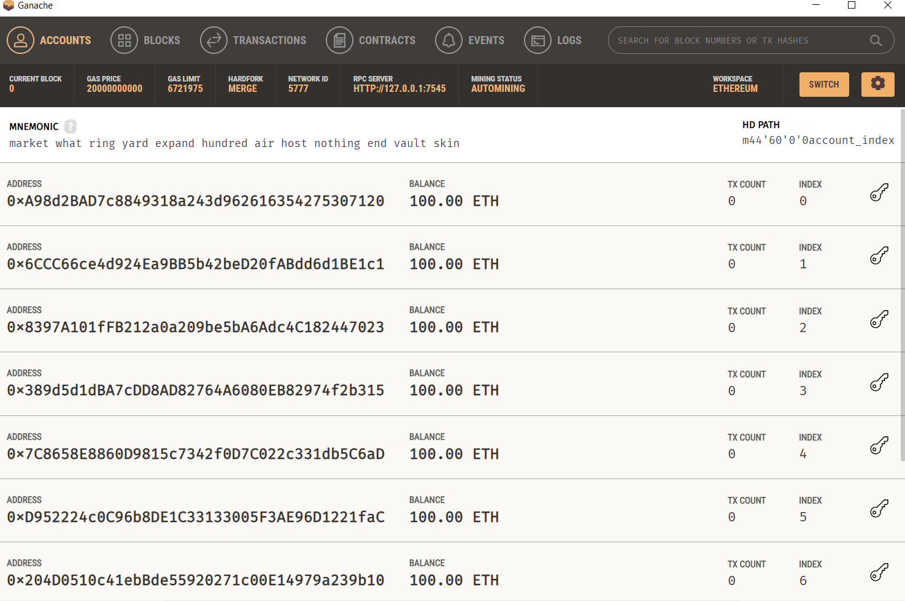

*Figure 14:- Ganache Connected To Eth*

**Ganache Block 0**

Block 0, sometimes referred to as the "genesis block," is the blockchain's founding block in Ganache. It is generated upon the initial launch of Ganache and serves to initialize the blockchain ecosystem. The blockchain's initial configuration, including the initial Ether distribution to the default accounts, is set up by the genesis block.

This block is essentially used to create the blockchain's foundation; it does not include any transactions or smart contracts. Building on the genesis block, each successive block in the blockchain inherits its original conditions and expands them with each addition of a new transaction or contract. Block 0 is a crucial element for developers testing and implementing Ethereum-based apps and smart contracts since it offers a consistent and regulated beginning point, ensuring the stability and dependability of the blockchain ecosystem in Ganache.

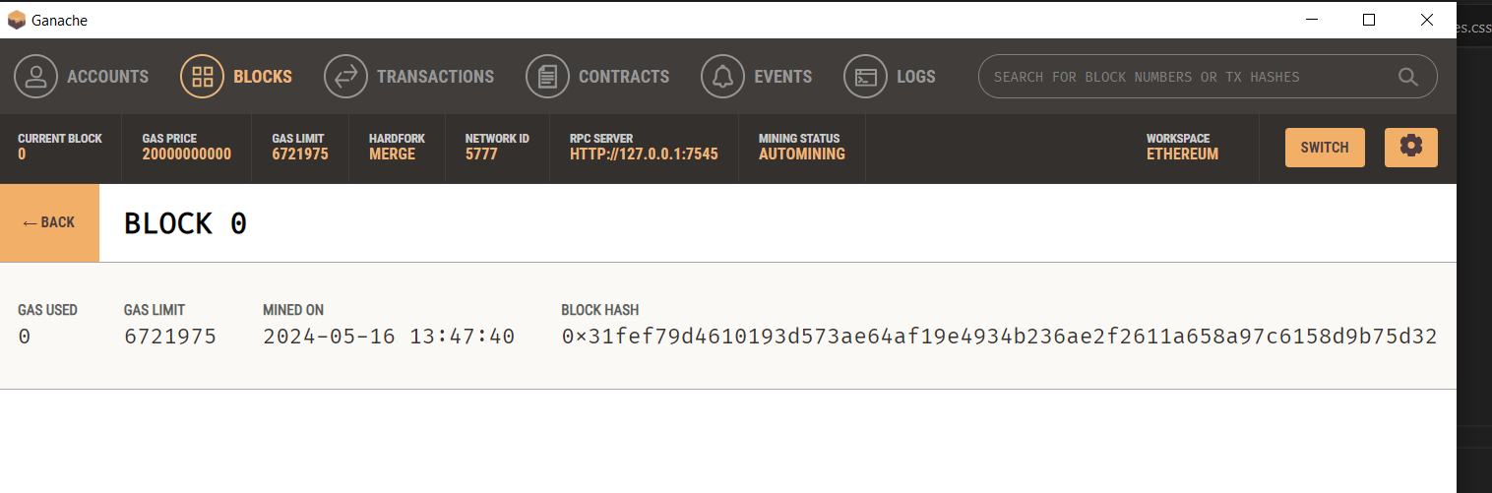

*Figure 15 :- Ganache Block 0*

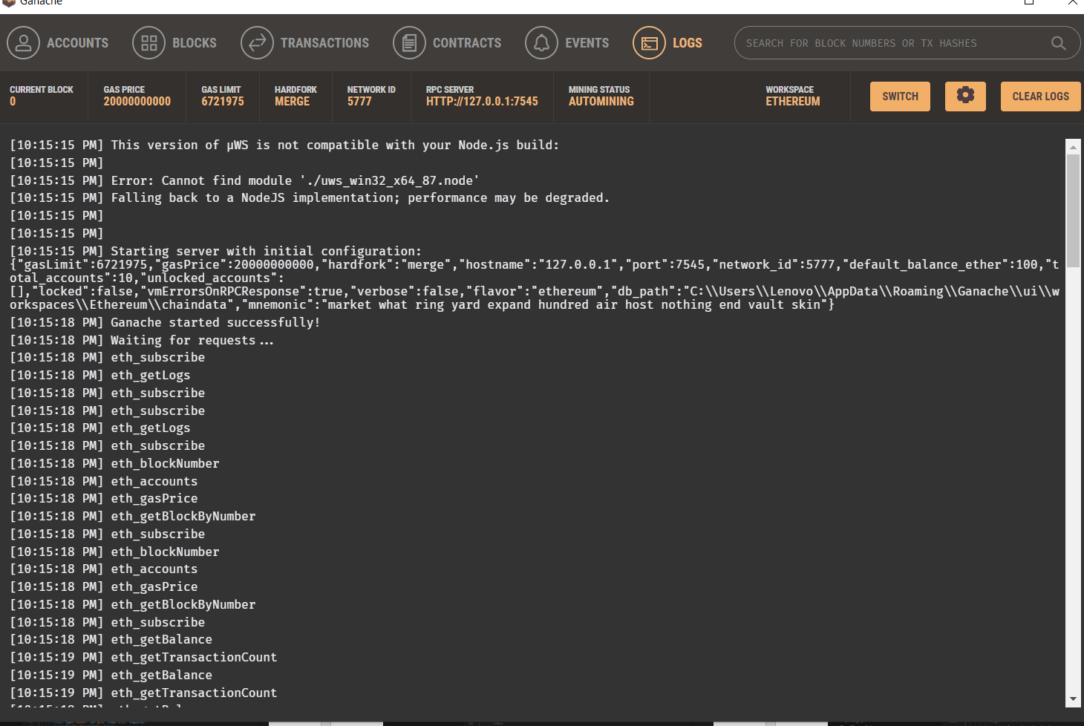

**Experiment: -**

**1.Crowdfunding. Sol**

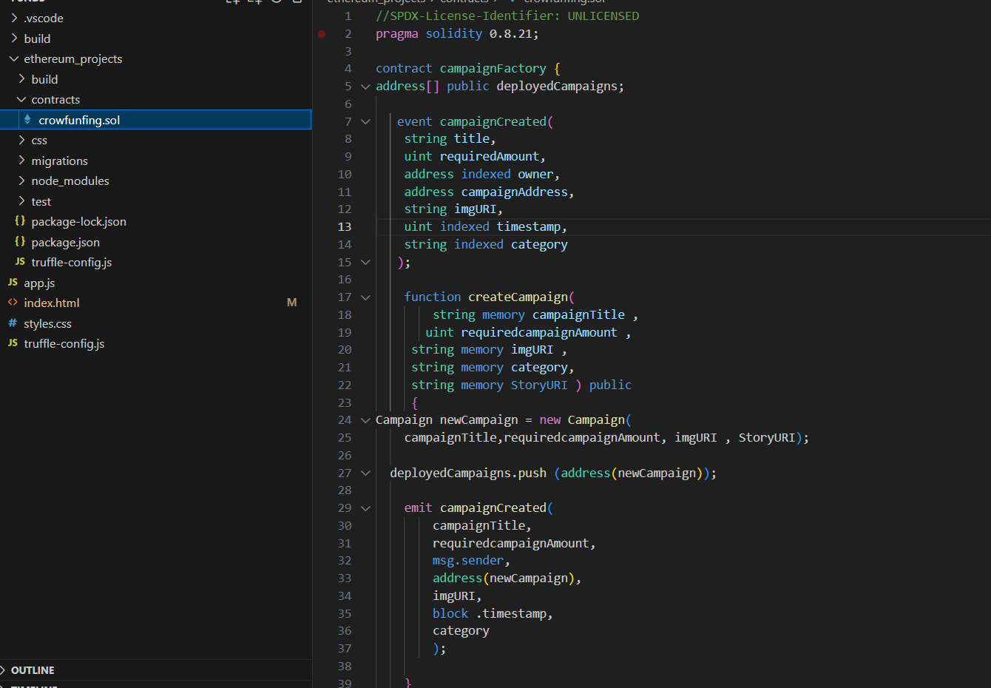

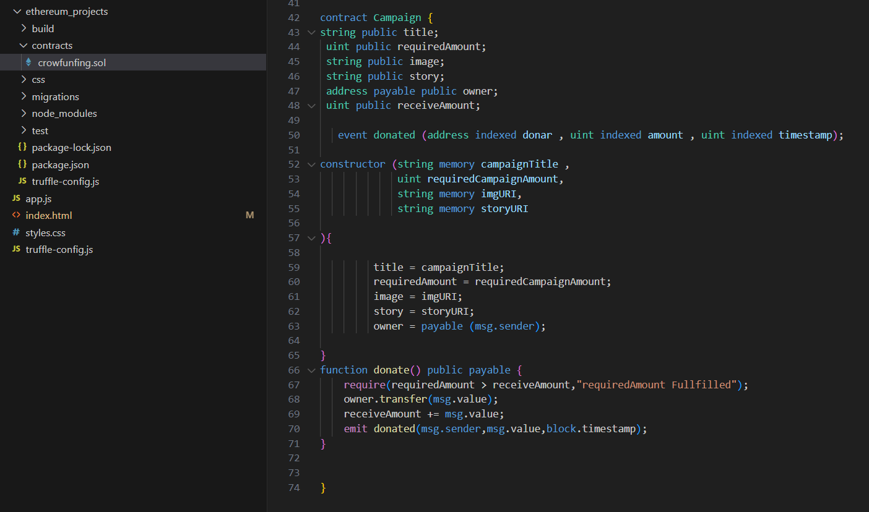

**2.Index.html**

**Code :-**

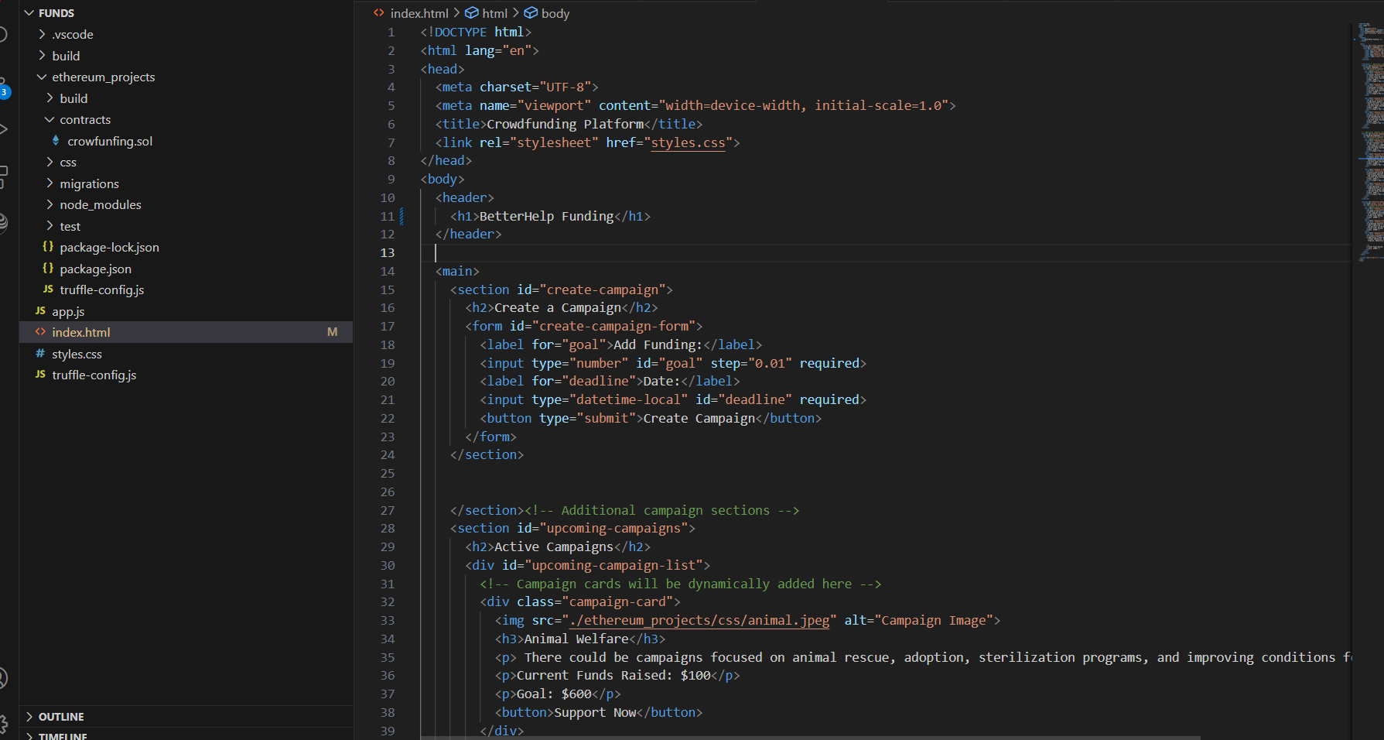

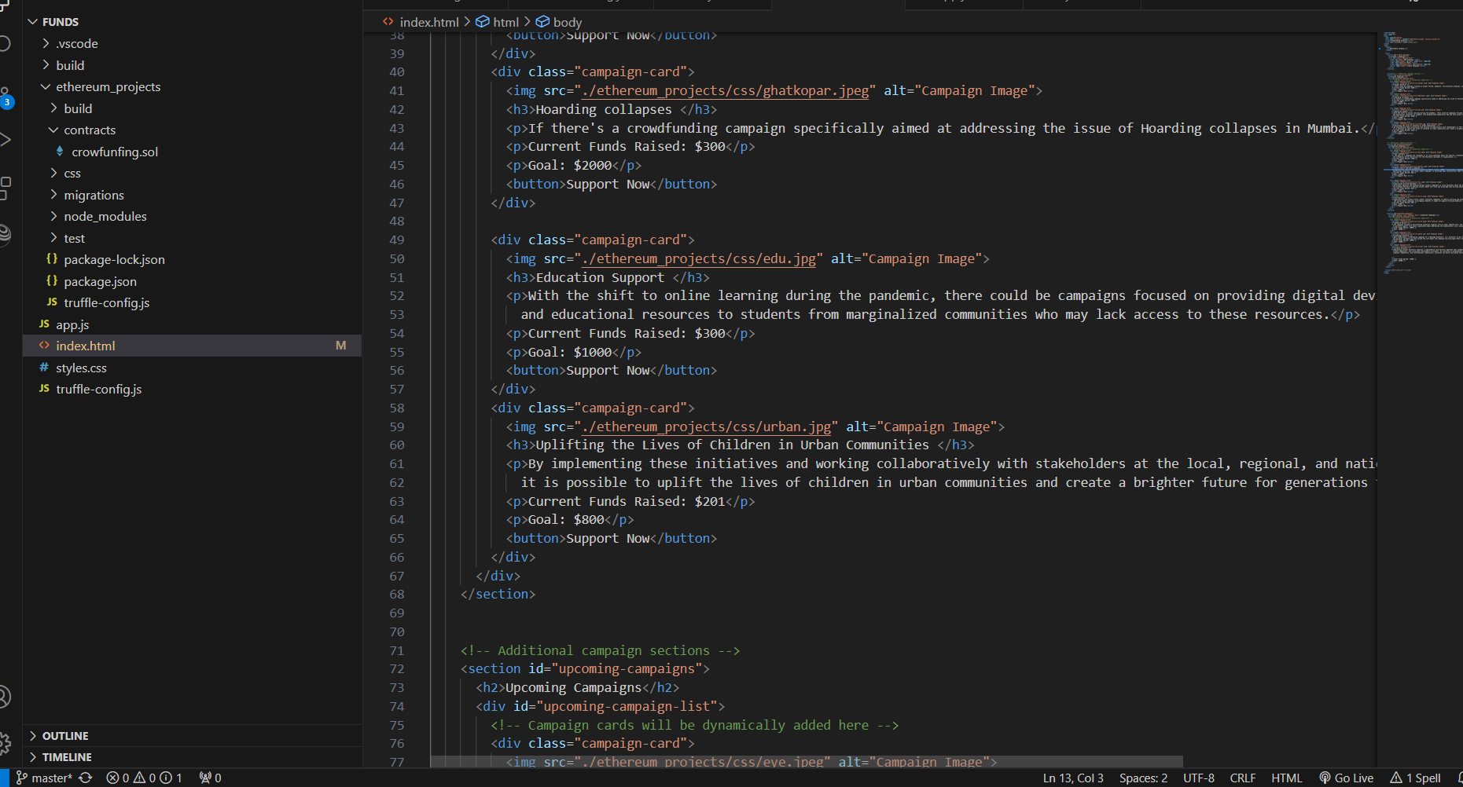

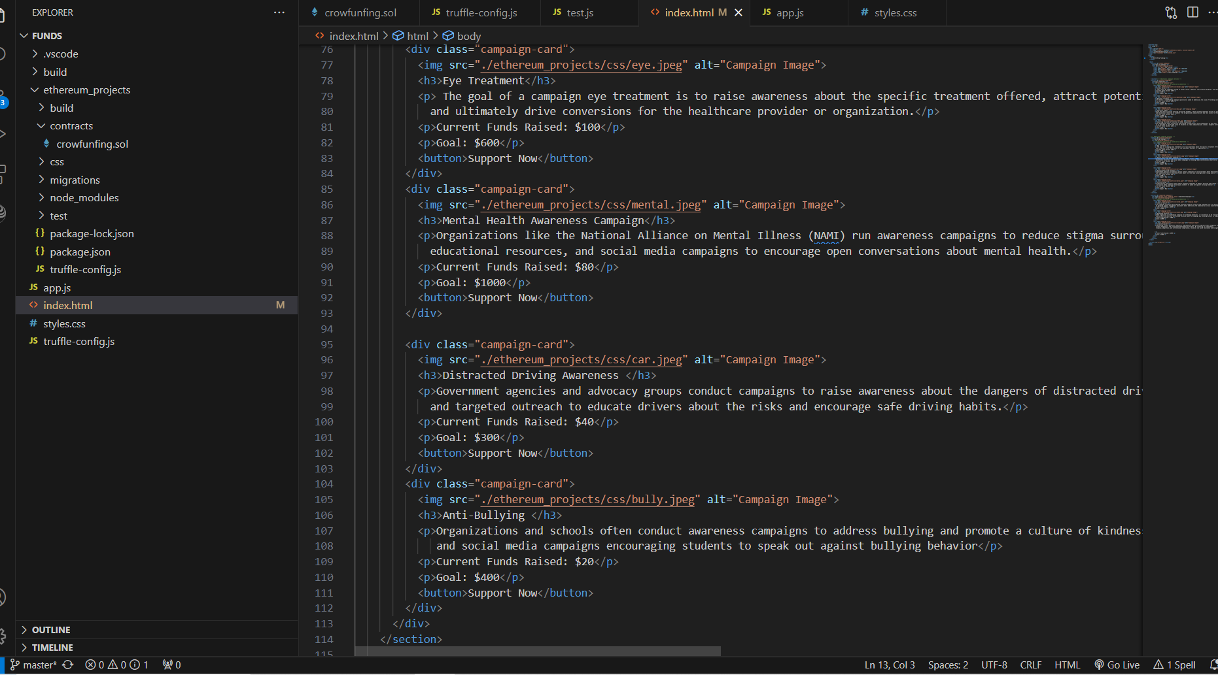

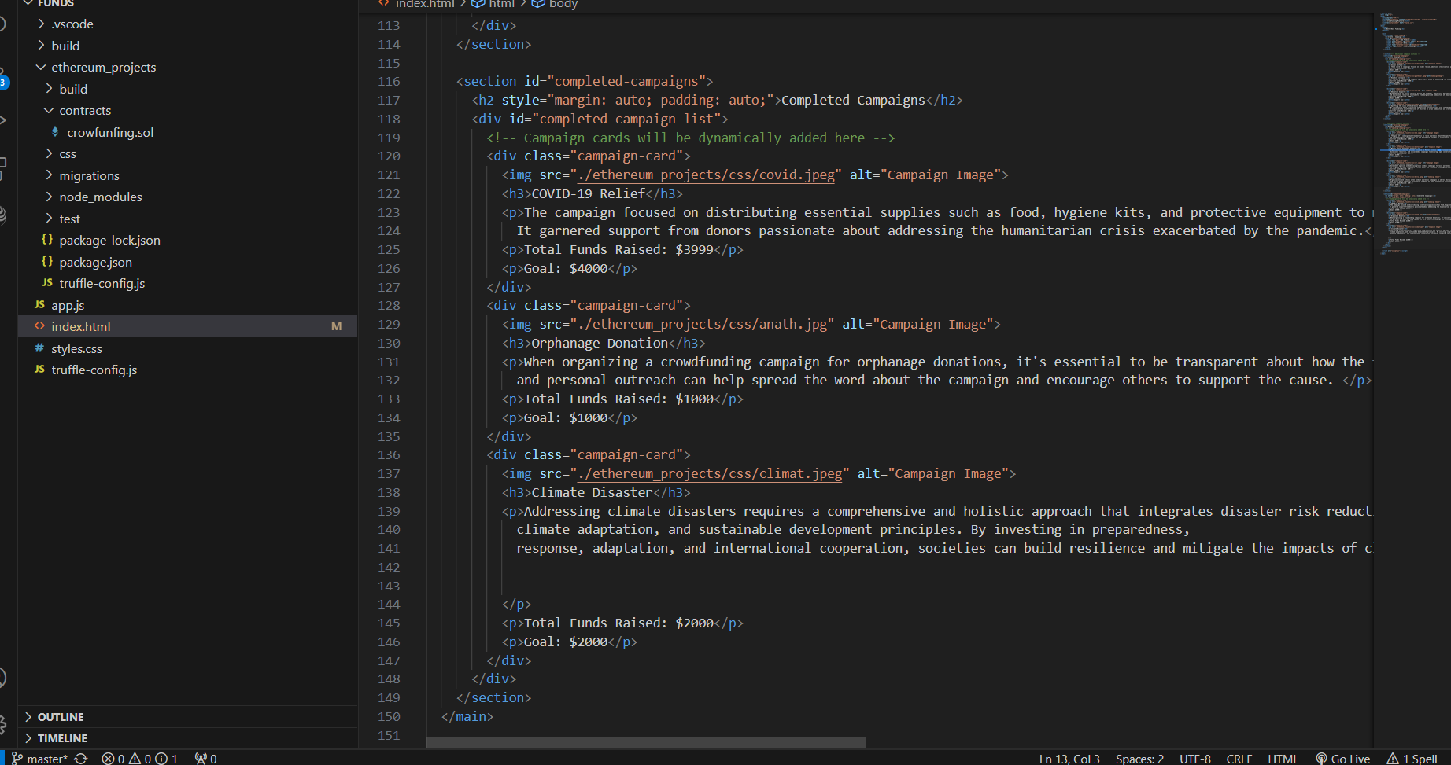

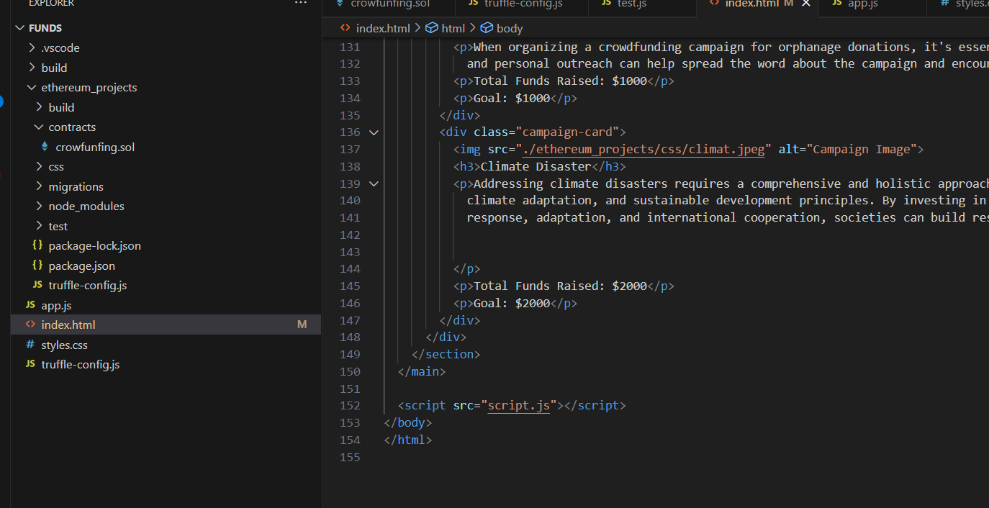

**3.Style.css**

**Code: -**



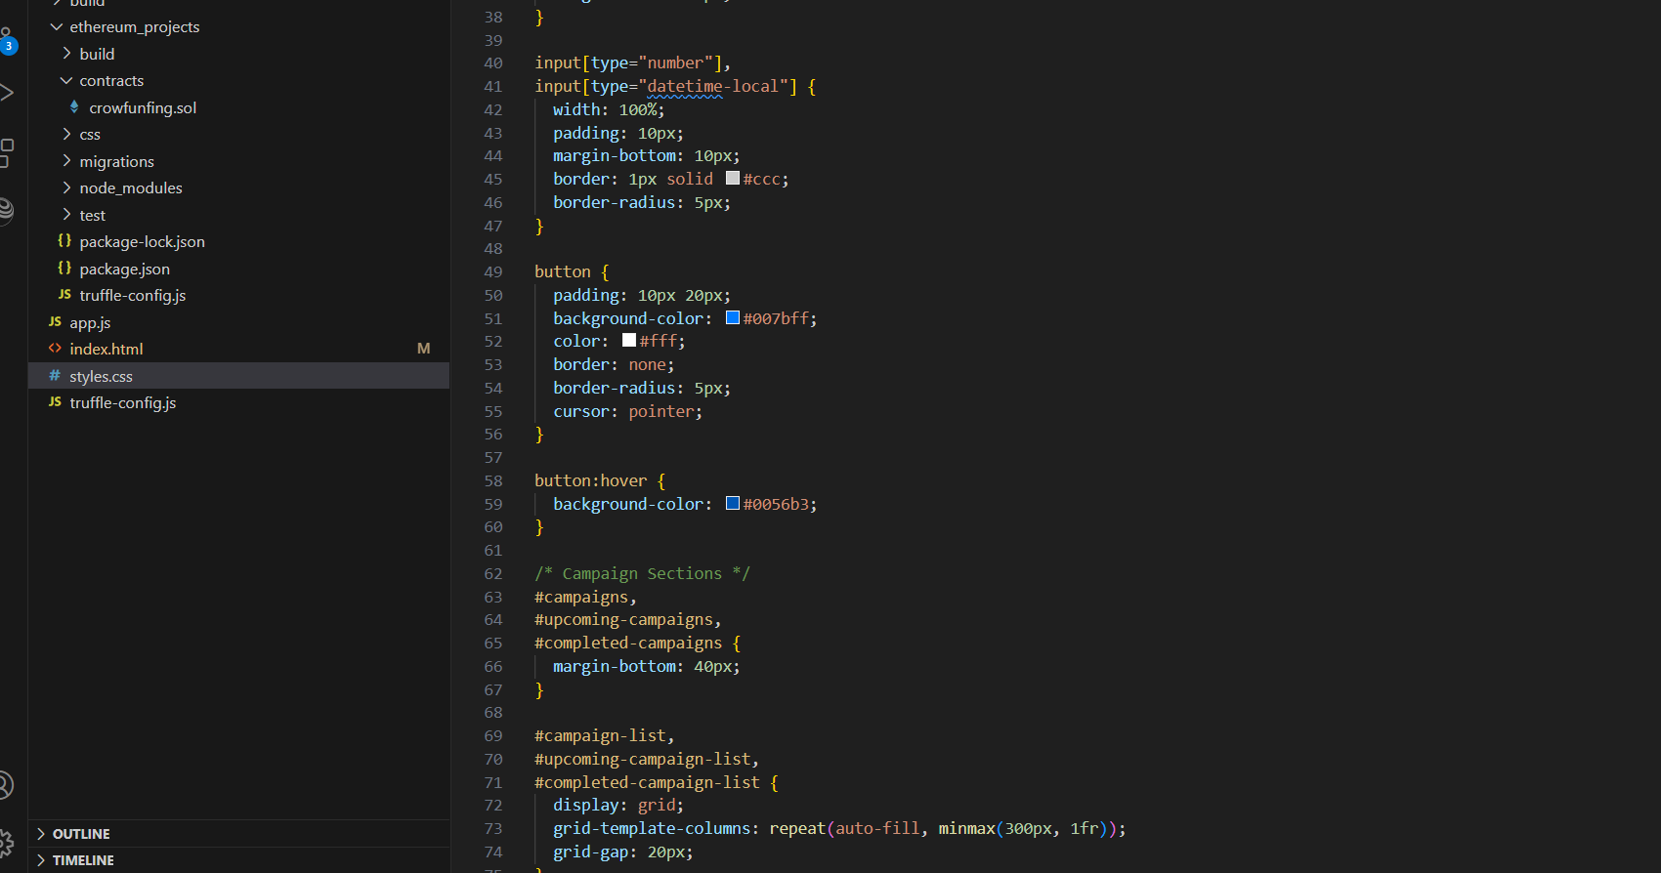

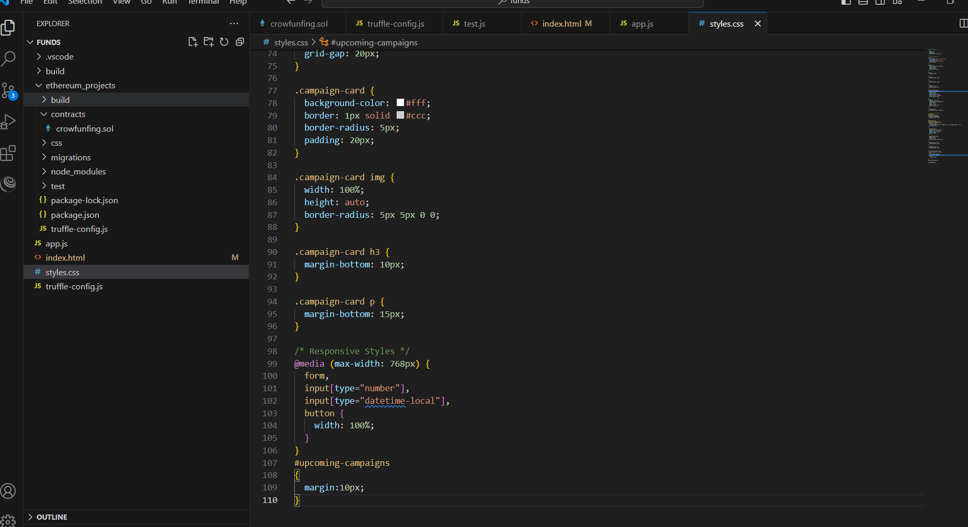

**4.Truffle-Config.js**

**Code: -**

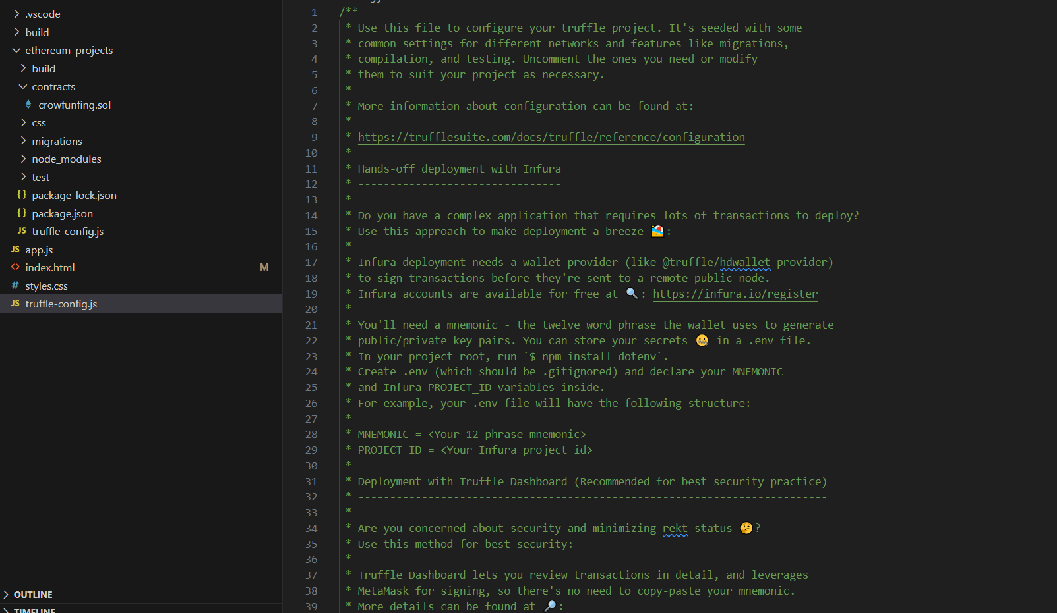

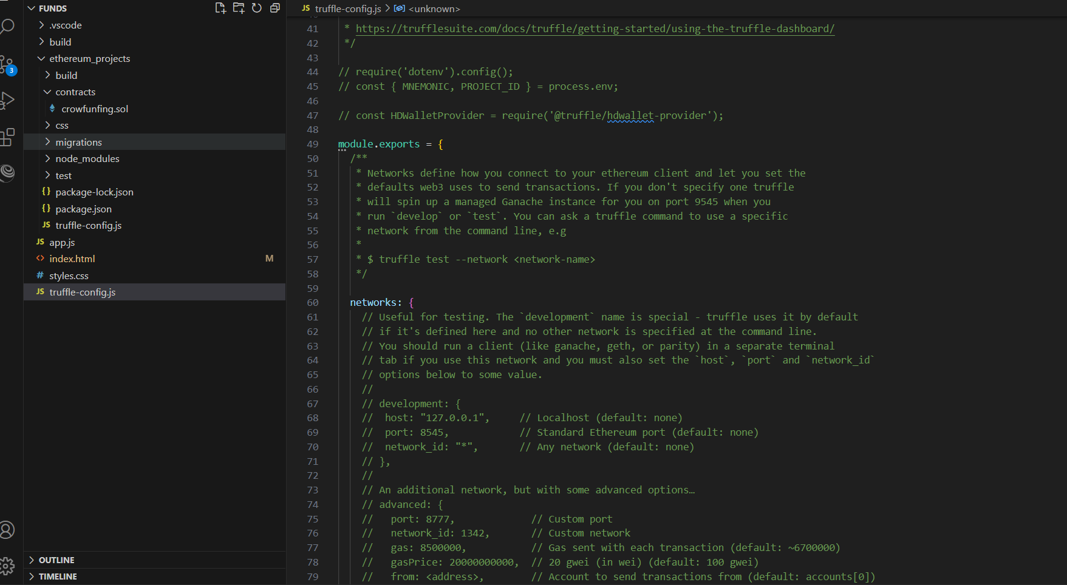

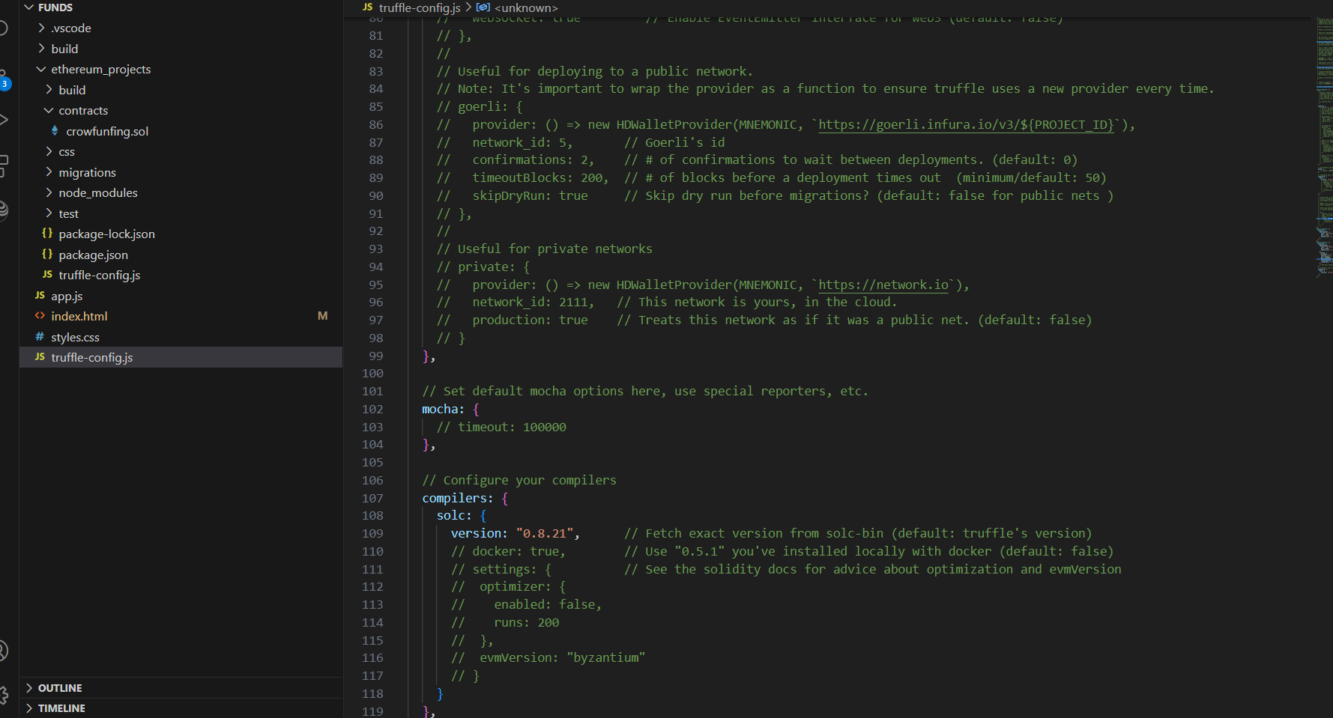

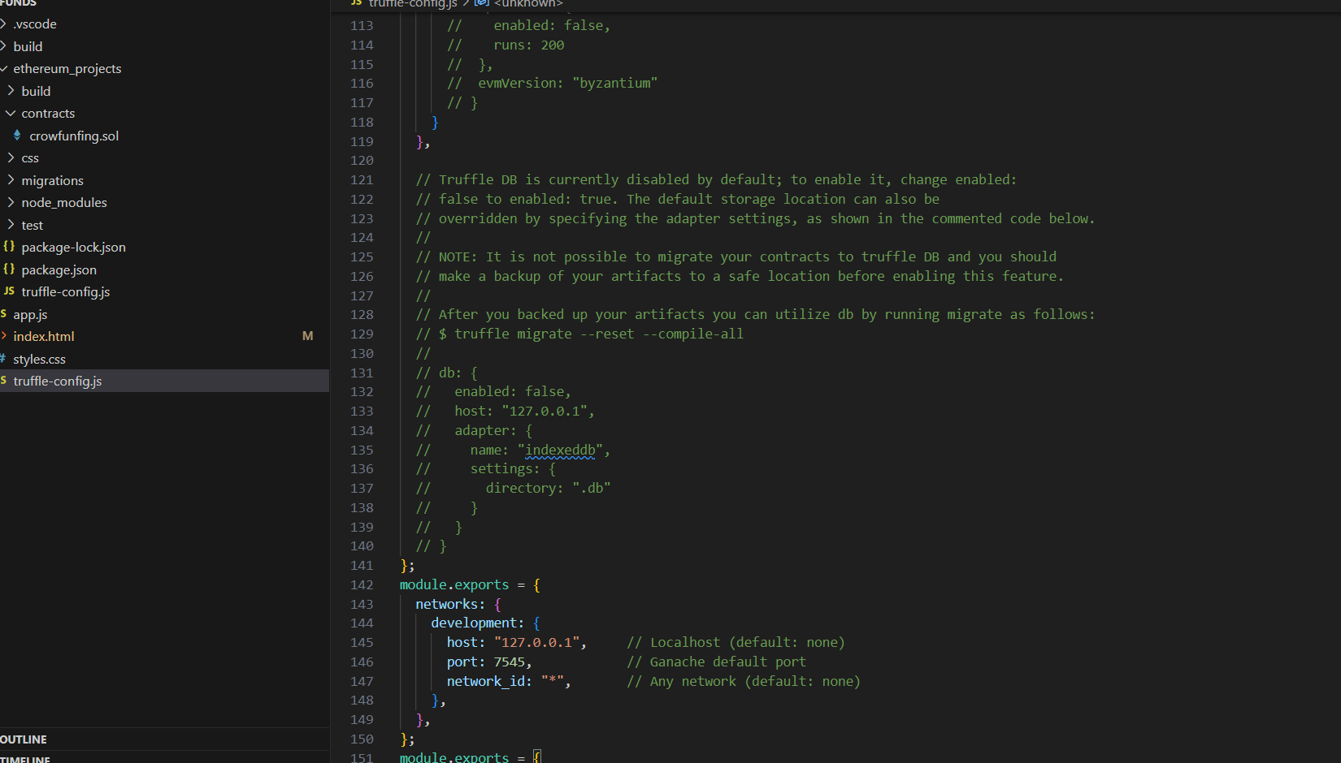

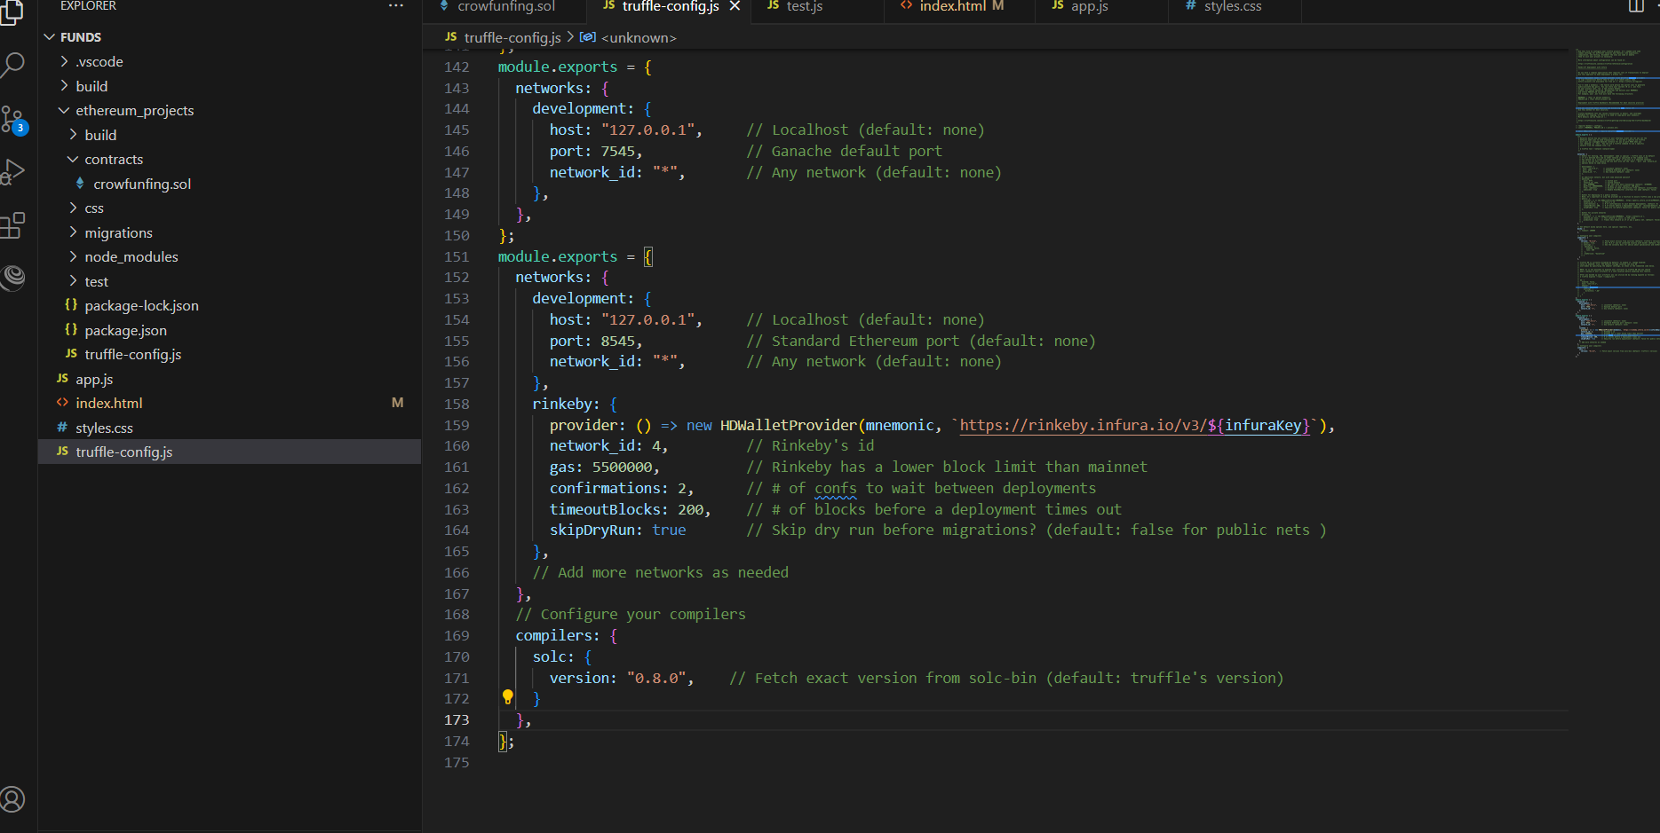

**Output:-**

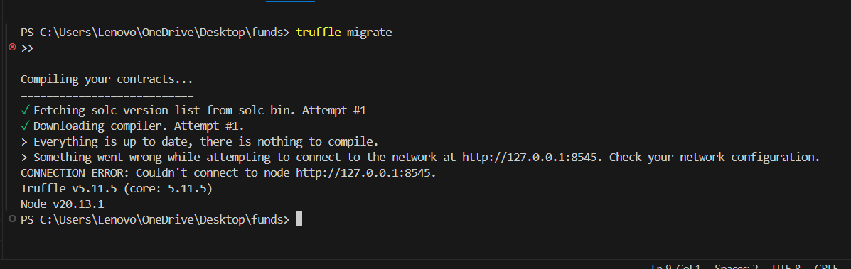

**5.Package-lock. Json**

**Code: -**

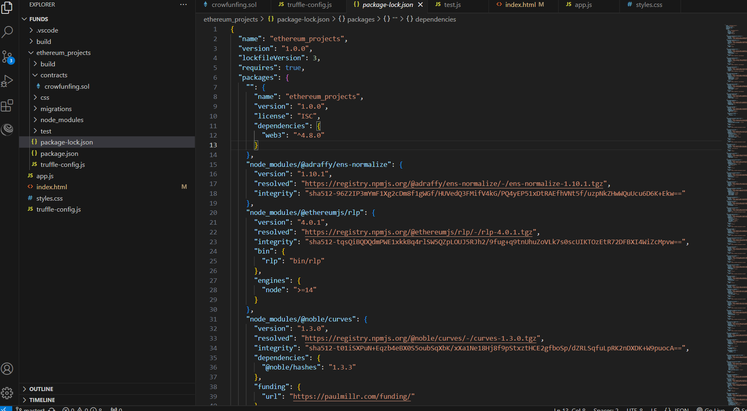

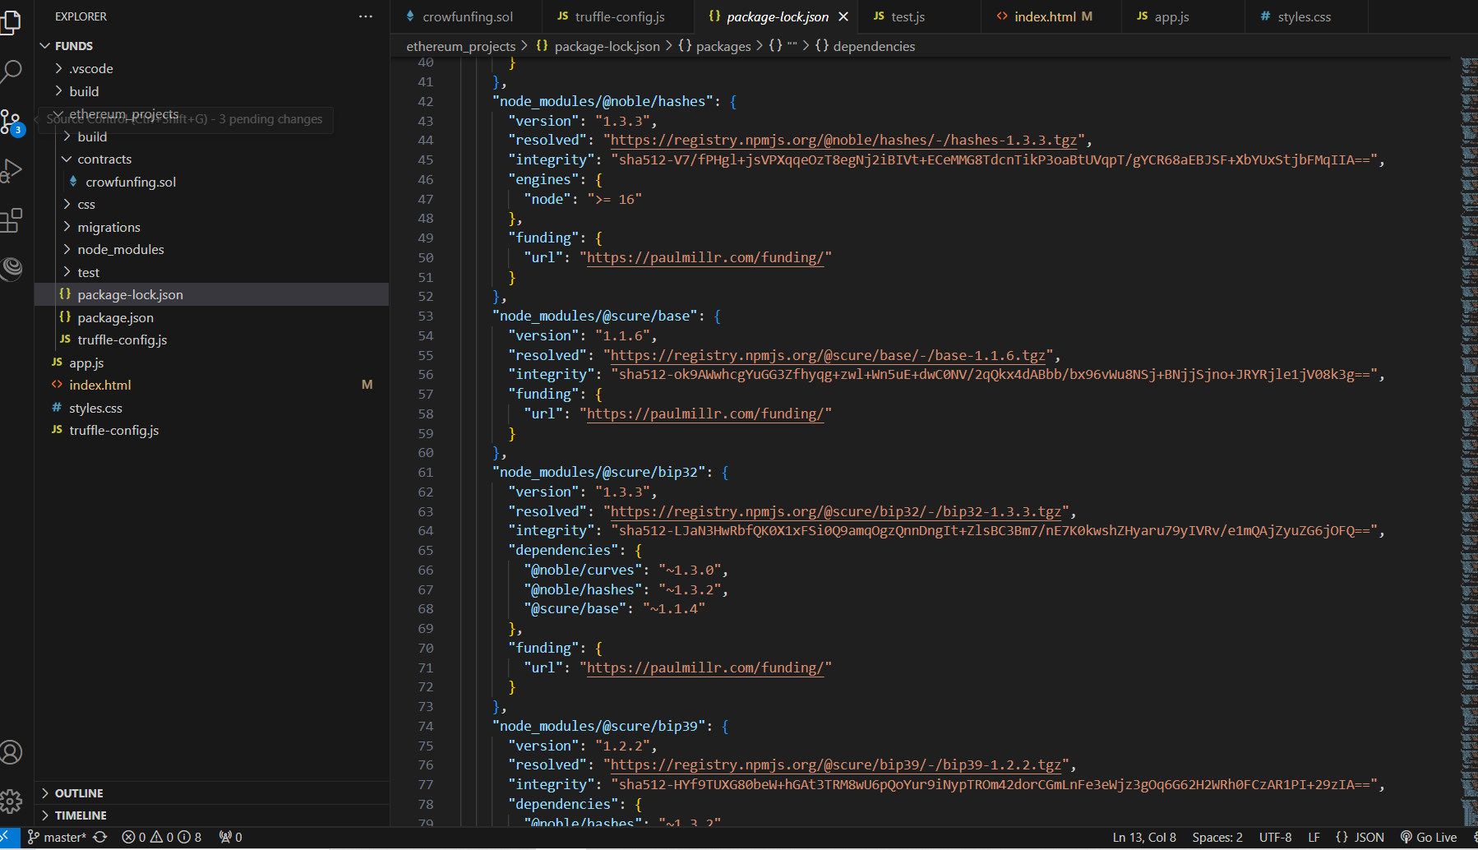

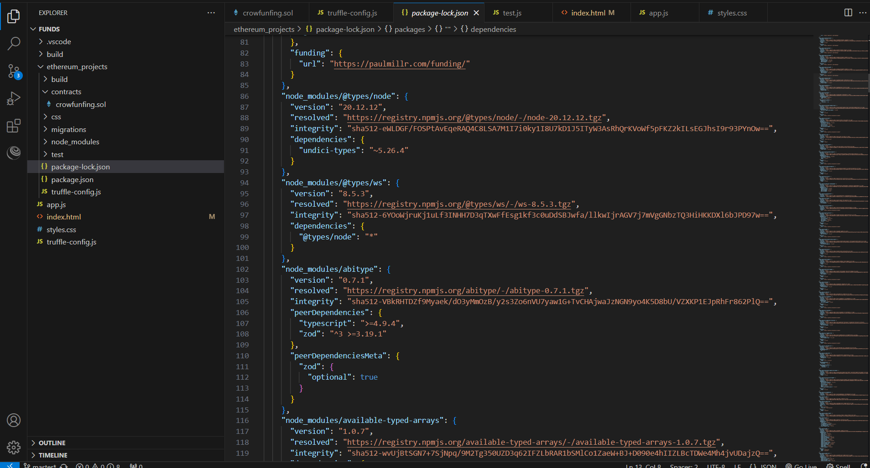

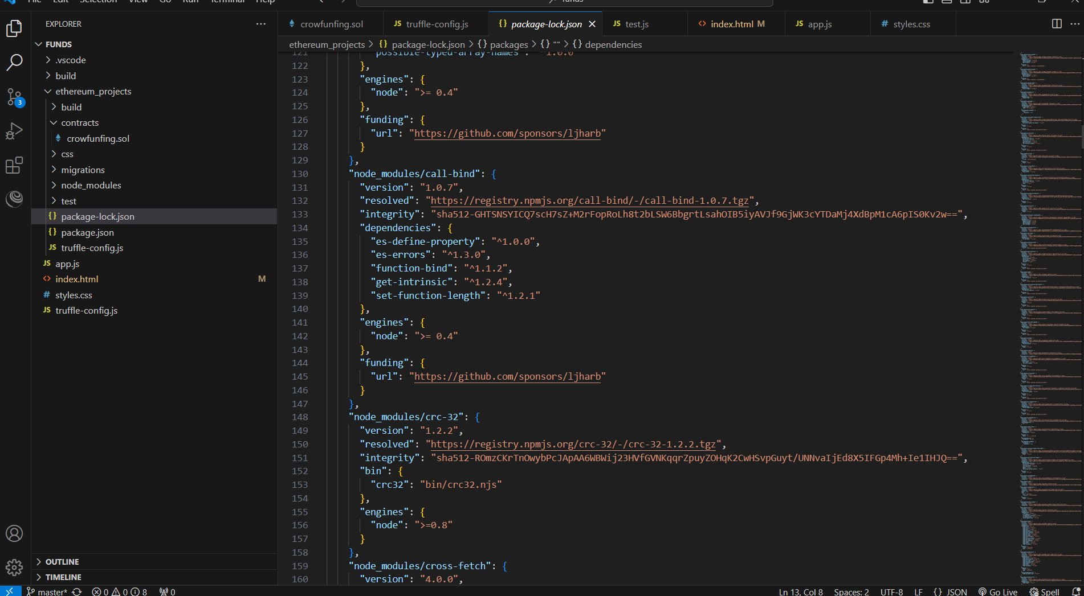

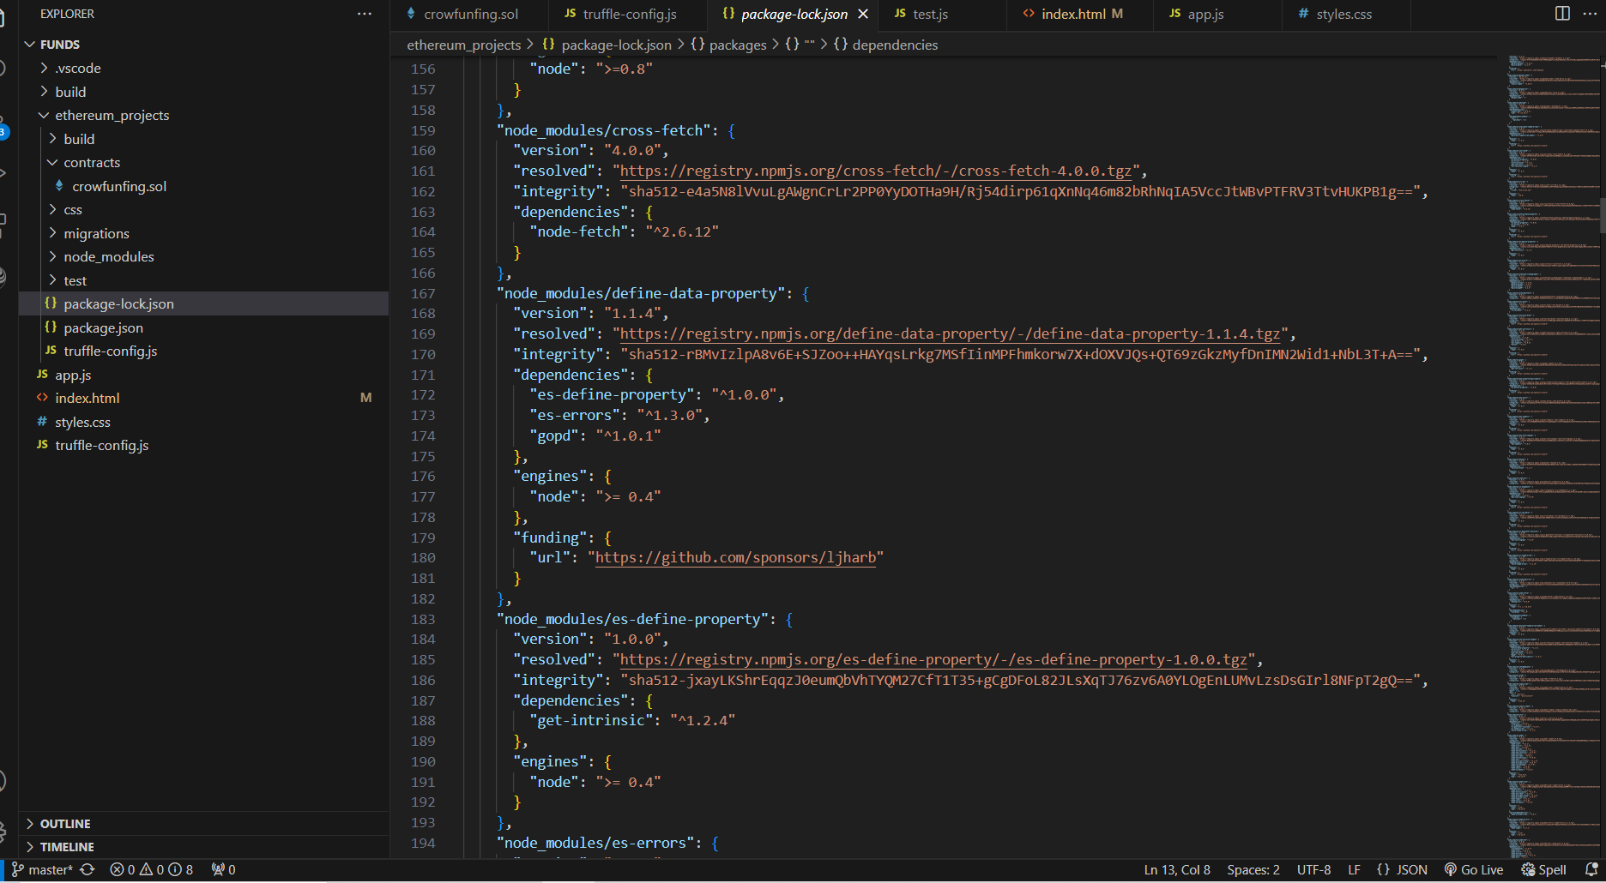

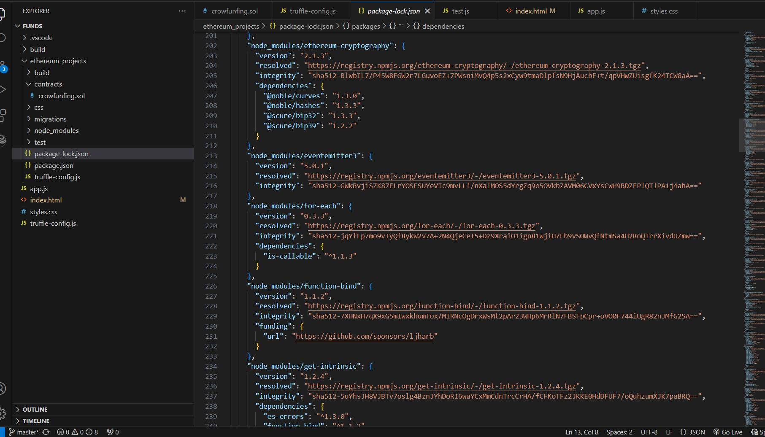

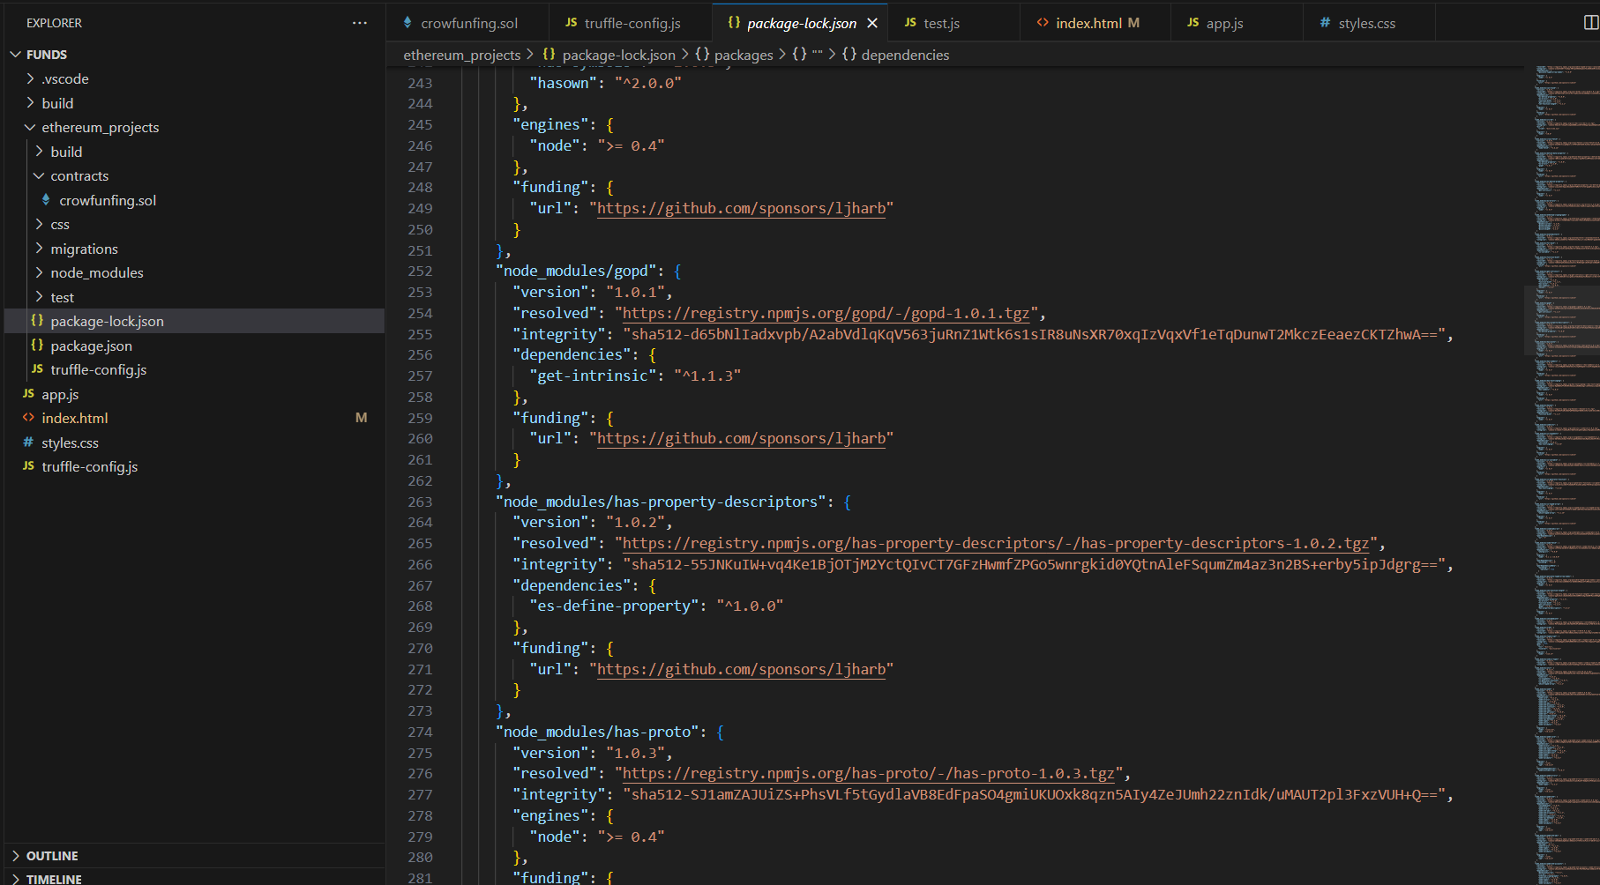

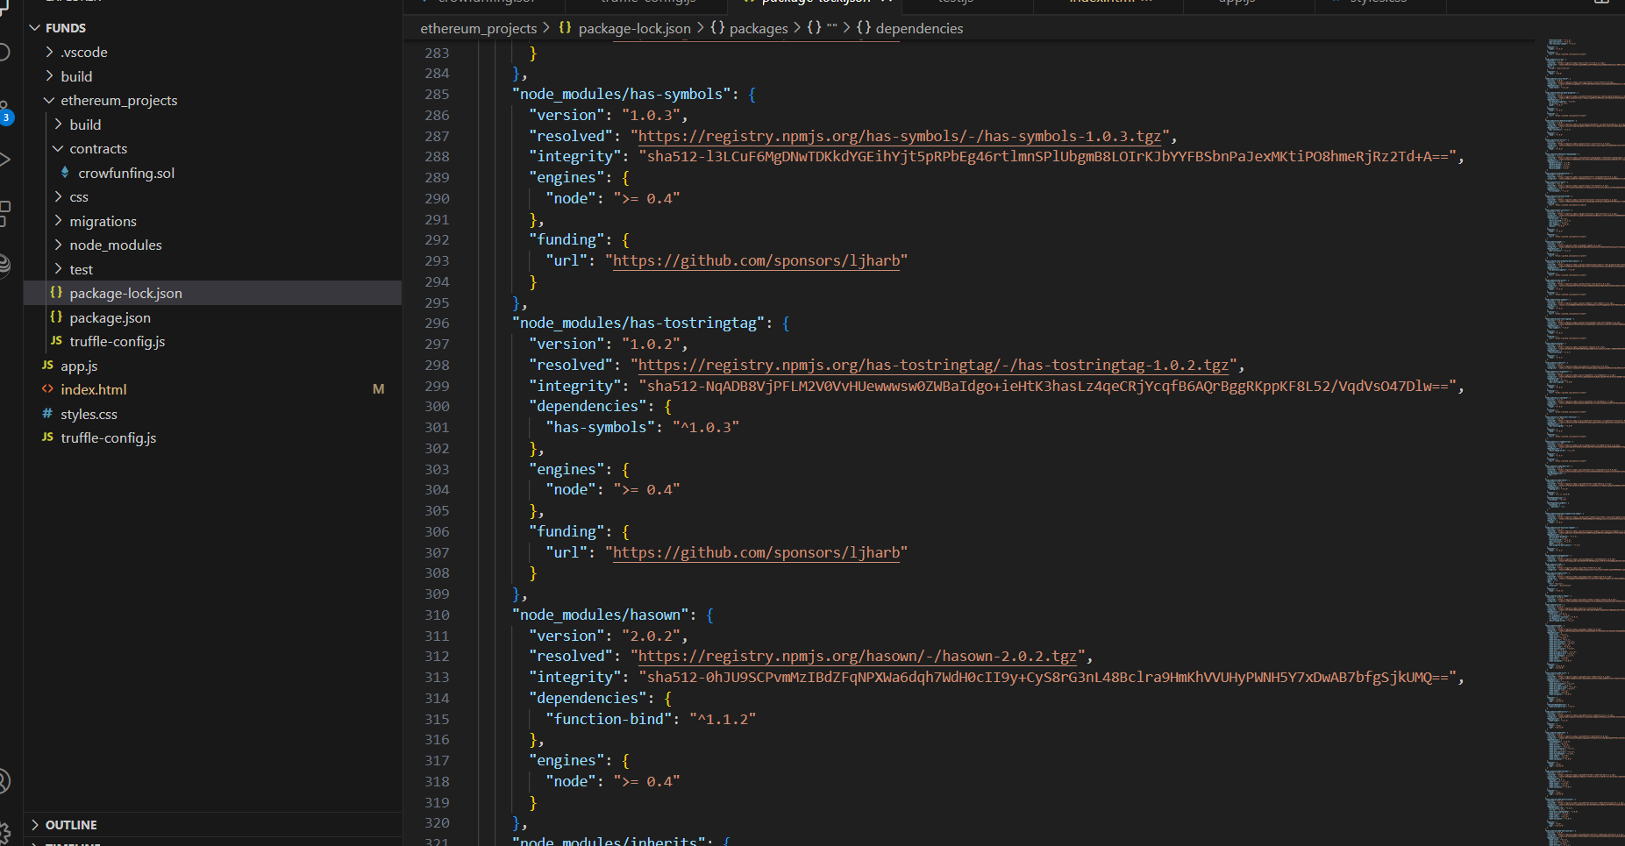

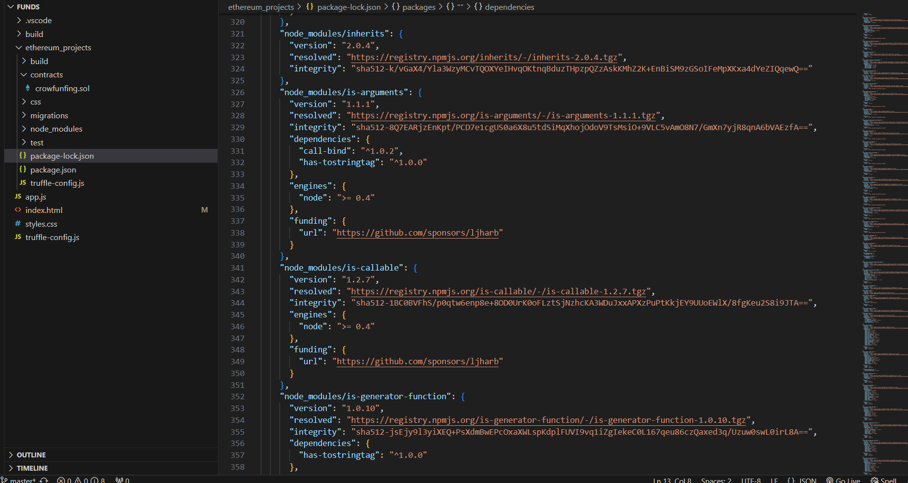

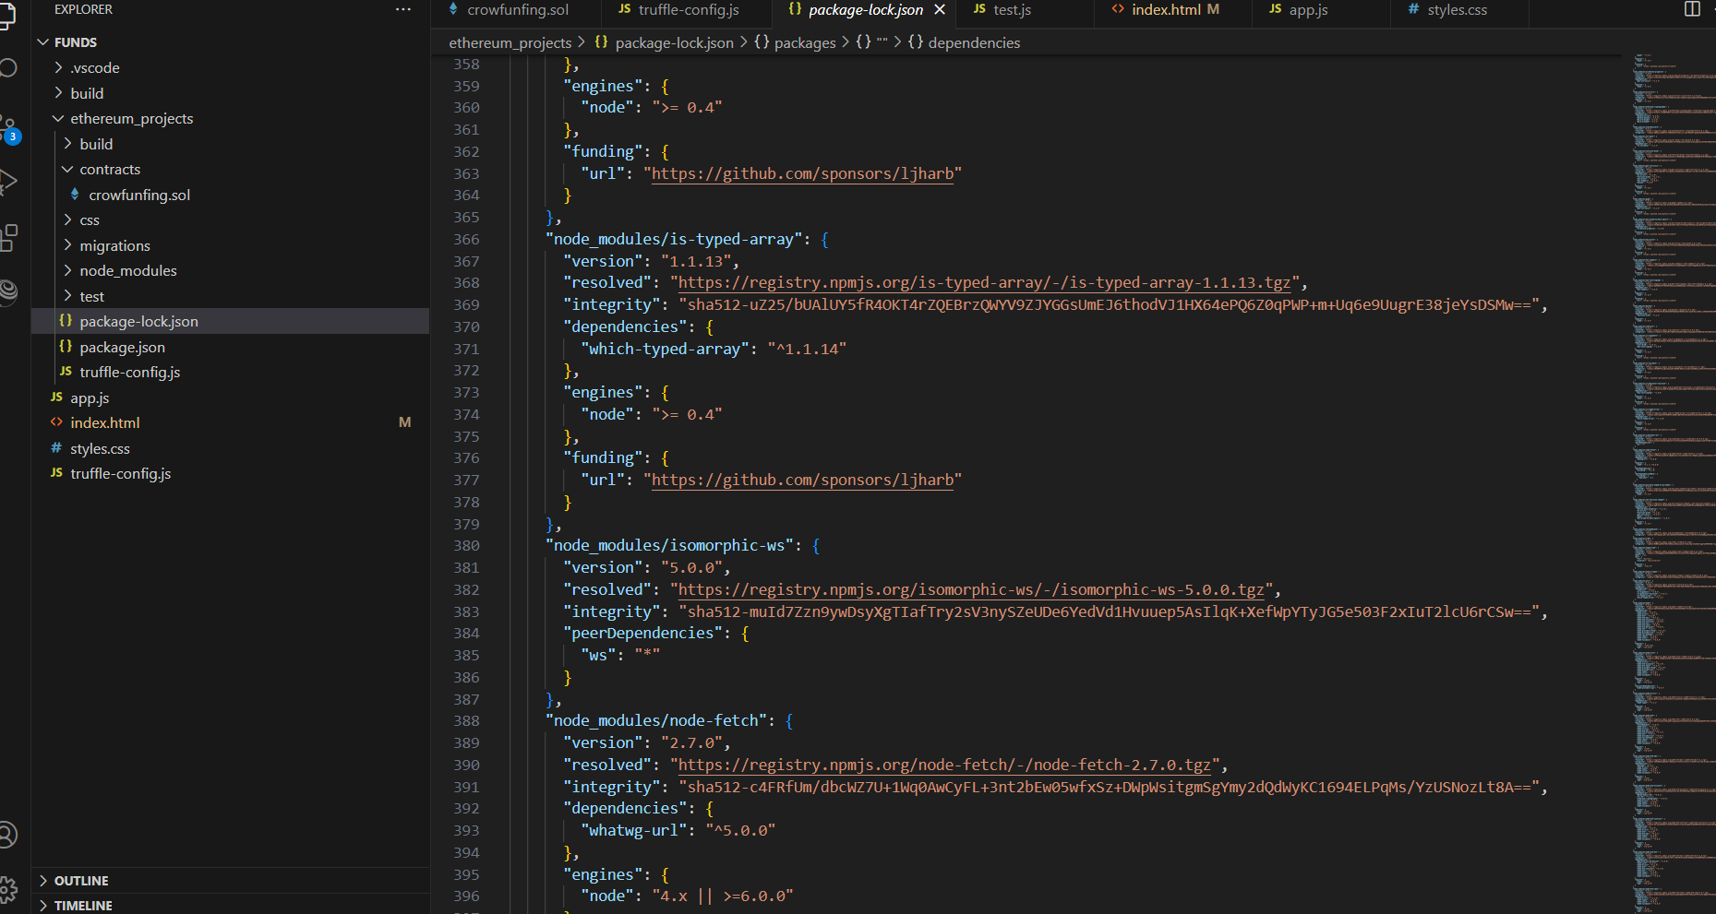

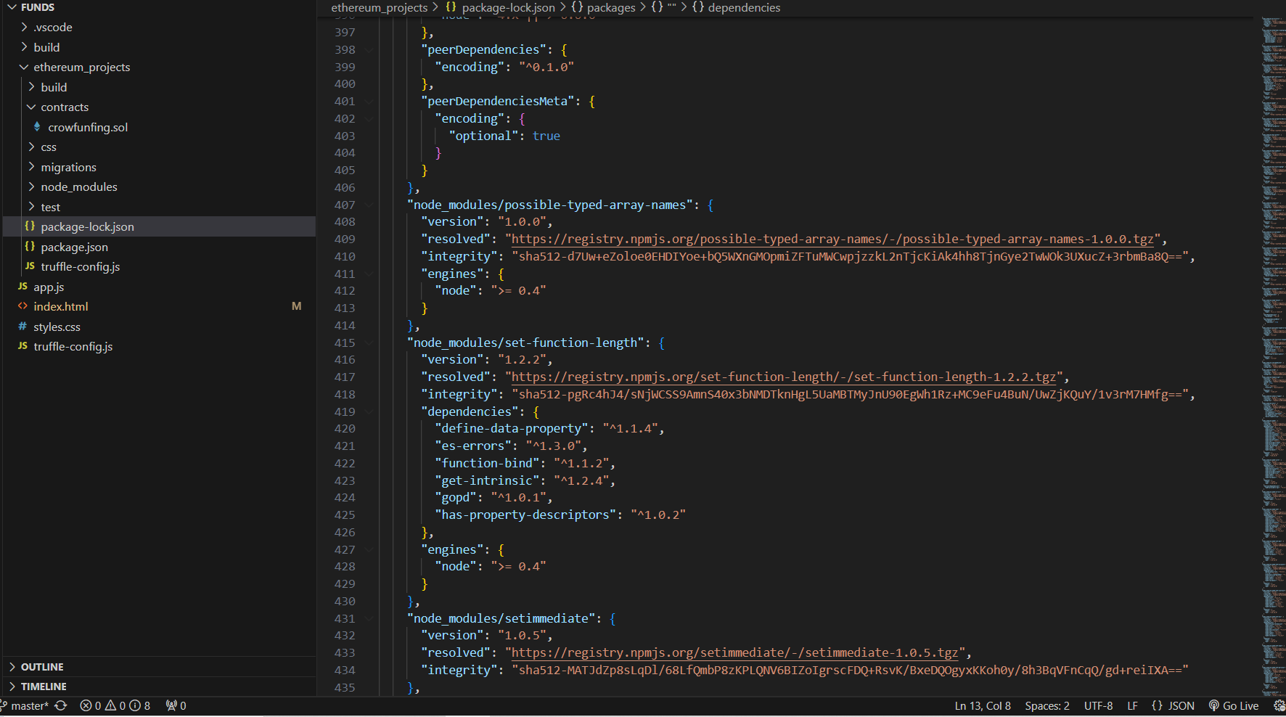

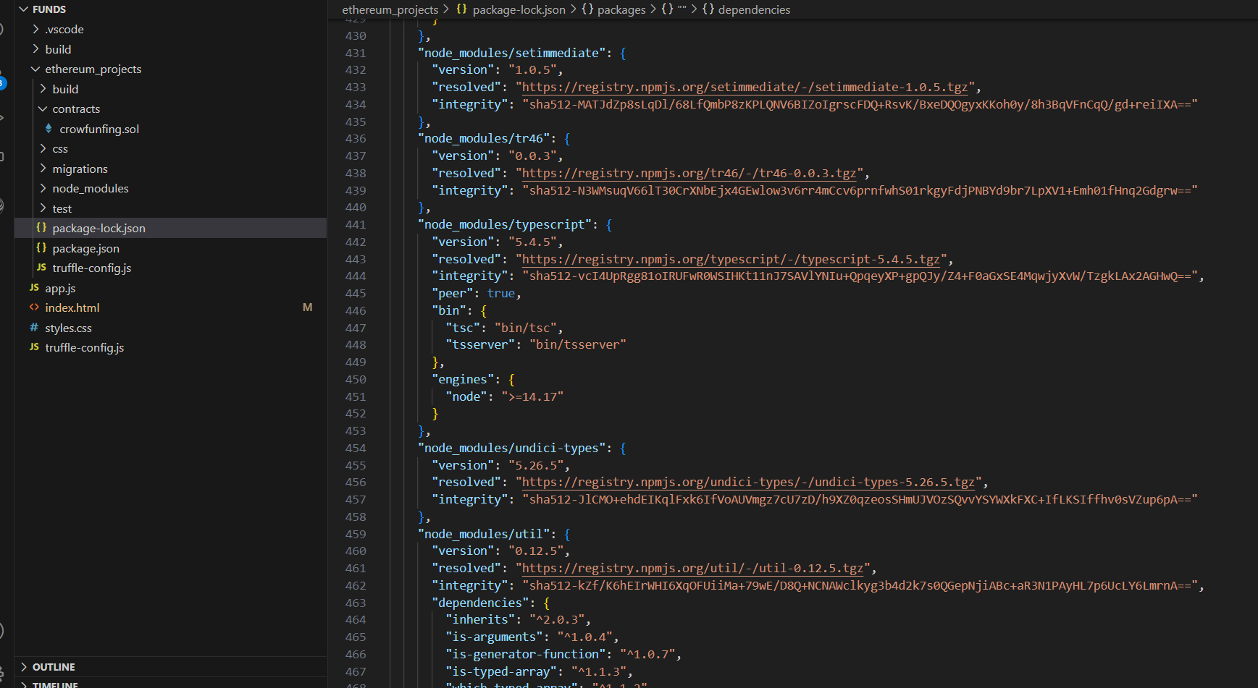

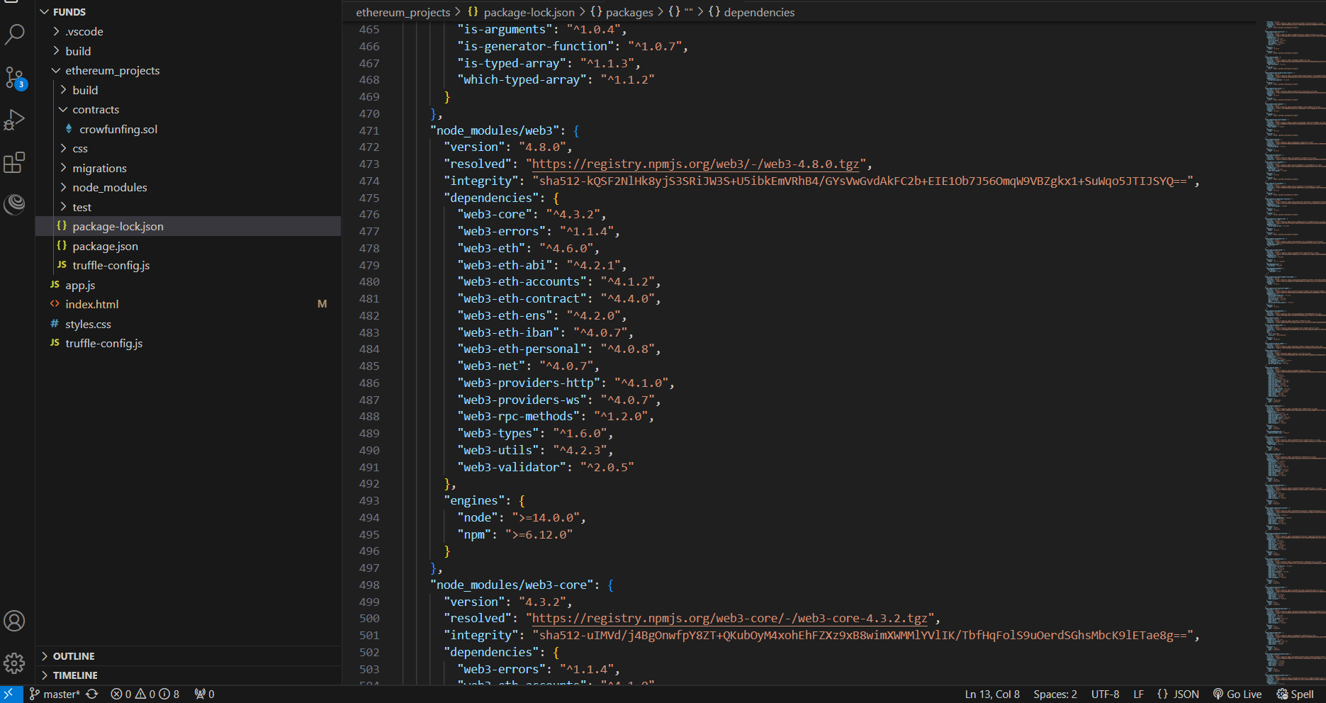

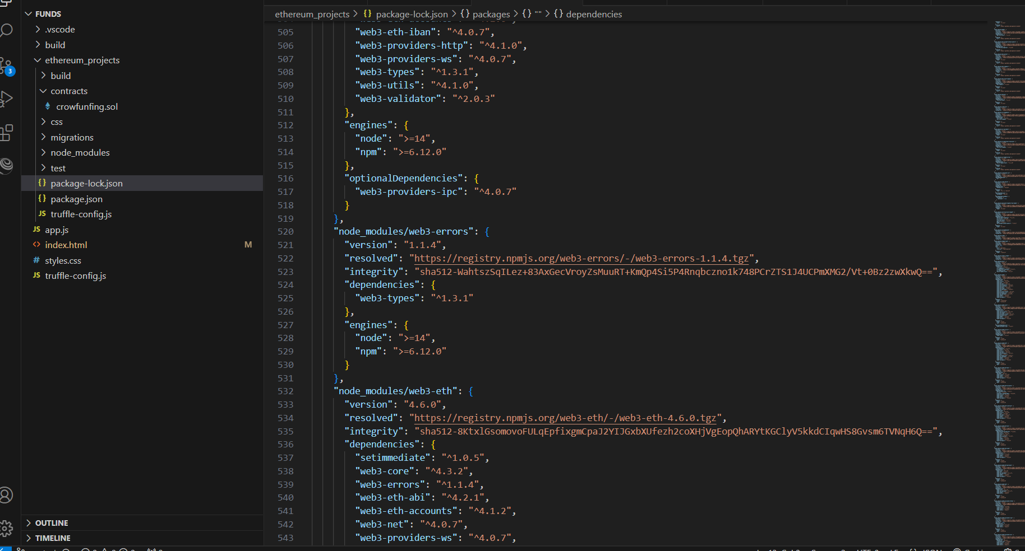

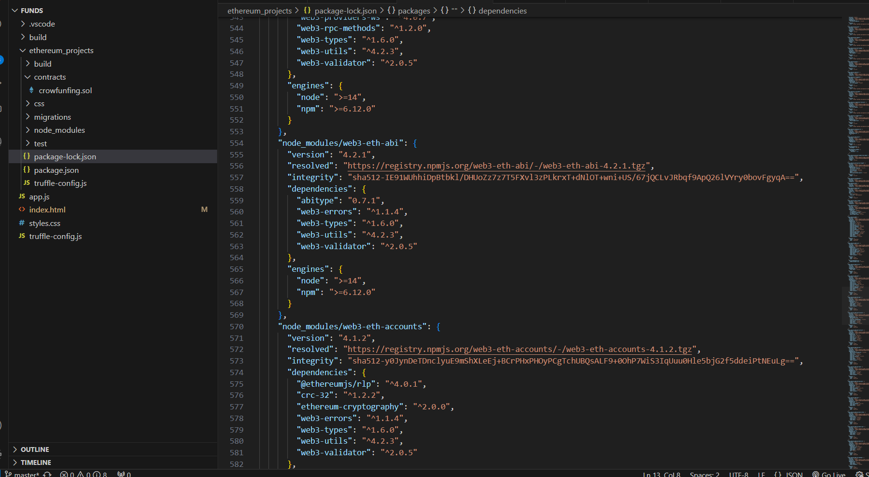

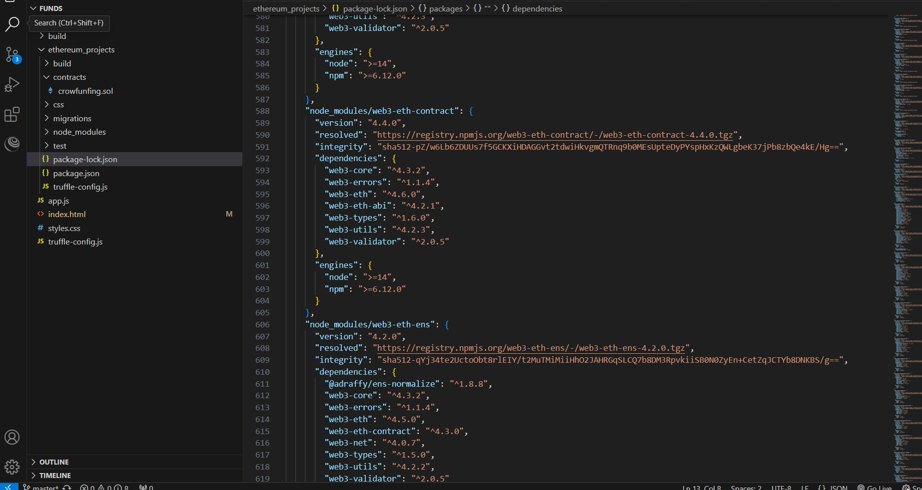

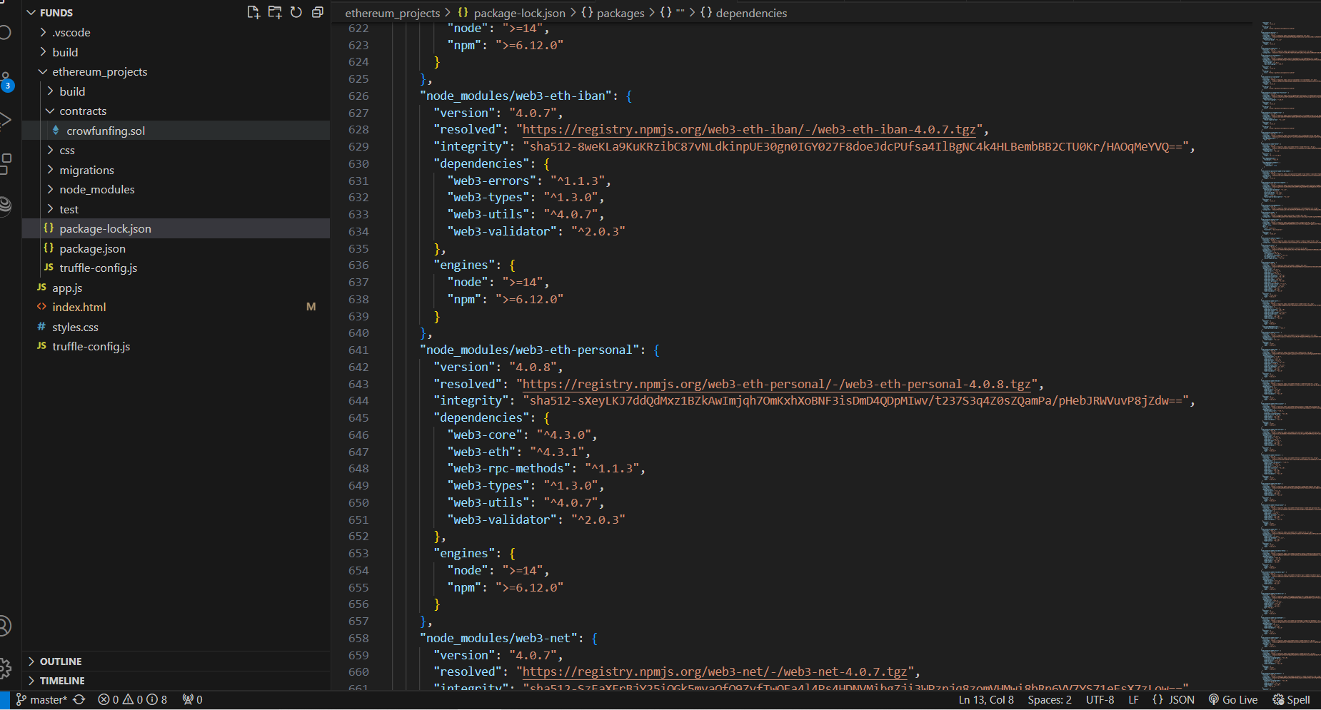

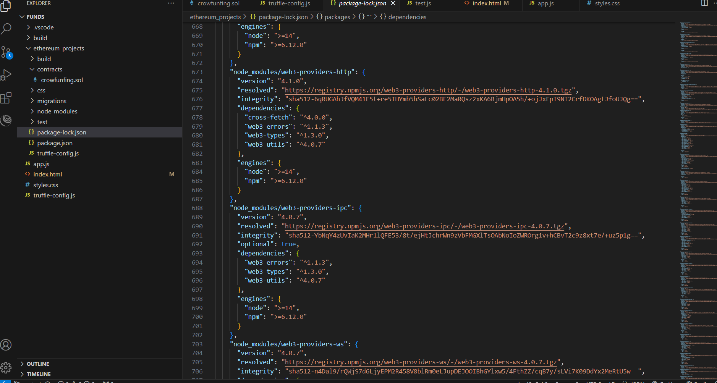

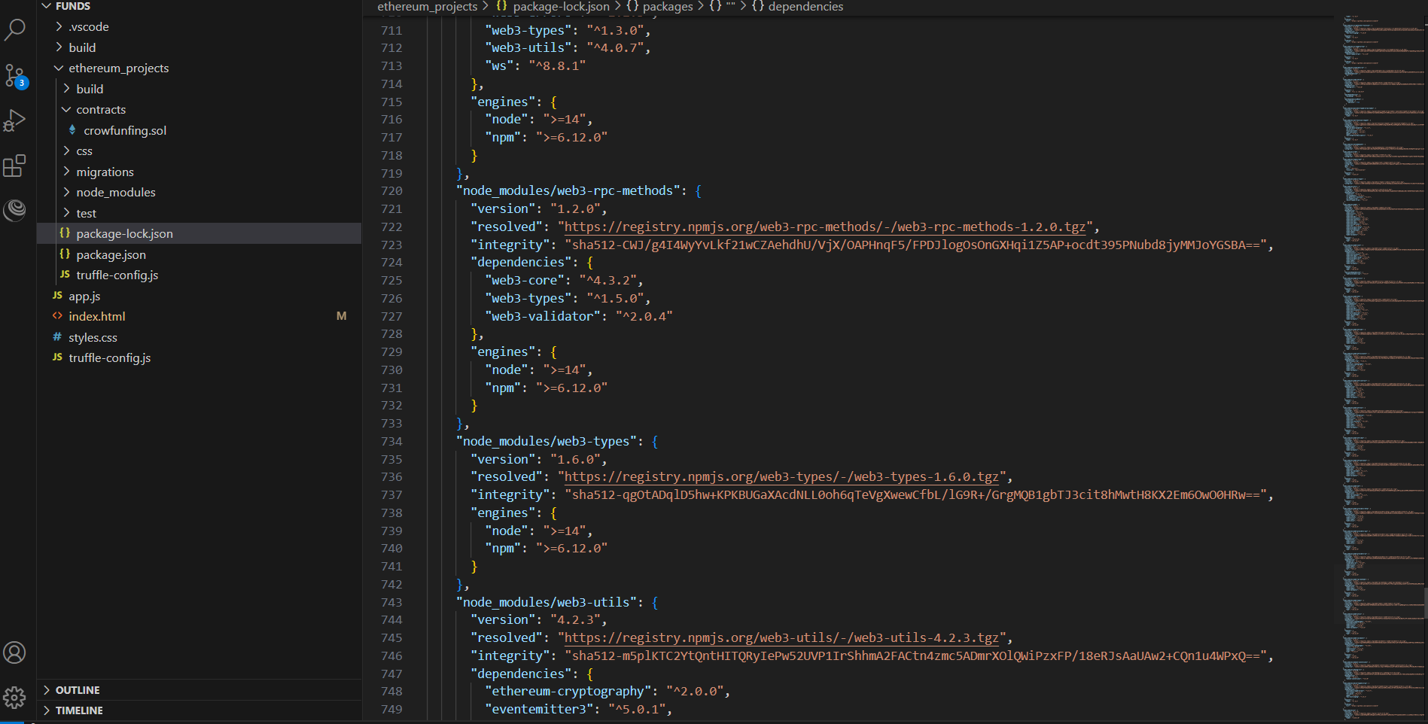

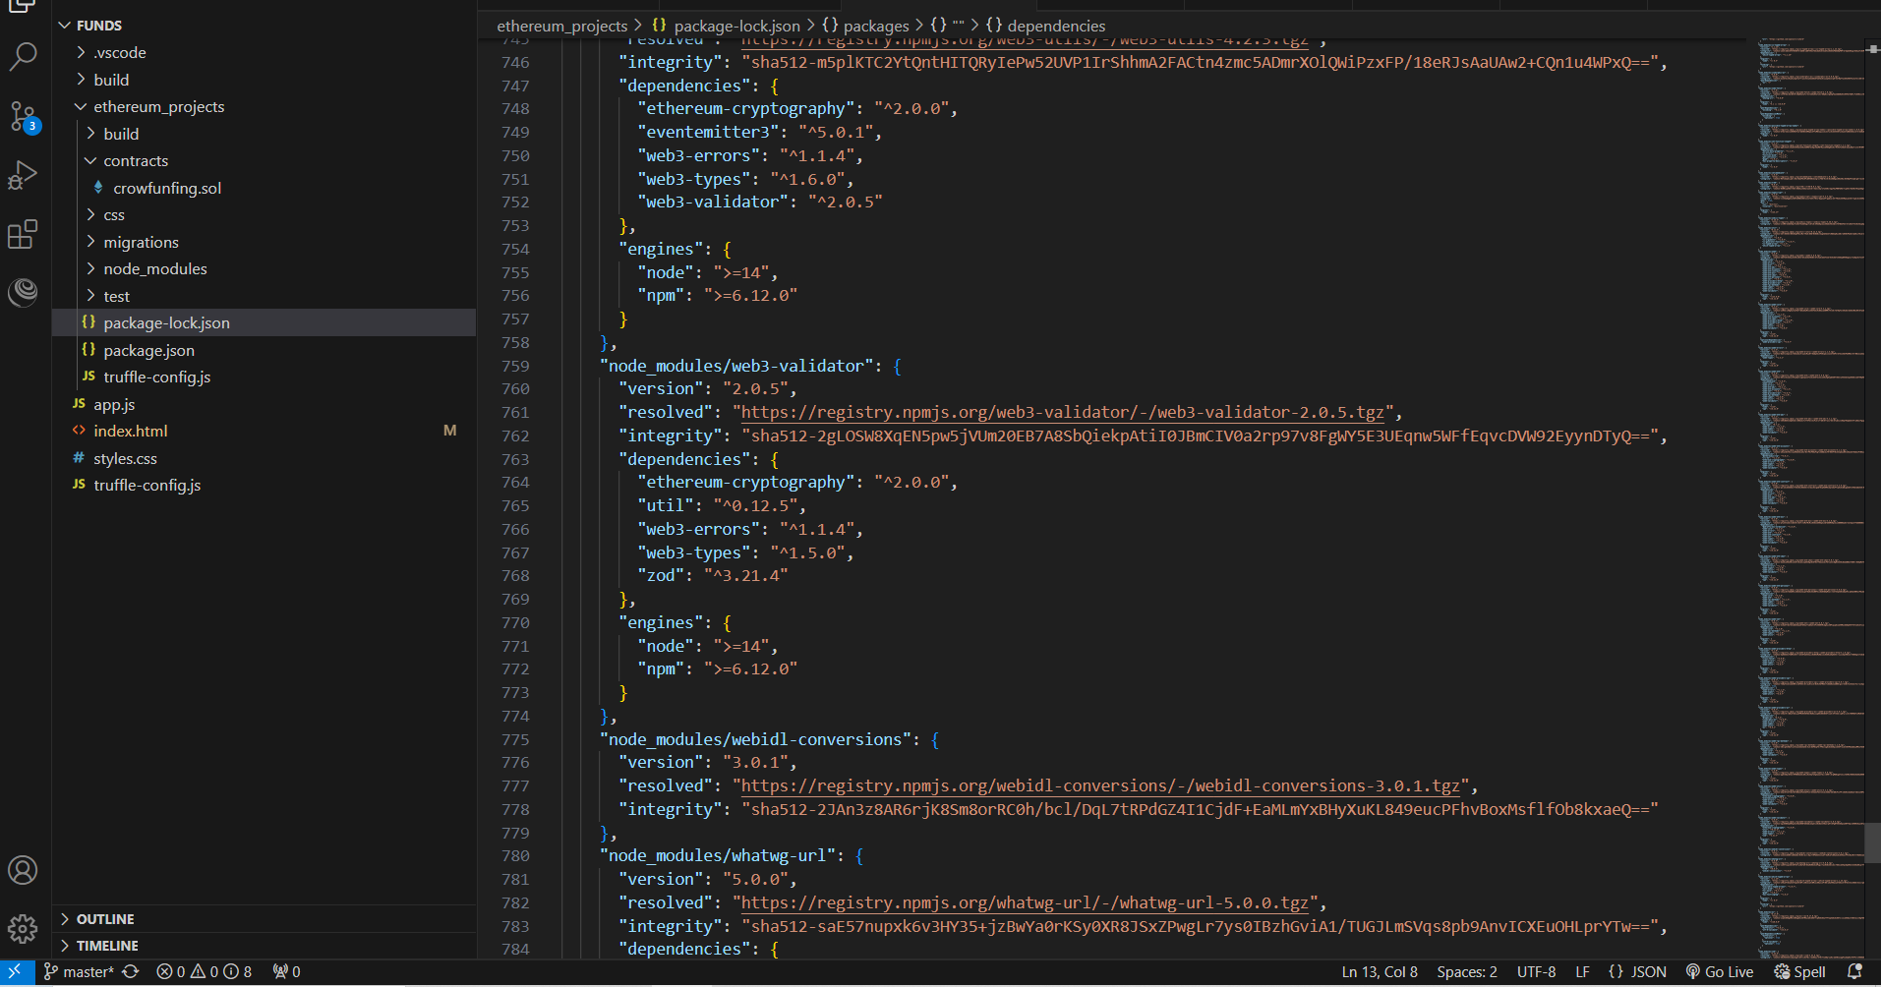

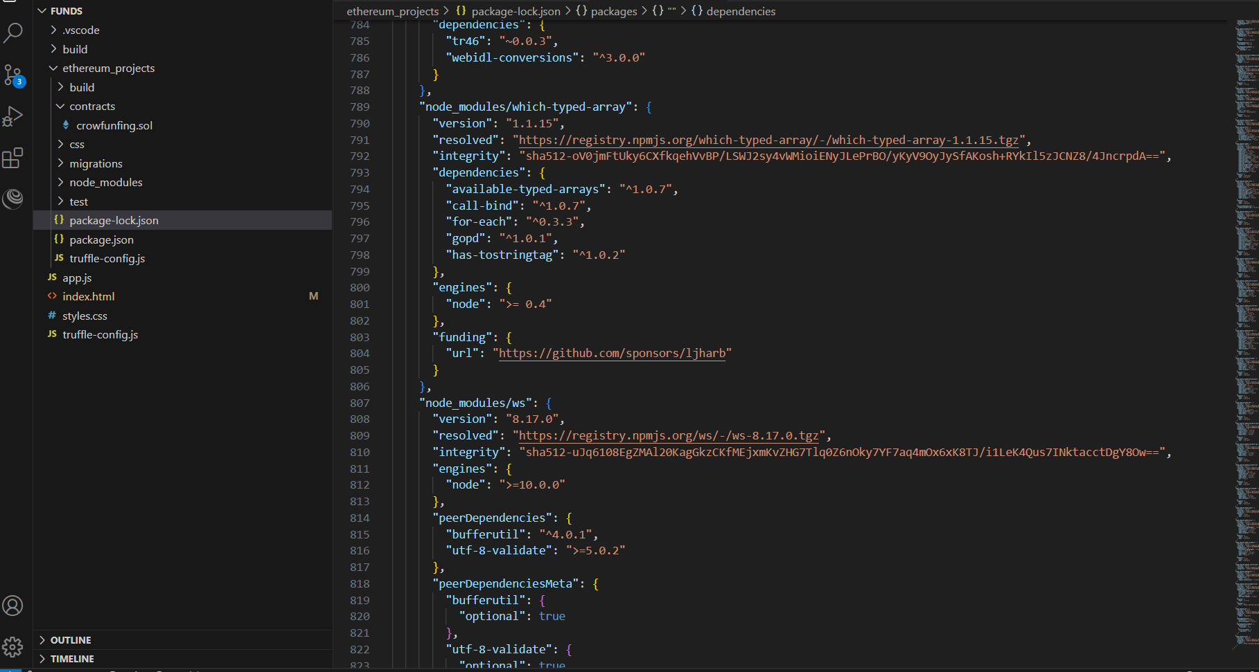

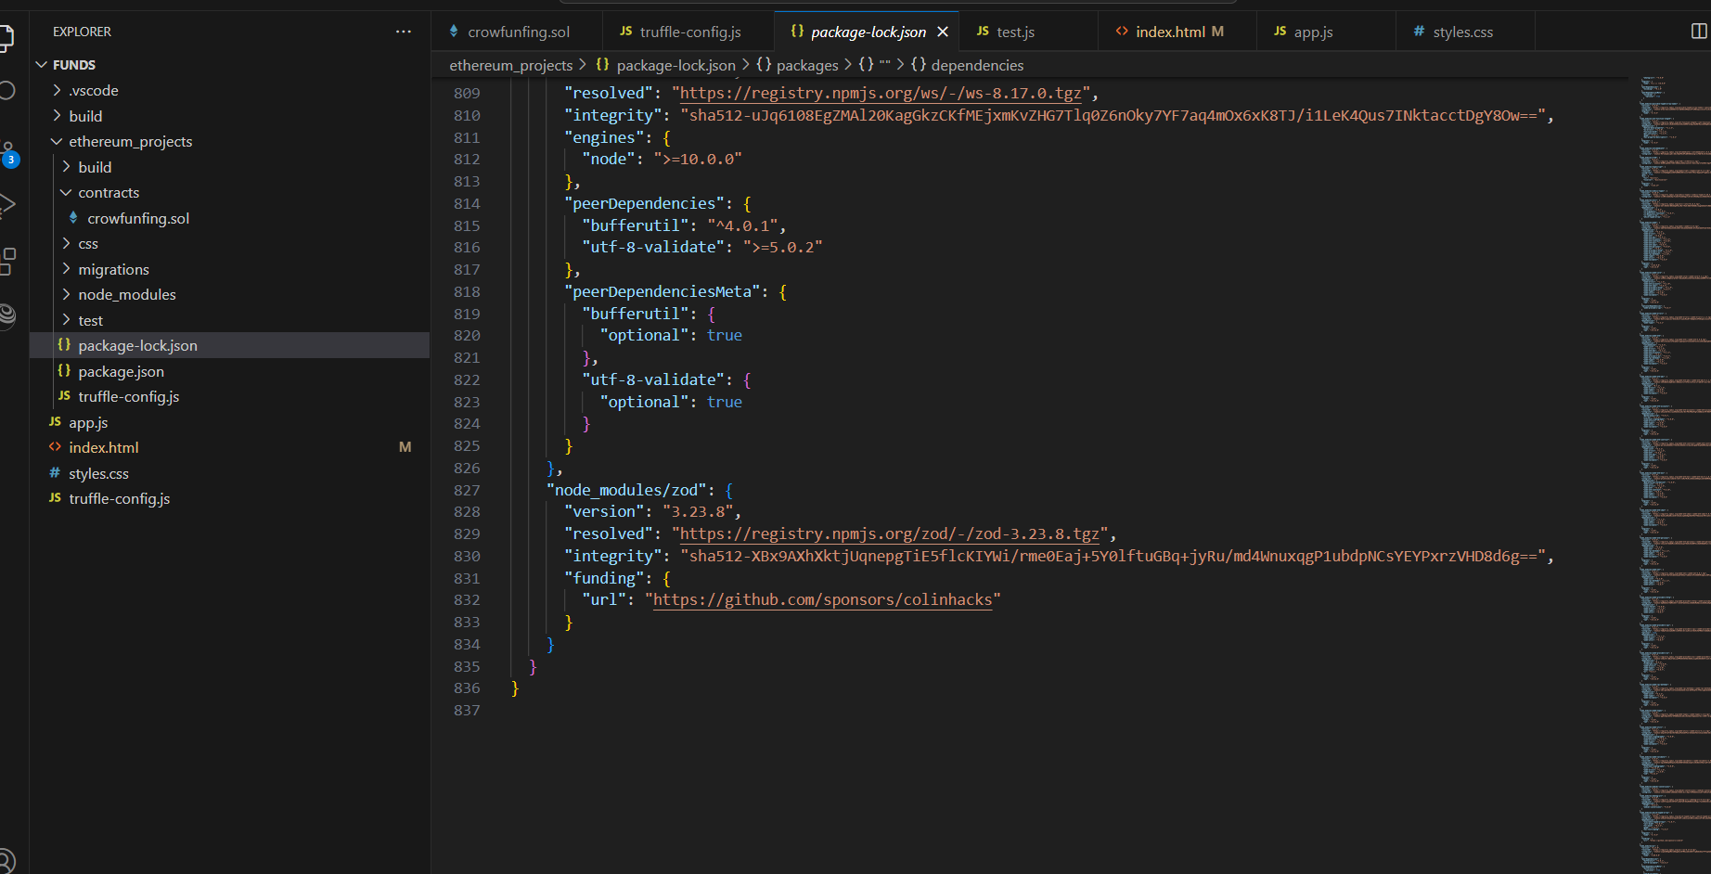

**6. test.js**

**Code:-**

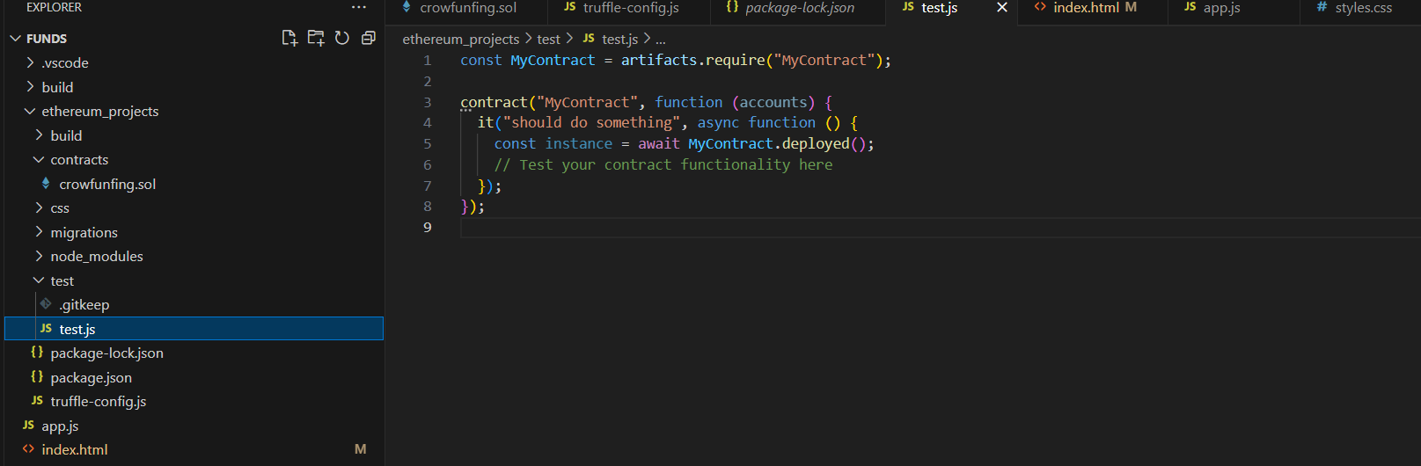

**7.App.js**

**Code: -**

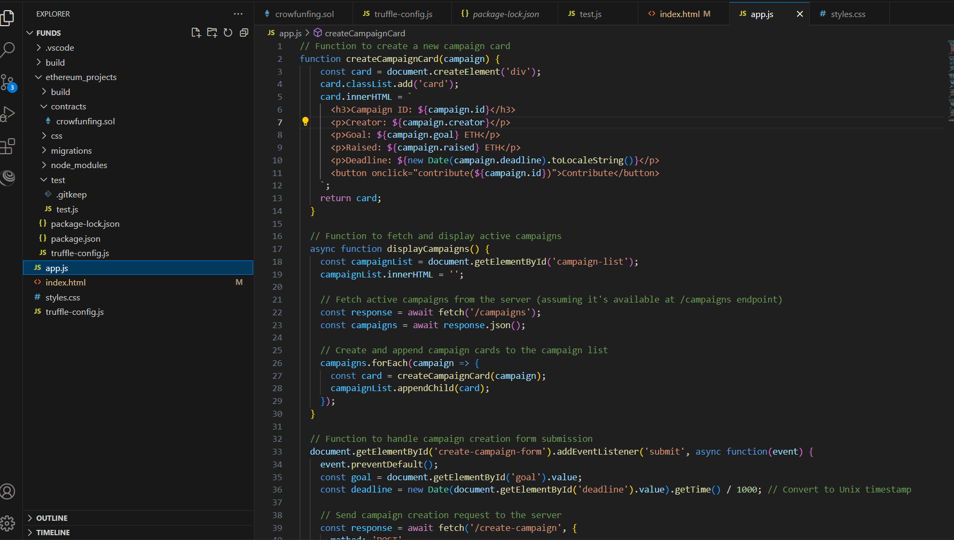

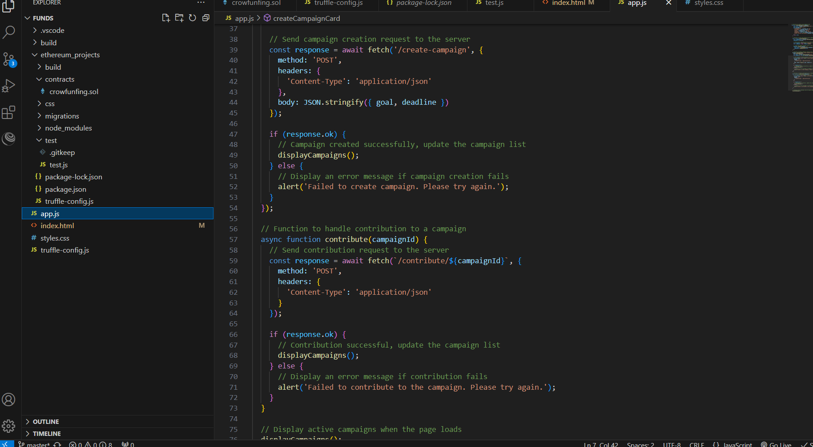

**8 .Truffle Workspace**

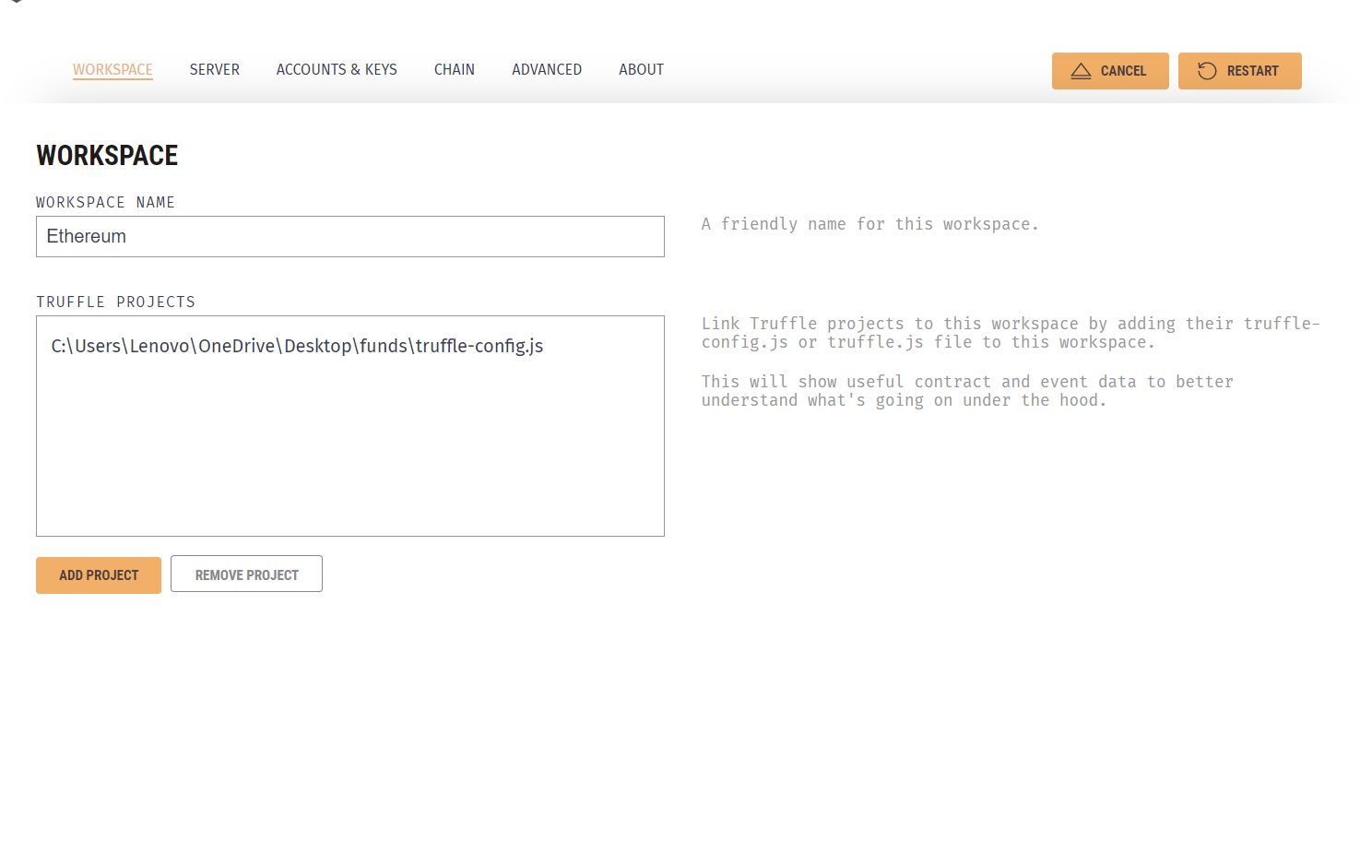

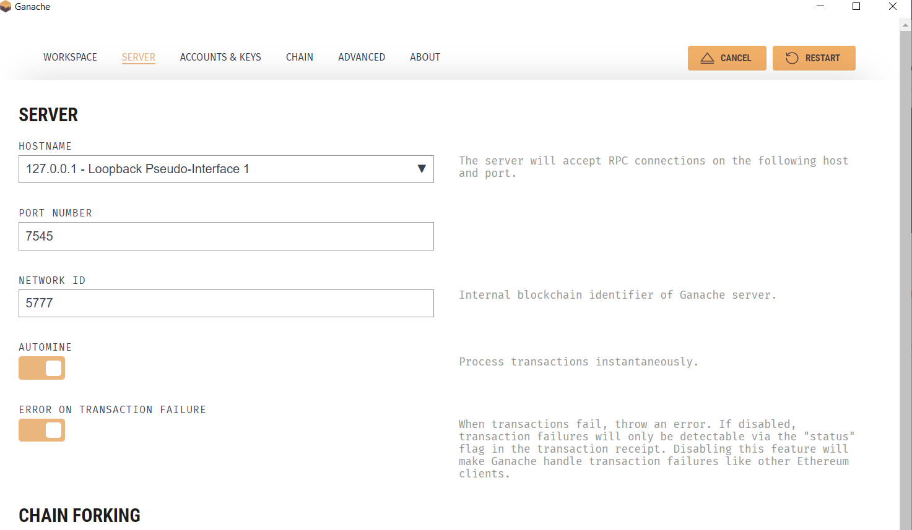

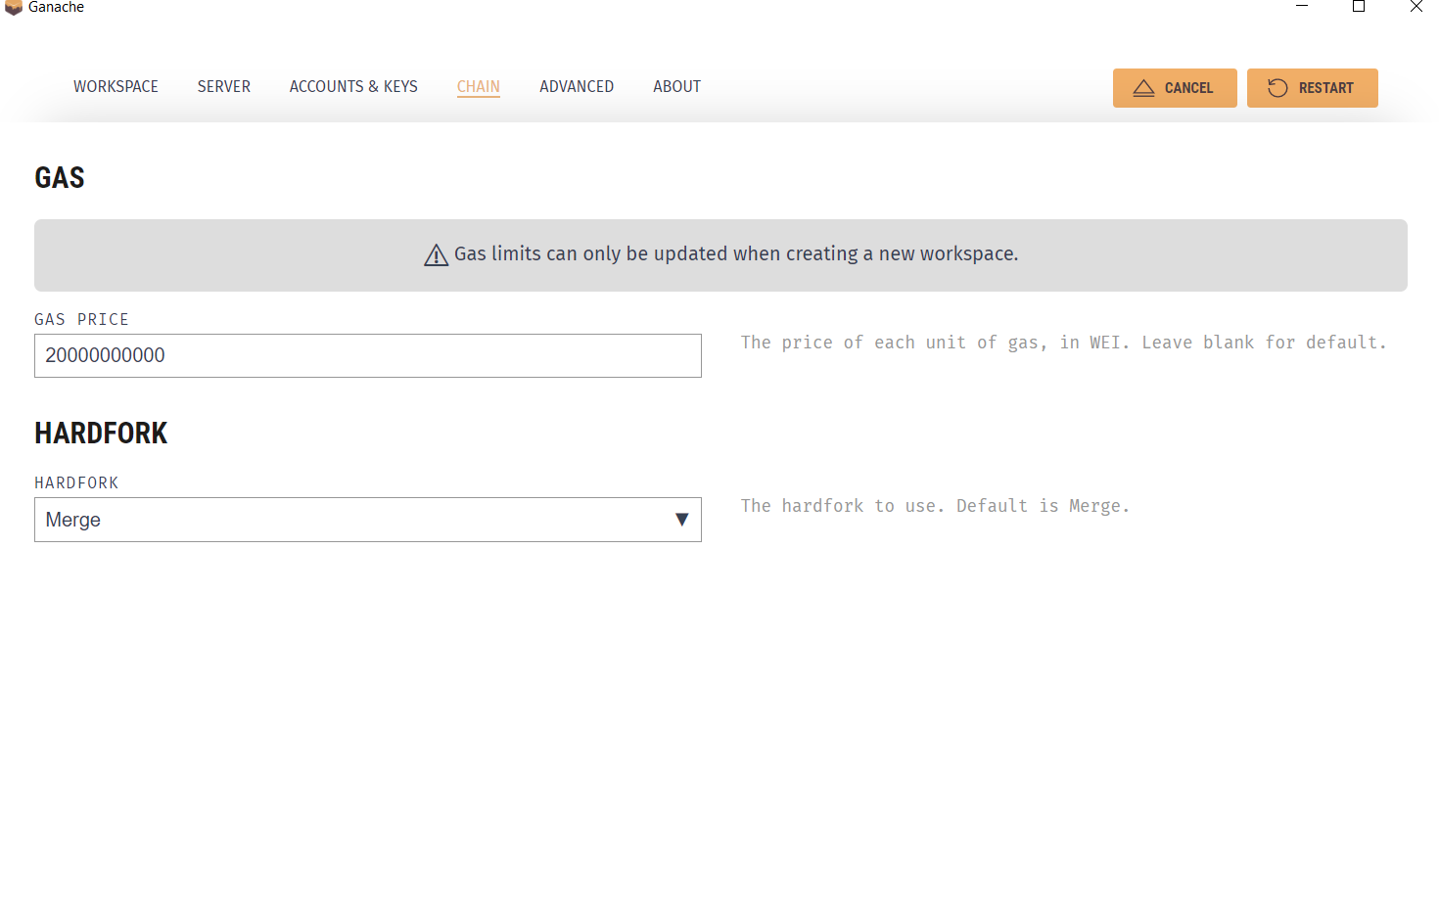

**Chapter 5**

**Conclusions and Future Work**

**5.1 Conclusion**

Blockchain-powered crowdfunding is a new frontier in the ICT industry that promises greater openness, efficiency, and inclusivity in fundraising efforts. Notable progress has been made in utilizing blockchain for crowdfunding projects, as demonstrated by the development and implementation of solidity code for campaign contracts, as well as the smooth incorporation of blockchain technology through platforms such as MetaMask. The emergence of decentralized web applications featuring user-friendly interfaces highlights the adaptability and reach of blockchain-driven crowdfunding platforms, facilitating smooth user participation in project creation, contribution, and management.

Nevertheless, it is recognized that blockchain applications for crowdfunding are still in the experimental stage and that there are still a number of technological and legal issues that need to be resolved. Adoption and implementation are still hindered by issues including interoperability, scalability, and regulatory compliance. However, there is still a great deal of room for innovation and advancement, providing a bright future for blockchain-based crowdfunding.  
In the future, our suggested work has a great deal of potential for improvement and development in step with the blockchain's continuous advancement. Subsequent investigations may concentrate on resolving current issues and improving the usability and functionality of blockchain-based crowdfunding applications. To improve the efficacy and efficiency of crowdfunding procedures, this may entail investigating sophisticated smart contract functions, putting strong governance mechanisms in place, and fusing cutting-edge technology like artificial intelligence and decentralized financing (DeFi).

Furthermore, as blockchain technology develops and becomes more widely accepted, chances for cooperation and integration with other industries—like supply chain management, healthcare, and finance—may present themselves. Blockchain-based crowdfunding platforms can open up new doors for innovation and influence by utilizing synergies across several disciplines, resulting in good change on a global scale.

A major turning point in the development of fundraising techniques has been reached with the introduction of blockchain-powered crowdfunding, which offers the ICT community never-before-seen levels of efficiency, inclusivity, and transparency. The fact that solidity code for campaign contracts has been deployed successfully and that blockchain technology has been integrated with ease using tools like Metamask demonstrate the real progress that has been made in utilizing blockchain for crowdfunding projects. Furthermore, the creation of decentralized web applications with intuitive user interfaces highlights the adaptability and accessibility of blockchain-based crowdfunding platforms, enabling users to easily and conveniently take part in fundraising initiatives.

Notwithstanding these noteworthy developments, it is crucial to recognize that blockchain applications for crowdfunding are still in their infancy and face a number of legal and technological obstacles that need to be overcome. Before blockchain-based crowdfunding systems are widely used and implemented, there are still a number of important obstacles that need to be overcome, including regulatory compliance, scalability challenges, and interoperability issues. Different jurisdictions have different legal frameworks governing blockchain technology and the use of cryptocurrencies, which presents compliance issues for both platform operators and consumers. Furthermore, scalability constraints present in blockchain technology, especially in open networks such as Ethereum, can make it more difficult for the platform to effectively manage massive crowdfunding campaigns. Furthermore, the promotion of smooth integration and cooperation within the crowdfunding ecosystem depends on the integrity of blockchain protocols and platforms.

However, there is a bright future ahead for blockchain-based crowdfunding, with lots of room for advancement and creativity. Through the resolution of current issues and the improvement of the functionality and usability of blockchain-based crowdfunding applications, our proposed work seeks to further this continuous evolution. In order to facilitate more intricate fundraising procedures and increase the adaptability of crowdfunding campaigns, one direction for future study is to investigate advanced smart contract functions like programmable money and conditional payments. Putting strong governance systems in place, such decentralized autonomous organizations (DAOs), can also help crowdfunding platforms make decision-making processes more accountable and transparent.

Moreover, combining cutting-edge technology like decentralized finance (DeFi) and artificial intelligence (AI) has a lot of potential to maximize the efficacy and efficiency of crowdfunding procedures. Through the use of AI-powered analytics, platform operators may make data-driven decisions and maximize fundraising tactics by gaining insightful knowledge about donor behaviour and campaign performance. The liquidity and accessibility of crowdfunding assets can also be improved by utilizing DeFi protocols for tokenization, lending, and liquidity provision. This allows for a wider range of fundraising methods and more widespread worldwide involvement in crowdfunding campaigns.

In conclusion, there is a ton of room for innovation and expansion in the crowdfunding industry even though blockchain-based platforms are still in their infancy. Through the resolution of current issues, enhancement of current features, and integration of new technologies, we can open up new avenues for open, effective, and inclusive fundraising procedures on the blockchain. With further advancements in technology, blockchain-based crowdfunding has the potential to revolutionize the way people participate in and support social projects and humanitarian causes.

**5.2 Future Work**

Further research on blockchain-powered crowdfunding platforms has great potential to improve fundraising efforts' efficiency, inclusivity, and transparency. There are numerous directions this field can go in terms of research and development:

1. Advanced Features for Smart Contracts: Adding sophisticated features to smart contracts can make it possible to implement more complex crowdfunding systems. Subsequent investigations may concentrate on including functionalities like contingent payments, funding depending on milestones, and flexible incentive schemes. These improvements have the potential to provide crowdfunding campaigns more adaptability and customization choices, meeting a range of project needs and donor preferences.

2. Integration of Decentralized Governance Mechanisms: Crowdfunding platforms can enhance accountability and transparency in their decision-making processes by integrating decentralized governance mechanisms like decentralized autonomous organizations (DAOs). Future research can examine the creation and application of DAOs specifically designed to oversee crowdfunding campaigns, allowing stakeholders to take part in governance functions and influence the platform's course.

3. Scalability Solutions: In order for blockchain-based crowdfunding platforms to effectively manage massive campaigns, it is imperative that scalability issues be resolved. Subsequent investigations may examine scalability strategies, like sharding and layer 2 scaling (such as state channels and sidechains), in order to enhance transaction throughput and lessen network congestion. These increases in scalability can help crowdfunding platforms expand and meet the growing demand from users.

4. Interoperability with Other Blockchains: Encouraging communication and exchange between other blockchain networks will improve crowdfunding sites' adaptability and use. Subsequent efforts should concentrate on creating standards and protocols for cross-chain compatibility, which will allow for smooth asset transfers and communication between different blockchain ecosystems. A more connected and active crowdfunding ecosystem can be fostered by interoperability solutions, which can encourage collaboration and integration across various crowdfunding platforms.

5. Integration of Machine Learning and Artificial Intelligence: Using ML and AI technologies can improve the efficacy and efficiency of crowdfunding procedures. Future studies can examine the application of AI algorithms to sentiment analysis, campaign optimization, and donor profiling. AI-powered analytics can help platform operators and campaign organizers make data-driven decisions and enhance fundraising results by evaluating massive datasets of donor behaviour and campaign performance.

6. Strengthened Security Measures: To protect the confidentiality and integrity of crowdfunding platforms, security measures must be strengthened. In the future, work may concentrate on putting advanced security methods like secure multi-party computation, cryptographic hashing, and multi-factor authentication into practice. Additionally, to improve user privacy and confidentiality on the blockchain, research projects can investigate the usage of zero-knowledge proofs and privacy-preserving technology.

7. Integration of Decentralized Finance (DeFi) Protocols: By integrating DeFi protocols, crowdfunding platforms can take advantage of new sources of funding and liquidity. Subsequent research endeavoursmay investigate the assimilation of DeFi protocols for the purposes of tokenization, lending, borrowing, and liquidity provision in crowdfunding environments. These DeFi interfaces can enable fractional ownership of assets, streamline token transfers, and offer different funding channels for businesses of all sizes.

8. Community Engagement and Education activities: To increase awareness and adoption of blockchain-based crowdfunding platforms, it is essential to support community engagement and education activities. Subsequent efforts may concentrate on creating teaching materials, arranging community-driven gatherings, and holding seminars to enlighten consumers about the features and advantages of blockchain technology in crowdfunding.

**References**

1. N. Alblihed, M. Almutairi, R. Almahmoud, S. Aladhadh, and A. Alabdulatif, “Developing Food Charity Operations Management System,” in Proceedings of 2022 2nd International Conference on Computing and Information Technology, ICCIT 2022, Institute of Electrical and Electronics Engineers Inc., 2022, pp. 93–96. doi: 10.1109/ICCIT52419.2022.9711609.
2. [2] H. Zhao et al., “Voice of Charity: Prospecting the Donation Recurrence Donor Retention in Crowdfunding,” IEEE Transactions on Knowledge and Data Engineering, vol. 32, no. 8. IEEE Computer Society, pp. 1652–1665, Aug. 01, 2020. doi: 10.1109/TKDE.2019.2906199.
3. [3] T. Althoff and J. Leskovec, “Donor retention in online crowdfunding communities: A case study of DonorsChoose.org,” in WWW 2015 - Proceedings of the 24th International Conference on World Wide Web, Association for Computing Machinery, Inc, May 2015, pp. 34–44. doi: 10.1145/2736277.2741120.
4. [4] M. Kaur, P. D. Kaur, and S. K. Sood, “Blockchain Oriented Effective Charity Process During Pandemics and Emergencies,” IEEE Trans Comput Soc Syst, vol. 11, no. 1, pp. 431–441, Feb. 2024, doi: 10.1109/TCSS.2022.3232325.
5. [5] S. Saranya, S. P. Muvvala, V. Chauhan, and R. Satwik, “Crowdfunding Charity Platform Using Blockchain,” in 5th International Conference on Inventive Computation Technologies, ICICT 2022 - Proceedings, Institute of Electrical and Electronics Engineers Inc., 2022. doi: 10.1109/ICICT54344.2022.9850562.
6. [6] S. Patnaik, 2022 11th International Conference of Information and Communication Technology ICTech 2022 : Wuhan, China, 4-6 February 2022 : proceedings.
7. [7] A. Sirikham, “Development of Multi-Purpose Donation Box based on the Internet of Things,” in Proceeding of the 2021 9th International Electrical Engineering Congress, iEECON 2021, Institute of Electrical and Electronics Engineers Inc., Mar. 2021, pp. 507–510. doi: 10.1109/iEECON51072.2021.9440294.
8. [8] N. Salido-Andres, M. Rey-Garcia, L. Ignacio Alvarez-Gonzalez, and R. Vazquez-Casielles, “Nonprofit Organizations at the Crossroads of offline and online Fundraising in the digital era The Influence of the volume of target beneficiaries on the Success of Donation-based Crowdfunding through digital platforms.” [Online]. Available: http://microdonaciones.hazloposible.org/
9. [9] H. Wu and X. Zhu, “Developing a Reliable Service System of Charity Donation during the Covid-19 Outbreak,” IEEE Access, vol. 8, pp. 154848–154860, 2020, doi: 10.1109/ACCESS.2020.3017654.
10. [10] N. Salido-Andres, M. Rey-Garcia, L. Ignacio Alvarez-Gonzalez, and R. Vazquez-Casielles, “Nonprofit Organizations at the Crossroads of offline and online Fundraising in the digital era The Influence of the volume of target beneficiaries on the Success of Donation-based Crowdfunding through digital platforms.” [Online]. Available: http://microdonaciones.hazloposible.org/
11. [11] H. Saleh, S. Avdoshin, and A. Dzhonov, “Platform for tracking donations of charitable foundations based on blockchain technology,” in Proceedings - 2019 Actual Problems of Systems and Software Engineering, APSSE 2019, Institute of Electrical and Electronics Engineers Inc., Nov. 2019, pp. 182–187. doi: 10.1109/APSSE47353.2019.00031.
12. [12] T. Li, D. Hu, M. Li, Y. Li, and S. Zheng, “A Blockchain-based Material Donation Platform,” in Proceedings - 2022 International Conference on Blockchain Technology and Information Security, ICBCTIS 2022, Institute of Electrical and Electronics Engineers Inc., 2022, pp. 246–254. doi: 10.1109/ICBCTIS55569.2022.00061.
13. [13] J. S. Chiou and C. Droge, “Service quality, trust, specific asset investment, and expertise: Direct and indirect effects in a satisfaction-loyalty framework,” Journal of the Academy of Marketing Science, vol. 34, no. 4. pp. 613–627, Oct. 2006. doi: 10.1177/0092070306286934.
14. [14] 2011 International Conference on Business Management and Electronic Information. IEEE, 2011.
15. [15] Kyŏngbuk Taehakkyo. et al., Proceedings of the IEEE International Conference on Soft-Computing and Network Security : in association with “Kyungpook National University”, South Korea : February 14th, 15th, 16th, 2018.
16. [16] A. L. R. Gonzales, E. J. M. Ingalla, N. A. F. Javier, E. A. Serrano, and R. L. Rodriguez, “CharitAble: A Software Application for Charity Donation,” in 2022 IEEE 14th International Conference on Humanoid, Nanotechnology, Information Technology, Communication and Control, Environment, and Management, HNICEM 2022, Institute of Electrical and Electronics Engineers Inc., 2022. doi: 10.1109/HNICEM57413.2022.10109400.
17. [17] S. Govindarajan, S. S. Rajkumar, A. J. Mayan, and A. M. Posonia, “Blockchain Fundraising and Charity Platform,” in ViTECoN 2023 - 2nd IEEE International Conference on Vision Towards Emerging Trends in Communication and Networking Technologies, Proceedings, Institute of Electrical and Electronics Engineers Inc., 2023. doi: 10.1109/ViTECoN58111.2023.10157146.
18. [18] D. Nadar, S. Yadav, P. Tiwari, S. Sahani, and D. Pandey, “A Platform for Tracking Charity Donations using Blockchain,” in Proceedings of the 2nd International Conference on Applied Artificial Intelligence and Computing, ICAAIC 2023, Institute of Electrical and Electronics Engineers Inc., 2023, pp. 1306–1310. doi: 10.1109/ICAAIC56838.2023.10140888.
19. [19] A. Bagheri, H. Chitsazan, and A. Ebrahimi, “Crowdfunding motivations: A focus on donors’ perspectives,” Technol Forecast Soc Change, vol. 146, pp. 218–232, Sep. 2019, doi: 10.1016/j.techfore.2019.05.002.
20. [20] B. S. Lakshmi and K. S. Rekha, “Blockchain Technology and Supply Chain Management in a Charity Donation System: A Literature Review,” in ICRTEC 2023 - Proceedings: IEEE International Conference on Recent Trends in Electronics and Communication: Upcoming Technologies for Smart Systems, Institute of Electrical and Electronics Engineers Inc., 2023. doi: 10.1109/ICRTEC56977.2023.10111908.
21. [21] Salido-Andres, N., Rey-Garcia, M., Ignacio Alvarez-Gonzalez, L., & Vazquez-Casielles, R. (n.d.). Nonprofit Organizations at the Crossroads of offline and online Fundraising in the digital era The Influence of the volume of target beneficiaries on the Success of Donation-based Crowdfunding through digital platforms. http://microdonaciones.hazloposible.org/
22. Pathak, A., Pandit, A., Rajaraman, S., Sengupta, S., & Yawalkar, R. (n.d.). Ek Ka Josh-Cloud-Based mobile application for NGOs.
23. V, S., Dargar, A., Jariwala, J., H Rai, R., & Agarwala, S. (2024). Unified Blockchain Platform for Charitable Donations, Crowdfunding and CSR. 2024 International Conference on Distributed Computing and Optimization Techniques (ICDCOT), 1–6. https://doi.org/10.1109/ICDCOT61034.2024.10515608
24. Gonzales, A. L. R., Ingalla, E. J. M., Javier, N. A. F., Serrano, E. A., & Rodriguez, R. L. (2022). CharitAble: A Software Application for Charity Donation. 2022 IEEE 14th International Conference on Humanoid, Nanotechnology, Information Technology, Communication and Control, Environment, and Management, HNICEM 2022. <https://doi.org/10.1109/HNICEM57413.2022.10109400>
25. Vhatkar, H. V., Singh, H. G., Sonavane, A. S., Singh, S., & Pulgam, N. (2023). Crowdfunding using Blockchain. International Conference on Emerging Trends in Engineering and Technology, ICETET, 2023-April. <https://doi.org/10.1109/ICETET-SIP58143.2023.10151618>
26. Saranya, S., Muvvala, S. P., Chauhan, V., & Satwik, R. (2022). Crowdfunding Charity Platform Using Blockchain. 5th International Conference on Inventive Computation Technologies, ICICT 2022 - Proceedings. <https://doi.org/10.1109/ICICT54344.2022.9850562>
27. Govindarajan, S., Rajkumar, S. S., Mayan, A. J., & Posonia, A. M. (2023). Blockchain Fundraising and Charity Platform. ViTECoN 2023 - 2nd IEEE International Conference on Vision Towards Emerging Trends in Communication and Networking Technologies, Proceedings. <https://doi.org/10.1109/ViTECoN58111.2023.10157146>
28. Salido-Andres, N., Rey-Garcia, M., Ignacio Alvarez-Gonzalez, L., & Vazquez-Casielles, R. (n.d.). Nonprofit Organizations at the Crossroads of offline and online Fundraising in the digital era The Influence of the volume of target beneficiaries on the Success of Donation-based Crowdfunding through digital platforms. <http://microdonaciones.hazloposible.org/>
29. Kortleben, H. ;, & Vollmar, B. H. (n.d.). Crowdinvesting: Eine Alternative in der Gründungsfinanzierung? Standard-Nutzungsbedingungen. <https://hdl.handle.net/10419/71298>
30. Bradford, C. S., & Bradford, S. (2012). Crowdfunding and the Federal Securities Laws Crowdfunding and the Federal Securities Laws CROWDFUNDING AND THE FEDERAL SECURITIES LAWS. In Columbia Business Law Review. <https://digitalcommons.unl.edu/lawfacpub/119>
31. Agrawal, A. K., Catalini, C., Goldfarb, A., Azoulay, P., Cockburn, I., Dushnitsky, G., Florida, R., Furman, J., Horstmann, I., Lacetera, N., Lakhani, K., Marx, M., Roberts, E., Simcoe, T., Stern, S., Strange, W., Tucker, C., & Yin, P.-L. (2011). THE GEOGRAPHY OF CROWDFUNDING We thank The Geography of Crowdfunding. [www.netinst.org](http://www.netinst.org)
32. How to work the crowd: A snapshot of barriers and motivations to crowdfunding Artsupport Australia Australia Council for the Arts. (2012).
33. Hui, J., Gerber, E., & Greenberg, M. (n.d.). Easy Money? The Demands of Crowdfunding Work.
34. Moritz, A., & Block, J. H. (n.d.). Crowdfunding: A Literature Review and Research Directions.
35. Ahlers, G. K., Cumming, D., Günther, C., Schweizer, D., Asano, C., Block, J., Dushnitsky, G., Groh, A., Hornuf, L., Johan, S., Matear, J.-A., Proelss, J., Rossi, C., Sorenson, O., Topp, E., & Tykvova, T. (2013). Ontario Securities Commission, 11 th International Open and User Innovation Workshop, 4 th HEC Workshop on Entrepreneurship. In European Financial Management Association (Reading University). <http://ssrn.com/abstract=2362340Web:http://ssrn.com/>
36. Cumming, D. J., Leboeuf, G., & Schwienbacher, A. (n.d.). Crowdfunding Models: Keep-It-All vs. All-Or-Nothing *.
37. Bruton, G., Khavul, S., Siegel, D., & Wright, M. (2015). New financial alternatives in seeding entrepreneurship: Microfinance, crowdfunding, and peer-to-peer innovations. Entrepreneurship: Theory and Practice, 39(1), 9–26. <https://doi.org/10.1111/etap.12143>
38. Hu, M., Li, X., & Shi, M. (n.d.). Product and Pricing Decisions in Crowdfunding. <http://ssrn.com/abstract=2405552Electroniccopyavailableat:https://ssrn.com/abstract=2405552Electroniccopyavailableat:http://ssrn.com/abstract=2405552>
39. Belleflamme, P., Lambert, T., & Schwienbacher, A. (2010). Crowdfunding: An Industrial Organization Perspective Crowdfunding: An Industrial Organization Perspective *. <https://www.researchgate.net/publication/228468454>
40. Belleflamme, P., & Lambert, T. (2014). Crowdfunding: some empirical findings and microeconomic underpinnings *. <http://ssrn.com/abstract=2437786Thomas.Lambert@uclouvain.be.Otheraffiliation:UniversitéLilleNorddeFrance-SKEMA.Electroniccopyavailableat:https://ssrn.com/abstract=2437786Electroniccopyavailableat:http://ssrn.com/abstract=2437786>
41. Cohn, S. R. (n.d.). The New Crowdfunding Registration Exemption : Good Idea, Bad Execution. <http://ssrn.com/abstract=2066016>
42. Hornuf, L. (n.d.). Zu den Autoren. [www.vc-magazin.de](http://www.vc-magazin.de)
43. Moritz, A., & Block, J. H. (n.d.). Crowdfunding: A Literature Review and Research Directions.
44. Ingram, C., Teigland, R., & Vaast, E. (2014). Solving the puzzle of crowdfunding: Where technology affordances and institutional entrepreneurship collide. Proceedings of the Annual Hawaii International Conference on System Sciences, 4556–4567. <https://doi.org/10.1109/HICSS.2014.559>
45. Everett, C. R. (n.d.). Group Membership, Relationship Banking and Loan Default Risk: The Case of Online Social Lending. <https://ssrn.com/abstract=1114428>
46. Hildebrand, T., Puri, M., & Rocholl, J. (2014). Adverse Incentives in Crowdfunding. <https://ssrn.com/abstract=1615483>
47. Feller, J., Gleasure, R., & Treacy, S. (2015). From the wisdom to the wealth of crowds: A metatriangulation of crowdfunding research. TOTO Working Paper.
48. Hornuf, L., Schwienbacher, A., Block, J., Borell, M., Colombo, M., Cumming, D., Johan, S., Morse, A., Nigro, C., Ritter, J., & Vismara, S. (n.d.). SHOULD SECURITIES REGULATION PROMOTE EQUITY CROWDFUNDING? *. <https://ssrn.com/abstract=2412124>
49. Hui, J., Greenberg, M., & Gerber, E. (2013). Understanding Crowdfunding Work: Implications for Support Tools. Conference on Human Factors in Computing Systems - Proceedings, 2013-April, 889–894. <https://doi.org/10.1145/2468356.2468515>
50. Barbash Willkie Farr, B., LLP Washington, G., Brandon Becker, D., York, N., Stephen Bigler Richards, N. C., Wilmington, F. P., Stephen Crimmins K, D. J., Gates LLP Washington, L., Ralph Ferrara Proskauer Rose LLP Washington, D. C., John Huber FTI Consulting Washington, D. J., Roberta Karmel, D. S., Liftin DE Shaw, J. M., New York, L., Sam Scott Miller Orrick, N., LLP New York, S., John Olson Gibson, N. F., LLP Washington, C., Richard Phillips, D. M., Pollack Pollack, I. M., … Cohen, M. (2013). A SECURITIES REGULATION & LAW REPORT CHAIRMAN PRESIDENT VICE PRESIDENT AND GROUP PUBLISHER EXECUTIVE EDITOR. http://ssrn.com/abstract=2211698http://www.bna.com/corp/copyrightorcall